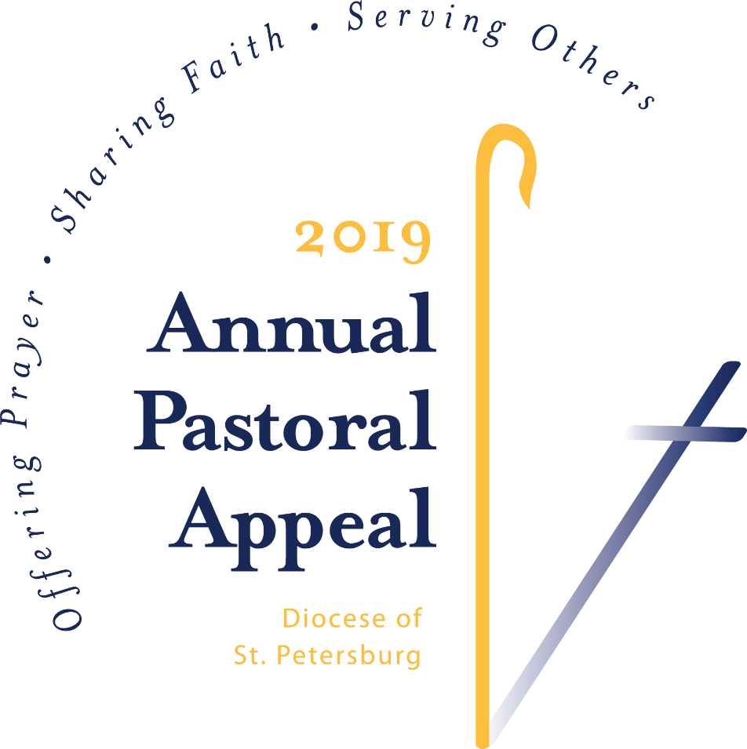
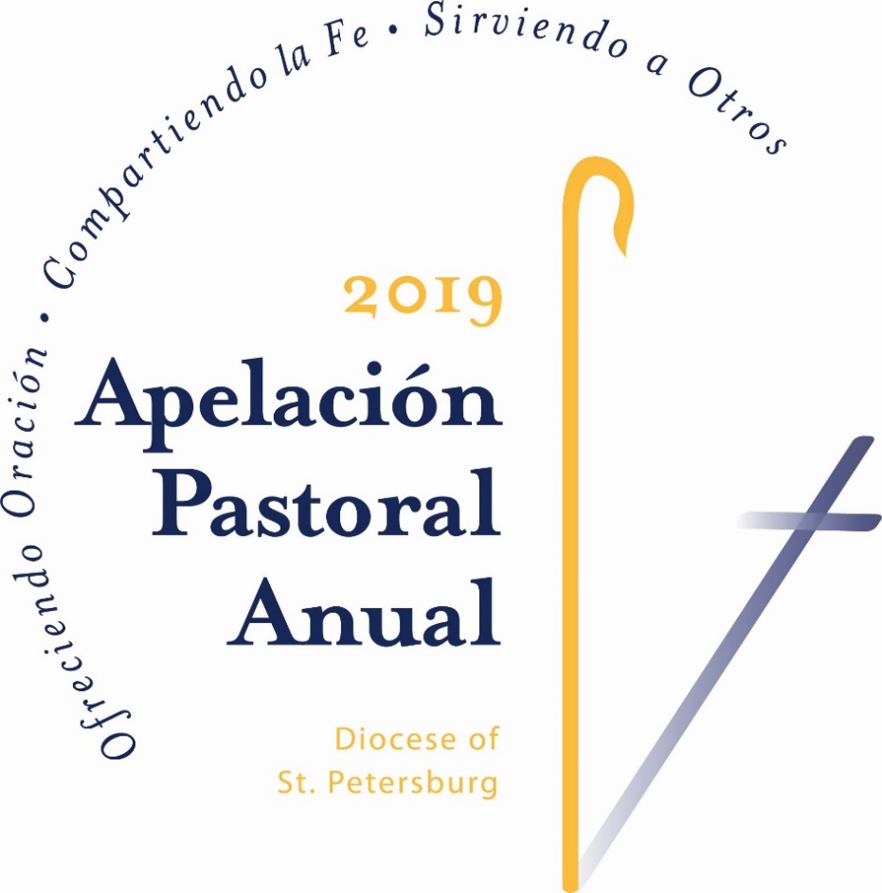

Leadership
Resource Manual
For Pastors, Parish Priests, Deacons, Religious, Business Managers, Parish Staff, Ministry, Lay Leaders & Volunteers
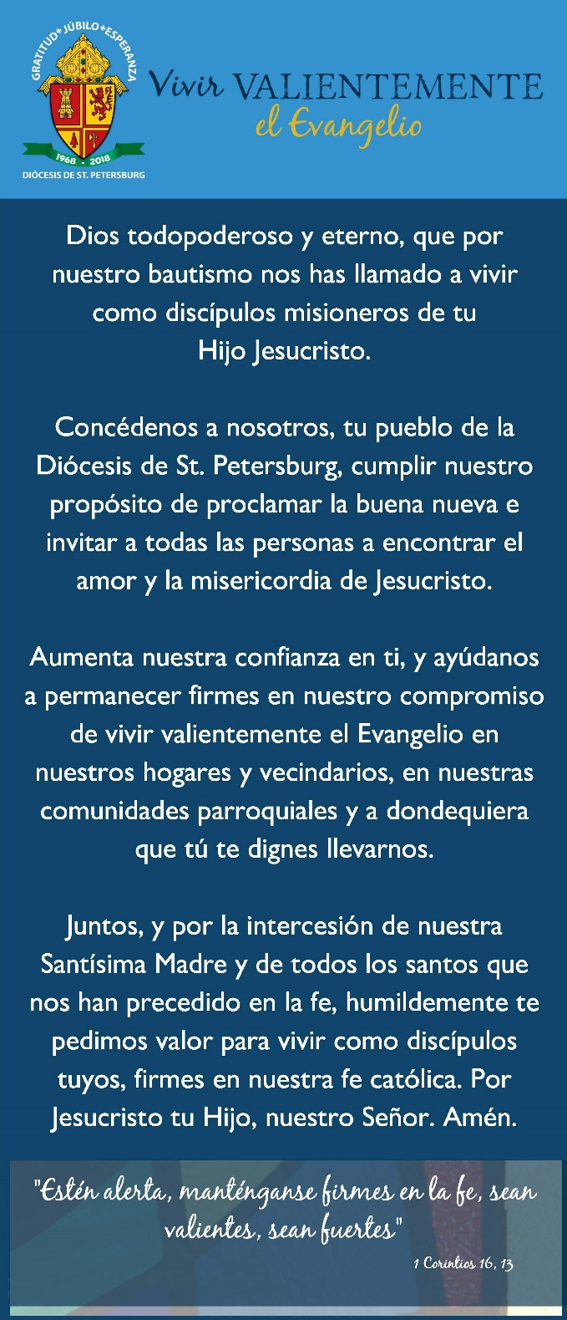
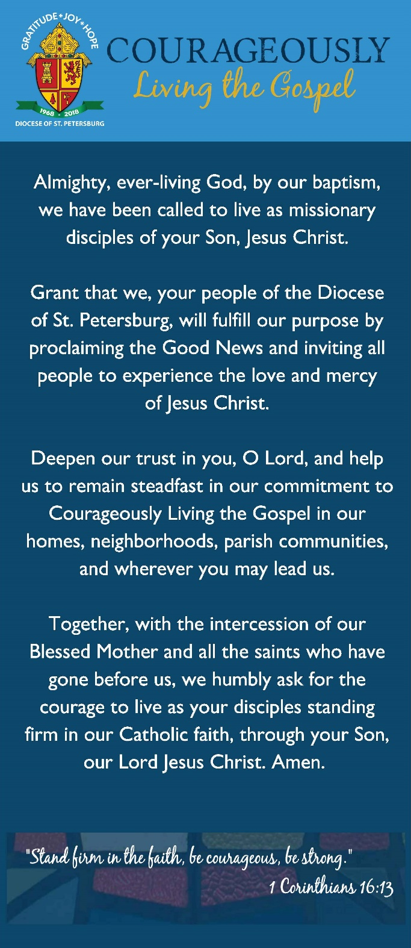
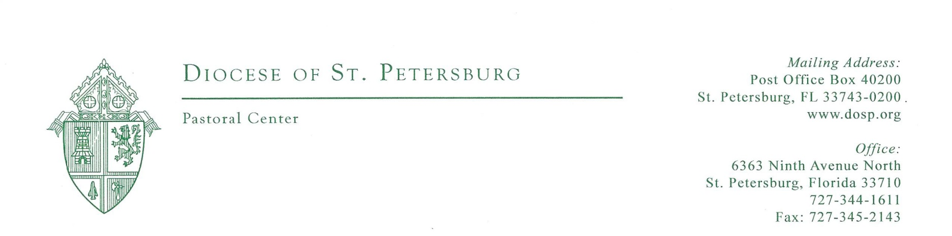
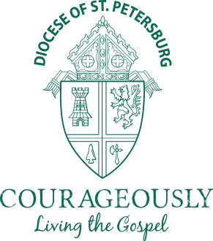

Happy New Year! We would like to take this opportunity to thank you for your leadership in the 2018 Annual Pastoral Appeal. As a faith family, we participated in celebrating a milestone year with great success, and we have one last inspiring aspect of 2018 left to celebrate surpassing the amount raised through the APA last year at this time! Over 27,000 generous, faithful parishioners from throughout our diocese have given over $9.9 million (as of 12/1/18) in support of each parish/mission and all we do together as Church. These donors are a great example of how to BE COURAGEOUS and Live the Gospel through the Annual Pastoral Appeal.

Good stewardship begins with a sense of who we are as disciples of the Lord, and every good steward knows that all blessings come from the Lord and that it is how we use these blessings to serve one another and those we encounter that matters most. It is clear more and more each year that through your leadership and example the concept of stewardship as a way of life is growing in our diocese. Because of this, countless individuals and families are able to directly benefit from the ministries, programs and services that are vital to their well-being and spiritual growth. Through your diligence, we are building awareness that participating in the Annual Pastoral Appeal truly does have an immediate and tangible impact.

Enclosed within this manual and available on our APA webpage at www.dosp.org/apa, are various best practices, helpful hints and effective tools and resources to guide you through a successful 2019 Annual Pastoral Appeal. However, it is important to keep in mind that the most effective strategy for a successful APA effort is to personalize your approach. Share stories about how the ministries, programs and services of our diocese, funded by APA, help you personally and your parish, and also make an impact on thousands of people each year.

Every gift is courageous, a gesture of good faith and an investment in building up the Kingdom of God as Jesus intended. We are here to serve you and help you reach your maximum potential in all areas of stewardship.
Thank you for all that you do.

Most Respectfully,
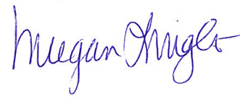

Meegan Wright, Executive Director Jeanne Smith, Associate Director Office: (727)344-1611 ext. 5337 Office: (727)341-6825 Cell: (727)278-3131 Cell: (727)251-0003 Email: mlw@dosp.org Email: jms@dosp.org

Table of Contents

Just the Facts 5
2019 Calendar of Activity 7
Parish Participation – Roles & Responsibilities 11
Basics for a Successful APA 12
2018 Fiscal Year Actuals 13
2018 Fiscal Year Actuals (Continued) 14
Ways to Give 15
APA Campaign Reporting 16
Campaign Processing 17
Remittance of APA Envelopes to Campaign Processing 19
Parish Mailing Update Information 20
In-Pew Solicitation for Commitment Weekend 21
How to Make Your In-pew Solicitation Successful 21
Breaking Down the In-Pew Envelope 22
Sample In-Pew Commitment Weekend Pulpit Presentation 23
In-Pew Solicitation for Multicultural Parishes 24
Promotional Materials & Resources 25
Prayers of the Faithful 26
Pastor & Pulpit Announcements 27
Bulletin Announcements 32
Diocesan Speakers 35

Just the Facts
What is the Annual Pastoral Appeal (APA)?
Every year, each parish and mission in the Diocese of St. Petersburg is given an assessment. That assessment is calculated based on an approved formula that takes into account self-reported total revenue of each parish and mission. The purpose of the assessment is to support diocesan ministries, programs and services that meet the physical, educational and spiritual needs of thousands within and outside of parish and mission boundaries.

The Annual Pastoral Appeal (APA) is a fundraiser created in the Office of Stewardship and Development to assist parishes and missions in raising funds for their assessment responsibility directly from their parishioners, instead of using offertory and operational resources. The appeal encourages participation from every Catholic household to uphold this mission of Jesus Christ in each parish and mission for our local Church and allows us, as one faith community, to fulfill God’s call to discipleship by sharing the gospel message in word and deed, serving each other with mercy and love.

Why do we need this manual?
The purpose of this Leadership Manual is to provide a detailed plan of the 2019 Annual Pastoral Appeal (APA) and include the necessary information to assist in making the effort successful in every parish and mission. The elements outlined represent best practice, helpful guidelines and sample communications designed to keep your appeal on track. It offers many options to enable the entire parish community, from pastor to parishioner, to achieve optimal results. Be creative…this is only a resource of structure and best practices; it does not compare, nor does it limit, what you may be able to produce with a group that knows your parish best.

Summary of APA 2018:
Faithful stewards of each parish and mission have upheld our purpose to be Christ for one another with their time, talent and generosity. United, as one faith family, we have been able to do what one cannot accomplish alone. Participation in diocesan programs and events is at an all-time high and with a total $9.93 million in pledges from 27,374 donors (as of December 1, 2018). Because of parish and mission diligent efforts, we have again surpassed where we were at this time last year. As we close the APA 2018 with joyous momentum, strength and true gratitude, we go forth celebrating a rich history and embark on the future with a new vision and experience of the success of stewardship as a way of life.

What’s NEW for 2019?
Our new diocesan mutually-shared vision: Courageously Living the Gospel! This initiative will be at the forefront of what we do and how we do it as disciples of one faith family in the name of Jesus Christ. To BE COURAGEOUS and Live the Gospel through the Annual Pastoral Appeal is our call to action to participate in successful efforts of proclaiming, inviting and encountering. This will enrich our faith life and bring those we serve closer to Christ.
- Impact reports and testimonials will be created to better understand and grow APA funded ministries
- All APA resources will be updated to demonstrate how we: Live the Gospel through the Annual Pastoral Appeal
- New e-giving webpage: https://s.dosp.org/give
- Ministry partnership- the Office of Stewardship and Development will coordinate with any interested parish/mission that would like to partner with any ministry, program or service funded by the Annual Pastoral Appeal. This offers a unique opportunity to learn about, volunteer for and participate in a ministry, program or service funded by APA.
3 Keys to Success:
These 3 key elements will further your success with overall giving in your parish:

- Your willingness to communicate appeal results and gratitude to your parishioners for their participation will make all the difference when you approach them for their next giving opportunity.

- Your public recognition of volunteers will remind them of the importance of their work and inspire them to return.

- Whether you are prayerfully considering your own gift, or consulting with your staff, lay leaders, volunteers or parishioners, the best giving is approached from an evangelistic or catechetical perspective and affirmed with your encouragement and appreciation for steadfast support. This, combined with your pastoral care, people are much more likely to understand and embrace the mission of our Church for your parish or mission and our diocese. There is no replacement for authentic encouragement and participation.

2019 Calendar of Activity
Now-January 12/13 Thank you Bulletin Insert Weekends (APA 2018) Bulletin inserts are available with or without tear off gift form. Please note, the Office of Stewardship and Development can assist in redesigning this insert to include donor names.

January 7 Materials for APA 2019 Commitment Weekend shipped to/digitally shared with all parishes

January 14 1st Request letter from Bishop Parkes delivered to Post Office
Letter packet sent to all Catholic households in the Diocese of St. Petersburg
Includes: personalized letter from Bishop, brochure, personalized intent/gift card and return envelope.

January 26/27 APA 2019 Prayer Weekend
Courageously
The 2019 APA prayer is our diocesan Living the Gospel prayer.
- Begin new bulletin articles, pulpit announcements and Prayers of the Faithful petitions
- Distribute prayer cards at each Mass and inform parishioners that with this dually used prayer we are not only praying for the success of the vision initiative for our diocese, but also for all that we do to serve the people of God through the APA
- Recite this prayer this specific weekend before Mass, during the announcements or before the final blessing, and each weekend thereafter

February 2/3 APA 2019 Education Weekend
Pastors, parish priests, deacons, ministry or lay leaders are encouraged to give witness to the positive impact the ministries, programs and services supported through the APA have on your parish and our diocese.
- Witness talk should convey a positive message with perspective of building on an affiliation and impact with APA funded ministry, program or service
- Show the 2019 APA Video – The BE COURAGEOUS Live the Gospel through the Annual Pastoral Appeal video focuses on diocesan-wide faith in action and the mission of our growing Church through the ministries/programs/services funded by APA
- Utilize the video vignettes and Snap Shots on specific ministries promoting the good works done for those in need throughout our diocese
- Continue bulletin articles, pulpit announcements, Prayers of the Faithful petitions, and use the dual-purpose prayer for all that we do to serve the people of God through the APA
- Remind parishioners at all Masses that the weekend of February 16/17 is 2019 APA Commitment Weekend, and ask them to come prepared to participate with the intent card they received at home

February 9/10 APA 2019 Clergy Support Weekend
Pastors, parish priests, deacons, ministry or lay leaders are encouraged to give witness to the positive impact the ministries, programs and services supported through the APA have on your parish and our diocese.
- Witness talk should convey a positive message with perspective of building on an affiliation and impact with APA funded ministry, program and/or service
- Show the 2019 APA Video – The BE COURAGEOUS Live the Gospel through the Annual Pastoral Appeal video focuses on diocesan-wide faith in action and the mission of our growing Church through the ministries/programs/services funded by APA
- Utilize the video vignettes and Snap Shots on specific ministries promoting the good works done for those in need throughout our diocese
- Continue bulletin articles, pulpit announcements, Prayers of the Faithful petitions, and use the dual-purpose prayer for all that we do to serve the people of God through the APA
- Remind parishioners at all Masses that NEXT weekend, February 16/17 is 2019 APA Commitment Weekend, and ask them to come prepared to participate with the intent card they received at home

February 16/17 APA 2019 Commitment Weekend
The authenticity in which the APA is explained and associated with your parish activity and how this solicitation exercise is done will determine the response of each parishioner!
- Pastor, parish priest or deacon leads this commitment with his own testimony through homily or reflection and filling out pledge/gift card with assembly. If you have prepared your parishioners for this weekend the enthusiasm will be contagious, and results will show support of our united mission
- Invite all parishioners at each Mass to participate with you in the Annual Pastoral Appeal in-pew solicitation and collection by using the intent cards they have brought with them or the pledge envelopes they have completed at Mass
- Continue bulletin articles, pulpit announcements, Prayers of the Faithful petitions, and use the dual-purpose prayer for all that we do to serve the people of God through the APA

February 23/24 APA 2019 Follow-Up Weekend #1
- “Thank you” is never over used or understated. Gratitude with successful detail should be expressed to those who have made a pledge or gift to the Annual Pastoral Appeal as of this date.
- Request consideration from those who have not yet responded, and those who have never given, ask them to invest in the mission of our local Church in which your parish is a participant
- A reminder should be given that information will continue to be available in the bulletin, at the pulpit, and in the Prayers of the Faithful petitions, and a request made for continued personal prayer of success for your parish, and the success of all parishes throughout the Diocese for the overall appeal goal and the good works we do as Church

March 2/3 APA 2019 Follow-Up Weekend #2
- Continue any education that is associated with your parish/mission and APA. Utilize available resources to promote APA in ministries, programs and services your parish can relate to
- “Thank you” is never over used or understated. Gratitude with successful detail should be expressed to those who have made a pledge or gift to the Annual Pastoral Appeal as of this date.
- Request consideration from those who have not yet responded, and those who have never given, ask them to invest in the mission of our local Church in which your parish is a participant
- A reminder should be given that information will continue to be available in the bulletin, at the pulpit, and in the Prayers of the Faithful petitions, and a request made for continued personal prayer of success for your parish, and the success of all parishes throughout the Diocese for the overall appeal goal and the good works we do as Church

March 6 Ash Wednesday – Lent begins
- 40 days of Prayer, Fasting and Almsgiving
- Create a Lenten mission that partners with a ministry funded by the APA, to build a better understanding of what is done and who is served outside of your parish
- All parishioners should be asked to keep your parish needs at the forefront of their Lenten offerings
- Continue bulletin articles, pulpit announcements, Prayers of the Faithful petitions, and using the dual-purpose prayer for all that we do to serve the people of God through the APA

April 14 Palm Sunday- Easter Triduum
April 21 Easter Sunday

April 29 2nd Request letter delivered to Post Office
This follow-up is a personal letter from the pastor, sent to previous APA donors who have not responded to date to ask for their support.
Includes: personalized letter from the pastor, personalized intent/gift card and return envelope

May-September Ongoing Activity
Until your parish APA goal is met, we recommend using any and all resources created within your parish and/or the materials the Office of Stewardship and Development has made available to you online for promotion, such as:
- Continue bulletin articles, pulpit announcements, Prayers of the Faithful petitions, and using the dual-purpose prayer for courage to live as disciples standing firm in our Catholic faith
- Report the progress of APA to your parishioners each week
- Ask those that have not given to give
- Pray. Guide all expectation and action through prayer
- Encourage lay witness. Personal testimony will engage parishioners and prompt them to give

- Evangelize. Your parish/mission ministries and outreach and all diocesan ministries, programs and services are part of the Church’s mission of helping those in need. Building that awareness and the triumph of bringing souls closer to God is what APA is all about. Share the good news through stories of success.

September 9 3rd Request letter: LYBUNT/SYBUNT – (Last or Some Year But Unfortunately Not This year)
This letter is sent to parishioners who gave in the last year and/or one of the previous two years and have not given yet this year.
Includes: personalized letter from the pastor/bishop, personalized intent/gift card and return envelope

October 1 All Souls Mailing
This letter is a Thank you from the Bishop sent to all APA donors who committed to $365 (a dollar a day) or more, which includes a request for prayer intentions for loved ones who have passed away. These prayer intentions are collected and placed in the Chapel of the Pastoral Center and prayed for at each Mass during the month of November.

EOY Success Go For the Goal
This mini-appeal can be organized and modified specifically for your parish to assist in reaching your APA goal. It may be started at any time beginning in July through September, and will include all elements of the prescribed APA effort, on a more condensed schedule.

Parish Participation – Roles & Responsibilities
Relationships, education and promotion are essential for a successful Annual Pastoral Appeal (APA). The appeal involves a positive partnership between parishes, missions, the Office of Stewardship and Development, and the Campaign Processing Office at the Pastoral Center.
- Parishes and missions are encouraged to promote the APA in a positive manner, present APA education and information to parishioners and personally invite participation.
- The Office of Stewardship and Development prepares and distributes all APA materials, offers informative training, arranges for guest speakers upon request, and provides a weekly update of current APA events and materials, including a weekly overall status report communicated through the APA Messenger. In addition, the office provides ongoing support to leadership during all aspects of the appeal.
- The Campaign Processing Office records all pledges and gifts and is responsible for the remittance process. Reports of real-time ongoing progress are available in ParishSoft Family Suite.
When parish leaders are informed and participate in the implementation and expectations
of the Annual Pastoral Appeal, the results are limitless.

For the pastor, parish priests and deacons -
- Build an awareness of the APA timeline projected for your parish/mission, especially with parish staff and volunteers
- Inform staff, volunteers and parishioners early that the first APA mailing will be coming as an invitation from Bishop Parkes
- Delegate a committee to implement and support an appeal plan
- Set a positive tone for the appeal
- Affirm the appeal through homilies, bulletin and pulpit announcements
- Approve or modify in a timely manner the 2nd invitation letter to parishioners to suite your parish activity
- Pray for the success of the Annual Pastoral Appeal whenever possible, including during parish ministry and staff meetings
- Make a personal gift/pledge

For the parish/mission business manager/staff -
- Stay in regular communications with your pastor, parish staff and appeal volunteers regarding APA status, parish inquiries, issues, etc.
- Contact the Office of Stewardship and Development for additional materials, speakers, development plans, committee implementation, or any other related support
- Include APA information or materials in the bulletin regularly and be sure pledge envelopes are placed in the pews for Commitment Weekend, or are visually accessible in the vestibule at all times
- Contact the Campaign Processing Office for financial reporting or assistance with payments, and remit all pledge envelopes to them that have been returned to the parish
- Make a personal gift/pledge

For the parish volunteers who are typically generous and consistent supporters -
- Recruit and coordinate volunteer leadership and provide the support needed to the pastor and parish staff
- Keep in regular contact with the pastor concerning any communications regarding APA
- Prepare personal presentations at all Masses during the Appeal, offer consistent understanding and support for APA, be enthusiastic about promoting its success, and encourage all parishioners to consider a sacrificial gift
- Make a personal gift/pledge

Basics for a Successful APA
In order to build momentum and inspire participation, it is vital to plan and implement activity that educates and gains the attention of historical donors as well as new donors. Here are some helpful tips to assist in a successful parish APA effort.

- Pray. The power of prayer creates a unified strength that should always be encouraged and never underestimated.

- Review your results from last year. Use the final report to evaluate all approaches that were taken, determine ways to improve results and create a plan that will achieve your parish goal. Share that plan with your parishioners.

- Make your own pledge first. This cannot be stressed enough. As a faithful parish leader, make your own gift/pledge first, leading others to support the Appeal by your own example.

- Offer EVERYONE the opportunity to participate. After offering education and understanding of the APA, convey the impact for your parish and our diocese. Be sure to offer the many different ways to give.

- Include and encourage youth, parish ministries & staff. Being part of the APA for your parish draws these important ambassadors into participation in the life, mission and work of our Catholic faith community.

- Know the facts. Be sure that everyone sharing the good news of the physical, educational and spiritual programs funded by the Annual Pastoral Appeal is speaking with factual information. There is plenty of it, and it’s all good.

- Target a specific amount. Do not generalize gift giving. Mention pledge options to maximize your offer. Everyone appreciates knowing what is expected of them.

- Keep your sights high. Do not seek the lowest gift option first. Figure out an average gift for your parish (using the highest amount), but always affirm that EVERY gift helps your parish and changes a life.

- Keep a positive attitude. This is a parish appeal, and a positive approach to its objective and overall importance to your parish should remain sincere and upbeat.

- Prepare informative parish announcements. Bulletin and pulpit announcements each week regarding the Appeal are essential. Be short, informative and grateful.

- Ask. Ask. Ask. If you do not ask, donors will not give. Everyone likes to be asked. A donor does not know what you want, need or what is expected until they are asked.

- Thank everyone! There is no substitute for genuine gratitude and affirmed progress. These two things help us to recognize that by giving, we increase our blessings!
BE COURAGEOUS

Live the Gospel through the Annual Pastoral Appeal

2018 Fiscal Year Actuals
Sources of Revenue:
 | Donations from Parishioners for APA 2017 (for 2017-2018 operations) | 8,327,417
 | Parish Assessments for Fiscal Year 2017-18 | 3,490,056
 | Total APA and Assessment | 11,817,473
 | Program Service Fees and Reimbursements | 3,781,223
 | Bequests, Donations, Grants, and Interest Earnings | 209,359
 | Total Operating Revenue | 15,808,054
Operating Expenses: |  | Expense $ | Specific Program Revenue $ | Net  Expense $ | % of  Net Expense
Clergy, Religious, Vocations and Seminarian Education
 | Seminarian Education and Support Costs | 1,285,763 | (550,000)
 | Vocations Office, Chancellor, Secretary for Priest Personnel, Vicar for Religious | 449,731 | 0
 | Graduate Study for Priests, Continuing Education and Formation for Priests, Clergy Care, Permanent Diaconate Program | 922,958 | (154,885)
 | Facility Cost for Associated Ministries | 106,641 | (5,054)
 | Total | 2,765,093 | (709,939) | 2,055,154 | 18.9%
Catholic Formation and Education
 | Office of Catholic Schools and Centers | 700,316 | (217,514)
 | Office of Faith Formation, Lay Pastoral Ministry Institute, Campus Ministry, 60% of Youth and Young Adult Ministry Office, Scouting, Marriage Preparation | 891,186 | (287,860)
 | Tuition Assistance Grants | 878,473 | (672,473)
 | Support of BMCHS, ACE and ECHO Programs | 66,979 | (12,000)
 | Legal Expense | 48,473 | -
 | Contributions made for National Collections (Catholic University of America and Catholic Communications Campaign) | 75,172 | -
 | College Campus Ministry | 76,034 | -
 | Facility Cost for Associated Ministries | 251,077 | (12,996)
 | Total | 2,987,710 | (1,202,843) | 1,784,867 | 16.4%
Catholic Social Services
 | Catholic Charities of the Diocese of St. Petersburg and Ministries of Mercy | 1,012,883 | (10,285)
 | Prison Ministry, Life Ministry | 225,657 | (22,141)
 | Contributions made for National Collections (Church in Latin America, Church in Central and Eastern Europe, Home Missions, Holy Land, Black and Indian Missions) | 169,140 | -
 | Contributions to La Clinica Guadalupana and many nonprofits | 91,340 | -
 | Facility Cost for Associated Ministries | 67,249 | (2,888)
 | Total | 1,566,269 | (35,314) | 1,530,955 | 14.1%

Parish, School and Diocesan Services
 | Multicultural Office, Community Relations, Marriage Tribunal, Office of Worship, Ordinations and Celebrations, Propagation of Faith Office, Archives, Subsidies to Missions and Apostolates, Cathedral Subsidy, 40% of Youth and Young Adult Ministry Office | 1,318,891 | (189,727)
 | Stewardship and Development, APA Marketing | 326,433 | 1,475
 | Construction Management Office, 70% of Real Estate Office | 244,377 | (22,739)
 | Human Resources Office | 203,051 | (56)
 | Safe Environment Office | 447,517 | (242,451)
 | Legal Services | 84,827 | -
 | Parish and School Financial Reporting | 360,341 | (353,850)
 | Campaign Processing Office | 343,095 | -
 | Spirit FM | 985,034 | (892,932)
 | Bethany Center | 400,959 | (30,000)
 | Facility Cost for Associated Ministries | 370,848 | (18,772)
 | Total | 5,085,373 | (1,749,052) | 3,336,321 | 30.7%
Pastoral Leadership
 | Office of the Bishop, Vicar General, Secretary for Administration, Secretary for Christian Services,  Bishop Emeritus | 821,453 | (48,073)
 | FCC, FCCB, and Holy See Quotas | 357,271 | -
 | Facility Cost for Associated Ministries | 39,392 | (2,166)
 | Total | 1,218,116 | (50,239) | 1,167,877 | 10.7%
Administration and Temporal Affairs
 | Accounting and Finance, Information Services | 617,908 | (14,704)
 | Legal Expense, 30% of Real Estate Office | 111,153 | (9,745)
 | Capital Expenditures | - | -
 | Bad Debt | 123,590 | -
 | Facility Cost for Associated Ministries | 170,697 | (9,386)
 | Total | 1,023,348 | (33,835) | 989,513 | 9.1%
Total Operating Expenses |  | 14,645,909 | (3,781,222) | 10,864,687 | 100%
 | Revenues in Excess of Expense | 1,162,145

2018 Fiscal Year Actuals (Continued)
Parish, School and Diocesan Services
 | Multicultural Office, Community Relations, Marriage Tribunal, Office of Worship, Ordinations and Celebrations, Propagation of the Faith, Archives, Subsidies to Missions and Apostolates, Cathedral Subsidy, 40% of Youth and Young Adult Ministry Office | 1,318,891 | (188,252)
 | Stewardship and Development, APA Marketing | 326,433
 | Construction Management Office, 70% of Real Estate Office | 244,377 | (22,739)
 | Human Resources Office | 203,051 | (56)
 | Safe Environment Office | 447,517 | (242,451)
 | Legal Services | 84,827 | -
 | Parish and School Financial Reporting | 360,341 | (353,850)
 | Campaign Processing Office | 343,095 | -
 | Spirit FM | 985,034 | (892,932)
 | Bethany Center | 400,959 | (30,000)
 | Facility Cost for Associated Ministries | 370,848 | (18,772)
 | Total | 5,085,373 | (1,749,052) | 3,336,321 | 30.7%
Pastoral Leadership
 | Office of the Bishop, Vicar General, Office of Communications, Bishop Emeritus | 821,453 | (48,073)
 | FCC, FCCB, and Holy See Quotas | 357,271 | -
 | Facility Cost for Associated Ministries | 39,392 | (2,166)
 | Total | 1,218,116 | (50,239) | 1,167,877 | 10.7%
Administration and Temporal Affairs
 | Accounting and Finance, Information Services | 617,908 | (14,704)
 | Legal Expense, 30% of Real Estate Office | 111,153 | (9,745)
 | Capital Expenditures | - | -
 | Bad Debt | 123,590 | -
 | Facility Cost for Associated Ministries | 170,697 | (9,386)
 | Total | 1,023,348 | (33,835) | 989,513 | 9.1%
Total Operating Expenses |  | 14,645,909 | (3,781,222) | 10,864,687 | 100%
 | evenues in Excess of Expense | 1,162,145

Ways to Give
Pledging:
Many people feel that they can participate at a sacrificial gift level if they make payments over a period of time. We currently work with monthly and annual pledge cycles. Donors who pledge will receive reminders according to their designated payment schedule.

One-Time Gift:
If donors prefer, a one-time gift can be paid at the time of commitment or payment can be scheduled a later date.

Electronic Giving:
We accept all major credit/debit cards (MasterCard, American Express, Visa and Discover) as well as direct debit payments. Electronic giving can be completed two ways:
- Donor managed online giving is available through our diocesan website at: https://s.dosp.org/give
- Authorization forms for credit cards and direct debit donations are available on all pledge cards and
in-pew envelopes.

If your parish would like assistance setting an APA e-giving link from the parish website, please contact Meegan Wright at mlw@dosp.org.

Checks:
When making a payment by check, please ensure the donor makes checks payable to the Annual Pastoral Appeal.

Matching Gifts:
Many companies have Matching Gift Programs for charity or educational purposes. Contact your company’s Human Resource Office concerning matching gift opportunities. Please keep in mind, there are necessary applications and procedures to follow; so once a donor completes the steps required by their company, please direct them to contact Kathy King in our Campaign Processing Office at kck@dosp.org to ensure the process is completed successfully.

Gifts of Appreciated Stocks, Securities or IRA:
Federal tax law allows a charitable deduction for the full market value of the securities on the date of a gift, and thanks to the passage of the PATH Act in the US Congress, making permanent the opportunity to give IRA assets to charity, free from federal tax, you can transfer up to $100,000 from your Individual Retirement Account (IRA). For more information or assistance, please contact Kathy King in our Campaign Processing Office at kck@dosp.org or by phone at 727-341-6841.

APA Campaign Reporting
Parish Summary updates are emailed weekly through the APA Messenger. If you are not currently receiving this communication, please email Jeanne Smith at jms@dosp.org and you will be added to the distribution list.

Detail Donor and Parish Roster Reports are available in real time through ParishSoft Family Suite at https://stpetersburg.parishsoftfamilysuite.com/. When converted into an Excel spreadsheet, you are able to maximize your opportunities to say thank you or invite your parishioners to give to the Annual Pastoral Appeal through parish level communications. If you have any questions or need assistance with Family Suite, please contact Ray Miller at rnm@dosp.org.

PLEASE NOTE: for full download function, use Mozilla Firefox as your Internet browser.
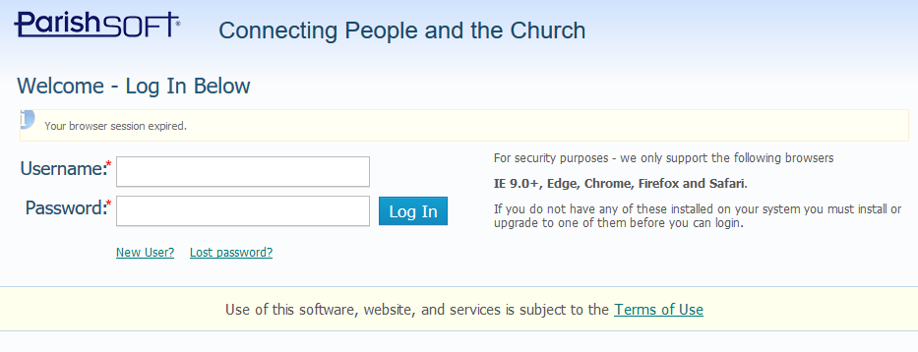
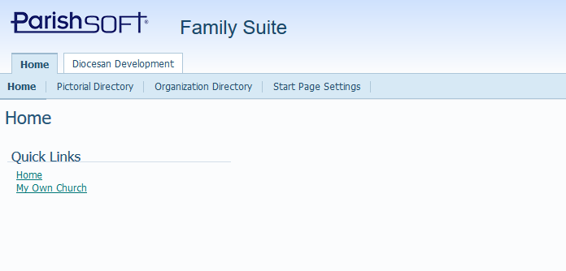

A Family Suite log-in is
required to gain access to reports.
This is only given through Pastor permission.

Once you log-in, select the
“Diocesan Development” tab

For DETAIL DONOR REPORTS:

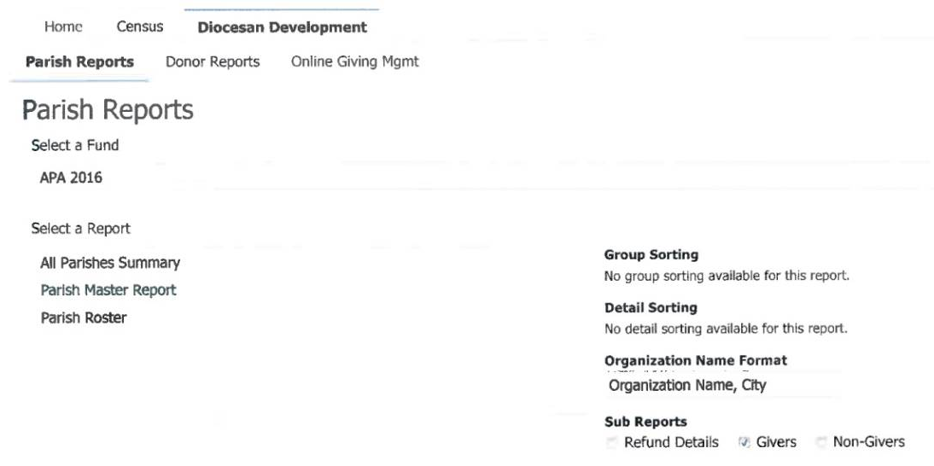
1-Select the “Parish Report” tab

2-Select a Fund (which APA year do you want a report for? 2016, 2015, 2014, etc.)

3-Select “Parish Master Report” from
the list

4-Remove the “checks” from the “Refund Details” and “Non-Givers” boxes.
This means a check mark should be in place for “Givers” ONLY.

5-Push the “Download PDF” button at the bottom of the screen.

For PARISH ROSTER REPORTS:

1-Select the “Parish Report” tab

2-Select a Fund (which APA year do you want a report for? 2016, 2015, 2014, etc.)

3-Select “Parish Roster” from
the list

4-Make sure checks appear in both “Givers” and “Non-Givers” boxes.

5-Push the “Download PDF” button at the bottom of the screen.

Through ParishSoft Family Suite you can also access your parish roster, convert it into an Excel spreadsheet and sort it different ways in order to maximize your opportunities to say “thank you” or invite your parishioners to give to the Annual Pastoral Appeal.

For any other specialized reporting, please contact Kathy King at kck@dosp.org.

Campaign Processing
15
The Campaign Processing Office is here to serve you and our generous donors from throughout the entire Diocese. We embrace the importance of accuracy and efficiency and strive to improve our procedures regularly so that we maybe the best stewards of what we have been entrusted.

Meegan Wright – Executive Director of Stewardship and Development Email: mlw@dosp.org
Responsible for day-to-day operations of the Campaign Processing Office as well as diocesan cash acceptance. Manages department personnel and oversees day-to-day processing and operations of the Annual Pastoral Appeal, diocesan capital campaigns, parish capital campaigns, WBVM Spirit FM 90.5 and matching gift fundraising.

Kathleen King - Senior Processing Specialist Email: kck@dosp.org
Primary contact for all Campaign Processing and responsible for day-to-day processing of diocesan capital campaigns, parish capital campaigns and WBVM Spirit FM 90.5 fundraising. Manages stock transactions as well as all electronic giving efforts. Responsible for daily reconciling reports, month end reconciling reports and parish campaign reports. Assistant to all parishes in data base maintenance.

Debra Burnett - Processing Specialist Email: dsb@dosp.org
Responsible for day-to-day credit card and direct debit processing for all campaigns, Annual Pastoral Appeal donor activity, general research of donor requests. Assistant to all parishes in data base maintenance.

Michelle Markievich - Processing Specialist Email: mmm@dosp.org
Responsible for day-to-day credit card and direct debit processing for all campaigns, Annual Pastoral Appeal donor activity, general research of donor requests. Assistant to all parishes in data base maintenance.

Contact the Campaign Processing Office
by phone at 727-341-6841
or by fax at 727-347-6508

Remittance of APA Envelopes to Campaign Processing
In order to serve all of our parishes in the most efficient way, the following procedures have been established to help expedite the remittance of APA envelopes received in each parish and forwarded to the Campaign Processing Office.

- For security and accuracy purposes, please do not open any APA envelopes

- To ensure prompt and accurate posting, please make sure all gift envelopes have your parish name on them

- Beginning in January, you may receive APA pledge envelopes in the collection basket

- The APA pledge cards and envelopes should be collected and sent to:

For UPS/FedEx For USPS
Campaign Processing Office Campaign Processing Office
Bishop W. Thomas Larkin Pastoral Center Bishop W. Thomas Larkin Pastoral Center
6363 Ninth Avenue N. Post Office Box 40200
St. Petersburg, FL 33710 St. Petersburg, FL 33743-0200

- To ensure the integrity of the enclosed gift the preferred method of sending in envelopes is FEDEX or UPS. If you use the USPS, please defer to the Pastoral Center PO Box

- Please submit all APA gifts to the Campaign Processing Office on a regular basis

- For Audit and Internal Control Purposes:
- The Campaign Processing Office cannot verify the contents or accuracy of envelopes if the seal is broken
- Parish staff handling the collection should count the number of APA envelopes and attach a slip with the envelope count on top of the bundle

- For remittance of cash gifts: APA gifts of loose cash should be deposited into the parish account and a check for the total amount of the cash gifts should be forwarded to the Campaign Processing Office with remittance identifying the check and cash gifts to ensure accurate acknowledgement

If you have any questions,
please contact the Campaign Processing Office at 727-341-6841.

Parish Mailing Update Information
As all parish leaders know, current mailing information is vital for maintaining a relationship with your parishioners. Sharing the integrity of this information is equally important.

The development of a comprehensive annual giving program like the Annual Pastoral Appeal can be a daunting task. The most important part of its success is identifying potential donors and acquiring their contact information in order to prepare personalized direct mail packets parishioners receive at home.

Do you know your parishioners?

Are you using their correct mailing information?

Do you want the APA letter coming from your pastor and our Bishop to be addressed correctly?

If you answered “Yes” to any/all of these questions, it is vital to keep your parishioner records up to date.

If your parish is not on ParishSOFT, we hope you are using the Family Suite program to share the additions, deletions and corrections of your parishioners’ mailing information. This updates the diocesan mailing data automatically.

The address information we have for your parishioners is what you provide us and is what will be used for the upcoming APA mailings on behalf of your parish. If you have not recently done so, please update your parish mailing information so that the upcoming mailings from the bishop and your pastor will reach all of your parishioners.

Each parish has been assigned to a campaign processing specialist and any issues regarding parishioner address information should be brought to their attention. They have each been in contact with a representative at their assigned parishes to discuss current status, updates and share notifications their office receives from parishioners.

Accurate mailing information sharing = a more accurate mailing

A more accurate mailing = more opportunities for your parishioners to feel
they are being included and invited to participate

In-Pew Solicitation for Commitment Weekend
An in-pew solicitation process is recommended for obtaining donations from a large portion of your parishioners at one time. This method of inviting participation requests a response by parishioners while at Mass following an informational and motivating clergy or lay witness presentation. If implemented thoroughly and properly, results have proven this practice increases both the number of donors and the dollars contributed.

How to Make Your In-pew Solicitation Successful
- Be sure that parishioners are given at least two weeks advance notice before they are asked for their gifts. This allows them to come to church prepared to make a pledge or one-time donation.

- Posters should be displayed in appropriate visible locations. Utilize special bulletin and pulpit announcements, as well as Prayers of the Faithful petitions to inform people of the upcoming appeal and its benefits to the parish and those in need.

- Recruit a lay witness. The use of a lay witness is an effective way of increasing participation. Select a parishioner who has been affected by or who is participating in a diocesan ministry, program or service funded by the appeal. They should be active, energetic and enthusiastic speakers. Remember that people give to people.

- One week prior to your scheduled in-pew commitment weekend, remind and encourage parishioners to read the Annual Pastoral Appeal letter and brochure that was mailed to them.

- On your scheduled in-pew weekend, place in-pew pledge envelopes and pens/pencils at the end of the pews. To assist with this, recruit volunteers from hospitality/ushers to assist in placing materials prior to the first Mass on Commitment Weekend and have volunteers available after every Mass to replenish the supply and straighten up.

- After the celebrant gives a brief homily, the celebrant or a lay witness shares a brief positive experience regarding a ministry, program or service funded by the Annual Pastoral Appeal and how it has affected them.

- Either the celebrant or the lay witness should then give step-by-step instructions on how to fill out the in-pew pledge envelope, encouraging the pledge option. Be sure they indicate a suggested amount (for example, offer a parish average gift amount) as part of the instruction. Urge the parishioners to complete the envelopes in church and provide an explanation on the ways to give (pledge, pledge with payment, one-time gifts). Remind donors that pledging will allow them to increase their gift without changing their budget too much and provides an easy payment plan.

- At this time, your parishioners should be prepared to make their donations. Allow 2-3 minutes for the parishioners to make their contributions. Those making a payment should enclose it and seal the envelope.

- The ushers or special collectors should now collect the gifts or parishioners should bring them to the altar.

- As with all methods of solicitation, the follow-up is a necessary and vital element of success to the appeal. Therefore, we recommend counting the gifts submitted as soon as possible, and preparing a bulletin and pulpit announcement citing the number who participated, along with an invitation for those who have not yet participated to do so.

- Make sure all envelopes are stamped with your parish name and send them to the Campaign Processing Office immediately.

Breaking Down the In-Pew Envelope

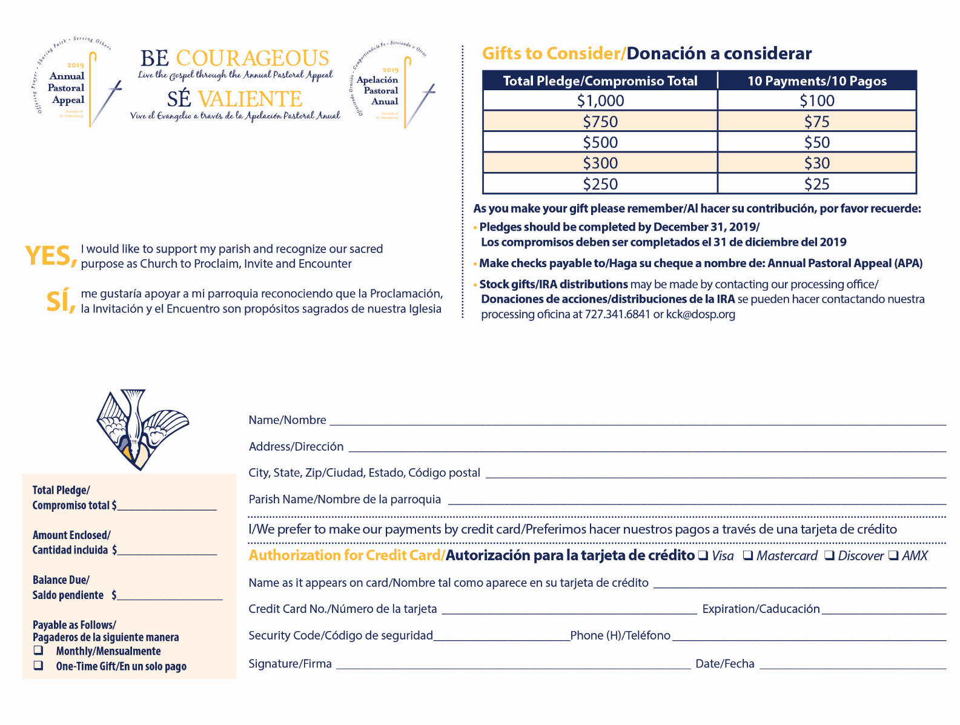
1

3

4

2

5

6

10
7

8

9

1. Theme BE COURAGEOUS Live the Gospel through the Annual Pastoral Appeal
2. Donor’s commitment to giving
3. Sample giving plans for donors to show how a pledge breaks down monthly
4. Important facts to remember:
- Pledges to be completed by December 31, 2019
- Make checks payable to
- Stock gifts info
5. Name and mailing address of donor
6. Amount recorded as pledge
7. Total dollar amount of payments included
8. Balance due (amount to be paid)
9. Payment schedules available to the donor (how many payments to complete the pledge)
10. E-giving via credit card

Questions? Contact the Office of Stewardship and Development at 727-341-6825.

Sample In-Pew Commitment Weekend Pulpit Presentation
This instruction is most successful when delivered by the pastor either before Mass or after the homily.

Here at (your parish name) and throughout our diocese we have much to be grateful for. We have truly been blessed as a faith family. Closing a milestone anniversary year with joyous momentum and heading into a new year filled with a new multi-shared vision of hope and promise. Truly an exciting time to be a disciple of Christ in the Diocese of St. Petersburg.

With this in mind, I want to introduce the 2019 Annual Pastoral Appeal (APA): BE COURAGEOUS Live the Gospel through the Annual Pastoral Appeal. This is our diocesan appeal that invites every parishioner to participate in supporting the ministries, programs and services of our local Church which serve us in our parish and many in need outside of our parish boundaries.

As your pastor, I want to let you know that I support this appeal and the hope it provides for both our parish and for those whom are brought closer to Christ. (You may mention here the ministries, programs and services that your assessment dollars fund and that this fundraiser known as APA helps pay that assessment.)

You should have received a packet in the mail at home which includes a message from Bishop Parkes, as well as a brochure that provides information on how your donations support diocesan ministries, programs and services. More information can be found online in the 2018 Annual Report – please see our bulletin for the website. I would like to emphasize the spiritual effect the appeal has on our parish and diocese. This appeal provides the means to continue the mission that Christ has entrusted to us: to serve, to educate, to care for the poor, and to be a beacon of hope. The ministries, programs, and services that are funded from this effort allow us to fulfill this responsibility given to us all. We are all invited to make a gift, a courageous gift, that demonstrates how as disciples we are living the gospel and sharing it with those we encounter.

I pray that each family will assess their own resources and generously make a gift of substance and not merely one of convenience. This appeal is based on equal sacrifice, not equal giving. I cannot ask everyone to consider the same size gift, but I ask that everyone let their gift reflect how generous God has been with His gifts. Can you consider a gift of $20, $30 or $40 each month for the rest of this year? That amount will equal a pledge of $200, $300 or $400.

I know from personal experience that it is easier to make a gift of sacrifice if you can spread it out, rather than make a full, one-time gift. It is easy, when surrounded by so many people, to think that it won’t matter if you don’t participate. But each gift does make a difference, and it is noticed. I need everyone to prayerfully consider participation. (Consider mentioning to those who have never given that now is the time to BE COURAGEOUS, take that leap of faith…their parish needs them and so does the Church).

As you think about what you will give, remember, this gift is different from your gift each weekend to our parish. This is in addition to your offertory giving. Also, please know these pledges are a “good faith effort.” I know that everyone will do their very best to fulfill their pledges, and that is all that we ask - that you do your best. We know that things happen, and you may need to change your pledge in the future. That’s ok. If a change is needed in the future, it can be made. And if that change is an increase, well, that is ok, too.

At this point, I ask everyone to make their commitment over the next few minutes. If you did not bring your pledge card from home, please complete a pledge envelope found in your pew. Please fill in all the information on the pledge envelope clearly. The pledge envelope has a section marked “Gifts to Consider” which breaks down what 10 equal monthly payments would be, and what the total pledge will come to if all payments are completed. For example, 10 monthly payments of $30 equal a total pledge of $300. Once you decide on the amount you want to give, fill out the giving information on the bottom left of the envelope – the area marked “Total Pledge/Amount Enclosed/Balance Due.” Also indicate if you want to make payments monthly or annually, or as one-time gift to complete your “Balance Due.”

A down payment on your pledge is not necessary or required. If you are able to make one, please do. If you can’t make a down payment, don’t let that stop you from making your pledge.

For those of you who have already made a gift or pledge by sending in your pledge card that you received at home, I thank you for your generosity. I am going to pause to give those who haven’t yet completed their commitment time to fill out their pledge forms, while I do the same. (PAUSE AND FILL OUT A PLEDGE ENVELOPE, EVEN IF YOU HAVE ALREADY DONE SO. THIS WILL ENCOURAGE YOUR PARISHIONERS TO DO THE SAME.)

At this time I ask the Hospitality Ministers/Ushers to pick up all pledge envelopes, including those pledge cards received at home that have been brought in today (or have parishioners bring them to the altar). Thank you once again for listening with an open heart. All gifts are an act of courage and in a few weeks when the active phase of the APA concludes, I know we will have done our part as a parish family to live the Gospel through the Annual Pastoral Appeal.

In-Pew Solicitation for Multicultural Parishes
For other cultures, sacrificial giving may not be the custom, and support for their Church by a way of pledging may not be a common or known practice. Below are some suggestions for adapting in-pew solicitation for multicultural parishes. As you present other options, please remember that it is important to stress the message of equal sacrifice, not equal gift.

Pledge with Weekly Payments:
Ask parishioners to consider a total amount to pledge, direct them to write that amount on the bilingual envelope provided, or perhaps, to choose one of the suggested amounts already listed on the envelope. Explain to the community that the amount they may choose to give can be paid over a number of specific weeks utilizing a particular envelope provided by the parish (in-pew). During your announcement, indicate the specific dates that will be assigned for the collection of the envelopes. During those weeks, envelopes will be collected at Mass during a special collection and submitted to the Campaign Processing Office as soon as possible.

EXAMPLE:
Your parish implements this idea and will conduct the effort over a period of 5 weeks.
Option one: Parish could use different colored envelopes for each week. The envelopes should have a place for the participant to write their name, address and the amount included.
Option two: The parish could use envelopes that are marked with a series of numbers and that represent collection weeks. The parish will have available (in-pew) the numbered envelope that corresponds for each collection. The envelopes should have a place for the participant to write their name, address and the amount included.
Parish Community Gift:
The entire community (Spanish, Vietnamese, or others), could offer a specific amount as their APA pledge to the parish. Over a period of time throughout the year, the community will fundraise, collect, donate funds, and submit as many payments as necessary toward the amount pledged. Parishioners can also individually consider a total amount to be pledged over a period of time. Please note, if a parishioner chooses this option, they will need to complete their own pledge card on behalf of the parish community.

Promotional Materials & Resources
In order to achieve your parish/mission goal set forth this year for the Annual Pastoral Appeal, we encourage you to utilize the provided promotional materials to educate and inform parishioners about the pastoral, education and charitable ministries supported through their donations.

Special Request Resources

- Direct Mail Packets – if a member of your parish notifies you that they did not receive a packet, please contact the Office of Stewardship and Development at 727-341-6825 to request a personalized mailing for the parishioner. It will include: letter, brochure, pledge vehicle, and return envelope.
- Diocesan Speaker – Each year, we provide a list of diocesan directors available to speak at Masses over the course of a weekend on behalf of their office(s)/ministry(s)/program(s) about how gifts to the appeal fund that particular outreach. The main purpose is to put a face on diocesan ministry and educate parishioners about the work we do and how we are able to do it. This list can be found on page 35 of this manual.
- DVD of 2019 Video – we can provide a DVD of the APA video by request. Please contact the Office of Stewardship and Development at 727-341-6825.

Resources Shipped to all Parishes January 7, 2019

- Posters
- In-pew pledge envelopes
- Extra brochures
- Leadership Manual

Resources Available through Manual and/or Download at www.dosp.org/apa/2019-materials/

- 2019 APA Video – The APA video is bi-lingual and approximately 5 minutes in length. If your parish requires a DVD in order to utilize the video, please contact the Stewardship and Development Office at
727-341-6825.
- Prayers of the Faithful
- Pulpit and Bulletin Announcements – Suggested pulpit and bulletin announcements are provided in this manual in English and are also available for download in both English and Spanish in Word on the 2019 APA parish resource page (www.dosp.org/apa/2019-materials/).
- Bulletin Inserts – Bulletin inserts in both English and Spanish will be available for use. The 2019 Annual Pastoral Appeal inserts focus on general information, education and promotion of the Appeal. They should be timed for use as the direct mail request packets are sent to parishioners in January.
- Snapshot Inserts - The “Snapshot” inserts provide more details about one particular ministry, service or program funded through donations to the Appeal and can be used at any time throughout the year to coincide with individual parish efforts to continue educating parishioners and building participation. Please note: over the course of the year, additional items will be added, including, but not limited to, new ministry “Snapshots”, “Go For the Goal” and “Thank You” inserts.
- Online Giving – all donors can access online electronic giving at https://s.dosp.org/give and contact the Campaign Processing Office at 727-341-6841 for assistance if needed.
- Ministry Mini-Videos – To focus on one particular ministry or office, download a ministry “Focus On” video for use on your website or for presentation at Mass.
- Give Now Graphic – Download a “Give Now” JPG file for use in providing your parishioners a link to diocesan online giving.

Prayers of the Faithful
To continue awareness and prayer, the following are sample prayer intentions for your consideration and use:

- As we begin the 2019 Annual Pastoral Appeal, let us pray for our shepherd, Bishop Gregory Parkes, and give thanks for his support of our parish and his leadership of the Diocese of St. Petersburg...
We pray to the Lord.

- For a successful Annual Pastoral Appeal from which the courage and generosity of our parishioners will benefit our parish, and extend God’s love and mercy to those in need…
We pray to the Lord.

- That all of us called to share the promise of the Gospel of Jesus Christ through our faith and actions will do so with humble confidence in response to God’s grace which has so freely been given to us ...
We pray to the Lord.

- That we may see the good works of our local Church through the Annual Pastoral Appeal as an opportunity to courageously extend our love and service beyond our parish boundaries to our local community…
We pray to the Lord.

- In thanksgiving for all that the Lord has given to us, may we show our gratitude by courageously sharing with others through our generous gift to the 2019 Annual Pastoral Appeal…
We pray to the Lord.

- That God may bless our parish, our new diocesan vision, strengthen our faith, and grant us the spirit of Christian stewardship by opening our hearts to BE COURAGEOUS and Live the Gospel through the Annual Pastoral Appeal…
We pray to the Lord.

- That those who have responded generously to the Annual Pastoral Appeal witness the love and joy that stewardship brings and are inspired to courageously work toward a future filled with justice, peace, beauty and love…
We pray to the Lord.

- That each one of us will be open to God’s call and prayerfully consider how we can courageously sacrifice to meet the needs of our faith community, living the Gospel through the Annual Pastoral Appeal…
We pray to the Lord.

- That God will bless all those in our parish family and in every parish throughout our diocese for the courageous support to the ministries, programs and services funded through the Annual Pastoral Appeal...
We pray to the Lord.

- That we may continue to journey with Jesus Christ filled with faith and gratitude, by being courageous and living the Gospel through the Annual Pastoral Appeal…
We pray to the Lord.

Pastor & Pulpit Announcements
Now – January 12/13 Thank You Weekends

Pulpit Announcement
Option 1:
Feeling blessed, we offer great thanks to everyone who generously made a sacrificial gift to the 2018 Annual Pastoral Appeal. Your faithful support has helped our parish and brought thousands within our diocese closer to God through the ministries, programs, and services funded through APA. We are blessed to have such caring and compassionate parishioners.

Option 2:
Feeling blessed, we offer great thanks to everyone who generously made a sacrificial gift to the 2018 Annual Pastoral Appeal. Your faithful support has helped our parish and brought thousands within our diocese closer to God with the ministries, programs, and services funded through APA.

With this New Year comes the launch of the 2019 APA. Please remember that we strive for a successful effort here in our parish. We must BE COURAGEOUS as individuals, as a parish and as a diocese, and Live the Gospel through the Annual Pastoral Appeal by supporting the good works done in the name of Jesus Christ, as joyful stewards.

Courageously participating in APA gives us opportunities to live the Gospel, reveal our faith and bring God’s hope and love to all those we encounter. Please BE COURAGEOUS with your gift to the Annual Pastoral Appeal.

January 26/27 Prayer Weekend

Pastor/Celebrant Announcement
I wish to take a moment to thank all of you for your prayer, participation and generosity to our parish. This is a place where we come to seek salvation, where we feel comfortable, yet we understand we have to give of our time, talent and treasure to keep it active and vibrant, and to preserve it for those who come after us.

This year the Annual Pastoral Appeal is themed: BE COURAGEOUS Live the Gospel through the Annual Pastoral Appeal. This is an opportunity to give thanks for our own blessings and courageously be a source of hope and life for each other and for people in need, here and now, and the future.

Please pray for the success of the 2019 Annual Pastoral Appeal. Let’s pray for our parish and our diocese, that those in need of charity, service, formation, and education will be assisted by us with God’s promise of love and mercy. Let’s pray that by our witness and courageous response, those in need will know the same comfort and hope that we have in our hearts and lives. In the coming weeks, you will receive an invitation from Bishop Parkes to participate in the 2019 APA. Please review the brochure that comes with it. The brochure provides information about the good works of our local Church made possible by APA.

Our parish needs your help, and more importantly, those who benefit from the services and outreach funded through the Appeal need your help. Every gift makes a difference. I ask that you pray about your own participation in this year’s APA. Our Commitment Weekend is in three weeks, BE COURAGEOUS and please come prepared to help give the hope of Jesus to someone in need through a gift to the Appeal. Thank you, and may God continue to bless you.

Pulpit Announcement
As beneficiaries of a rich history, we give thanks for the hope given to us by the self-sacrifice of clergy, religious, and laity that have come before us. As we pray for the success of our 2019 Annual Pastoral Appeal, let’s encourage each other to live as missionary disciples and build up our local Church for future generations. Please pray for the success of our appeal, which reaches beyond ourselves and our parish/mission, and gives hope to thousands through the ministries, programs and services that enrich a Christ-centered way of life. Our APA Commitment Weekend is in three weeks. So, please, BE COURAGEOUS, let’s live the Gospel through the Annual Pastoral Appeal. Please come prepared to participate and stand strong in our Catholic faith.

February 2/3 Education Weekend

Pastor/Celebrant Announcement
By now you should have received an invitation from Bishop Parkes to participate in the 2019 Annual Pastoral Appeal. In two weeks, we join with him and all of our sisters and brothers throughout the Diocese to give thanks for what we have received and to give hope to those we encounter.

The Annual Pastoral Appeal provides each of us with the opportunity to touch the lives of others with love and charity. This is a blessing for us AND for those we are able to help. Outreach efforts funded by the appeal help people struggling with homelessness and unplanned pregnancy. It helps provide awareness and support for those encountering racism and assistance to the incarcerated and their families. The Appeal supports our men studying for the priesthood and permanent diaconate. It provides assistance for students seeking a Catholic education and opportunities for people of all ages looking to grow in their relationship with Jesus Christ.

The brochure that is included with the packet mailed to you highlights some of the ministries, programs, and services supported by your Annual Pastoral Appeal gift. For those of you who have previously supported APA, I extend my heartfelt gratitude. While you may not have personally seen the joy felt by the thousands of people helped through your gift, I want to assure you that your gift has transformed lives. (Consider mentioning to those who have never given that now is the time to BE COURAGEOUS, take that leap of faith…their parish needs them and so does the Church).

I ask all of you to join me and joyfully make a gift to the 2019 Annual Pastoral Appeal. Please reflect on the blessings that you have been given and pray about how you can use your gifts to be a witness of God’s presence in our diocesan community, BE COURAGEOUS. In two weeks, our parish will be conducting our Commitment Weekend in-pew collection for the Annual Pastoral Appeal. I pray that together we will demonstrate our charity to those in need. Thank you, and may God continue to bless you.

Pulpit Announcement
In the upcoming days, you should receive your invitation in the mail from Bishop Parkes to participate in the 2019 Annual Pastoral Appeal. This year’s APA theme is: BE COURAGEOUS Live the Gospel through the Annual Pastoral Appeal, a message that provides an opportunity to reflect on our own blessings and the blessings and generosity in our parish and how we have used those blessings. This is our call to action to be grateful for what God has given us and participate in His work not yet done. Please prayerfully consider how you can BE COURAGEOUS and help to provide the gift of hope to all who encounter the ministries, programs and services funded by APA.

Our Commitment Weekend collection is in two weeks. Your generous gift or pledge to the Annual Pastoral Appeal on behalf of our parish will help us reach our goal and provide support for the ministries, programs and services that are essential to continue God’s work in our diocese, both now and for the future. Please spend some time in prayer to decide on the sacrifice you can make to give hope to those who are less fortunate. BE COURAGEOUS, be a witness of God’s love with your gift.

February 9/10 Clergy Support Weekend

Pastor/Celebrant Announcement
By now you should have received an invitation from Bishop Parkes to participate in the 2019 Annual Pastoral Appeal. I hope you have taken the time to read his letter and look at the brochure that accompanied it. Next week, we join with the bishop and all of our sisters and brothers throughout the Diocese to give thanks for what we have received and to give hope to those we encounter.

I want you to know that I support the Annual Pastoral Appeal and respect that this is an opportunity to touch the lives of others with love and charity. This is a fundraiser for our parish that benefits us as well as those we can help who may be struggling with homelessness or unplanned pregnancy. APA helps provide awareness and support for those encountering racism and gives assistance to the incarcerated and their families. The appeal supports our men studying for the priesthood and permanent diaconate. It provides assistance for students seeking a Catholic education and opportunities for people of all ages looking to grow in their relationship with Jesus Christ.

The Good Works that we do as a diocesan Church are carried out in the ministries, programs and services supported by our Annual Pastoral Appeal gifts. For those of you who have previously supported APA, I extend my heartfelt gratitude. While you may not have personally seen the joy felt by the thousands of people helped through your gift, I want to assure you that your gift has transformed lives.

I ask all of you to join me and joyfully make a gift to the 2019 Annual Pastoral Appeal. Please reflect on the blessings that you have been given and pray about how you can use your gifts to be a witness of God’s presence in our diocesan community, BE COURAGEOUS. Next week, our parish will be conducting our commitment weekend in-pew collection for the Annual Pastoral Appeal. I pray that together we will demonstrate our charity to those in need. Thank you, and may God continue to bless you.

Pulpit Announcement
In the upcoming days, you should receive your invitation in the mail from Bishop Parkes to participate in the 2019 Annual Pastoral Appeal. This year’s APA theme is: BE COURAGEOUS Live the Gospel through the Annual Pastoral Appeal, a message that provides an opportunity to reflect on our own blessings and the blessings and generosity in our parish and how we have used those blessings. This is our call to action to be grateful for what God has given us and participate in His work not yet done. Please prayerfully consider how you can BE COURAGEOUS and help to provide the gift of hope to all who encounter the ministries, programs, and services funded by APA.

Our Commitment Weekend is next weekend. Your generous gift or pledge to the Annual Pastoral Appeal on behalf of our parish will help us reach our goal and provide support for the ministries, programs, and services that are essential to continue God’s work in our diocese, both now and for the future. Please spend some time in prayer to decide on the sacrifice you can make to give hope to those who are less fortunate. BE COURAGEOUS, be a witness of God’s love with your gift.

February 16/17 Commitment Weekend

Pastor/Celebrant Announcement (if in-pew solicitation presentation is made by a lay witness or other parish leader)
It’s an exciting time to be a part of the Diocese of St. Petersburg, embarking on a new vision that brings us together as a joyful community of disciples, proclaiming the Good News and inviting all people to encounter the love and mercy of Jesus Christ. I want to thank everyone who has supported our parish by giving to the APA in the past. Those whose lives have been transformed through the good works of our Catholic faith community are thankful for your generosity. For the past two weeks, I have reminded you of the importance of your participation in the APA. The Appeal is an opportunity to share our gifts in support of our parish and our diocesan community. It is an effective and cost efficient way to provide necessary services, such as human resources, insurance, construction, and financial guidance to our own parish, as well as offer services, faith formation programs, ministries, and programs outside of our parish boundaries. I am asking today for your generous response. This is our opportunity as a parish to BE COURAGEOUS. Every gift, every prayer, and every sacrifice sends a Gospel message of hope to someone seeking the love and mercy of Christ. Thank you, and may God continue to bless you.

February 23/24 and March 2/3 Follow-Up Weekends 1 & 2

Pulpit Announcement
Every parishioner can fully participate in the mission of our Catholic Church and the continued works of Jesus Christ by participating in the Annual Pastoral Appeal. Please prayerfully consider the blessings you have been given, and the prayers answered in your times of need. If you weren’t prepared to make a commitment last week, we ask you to make a gift or pledge of support to the many ministries, programs and services of our diocese. These diocesan outreach efforts are a true blessing to those we serve, fulfilling the physical, educational and spiritual needs of thousands that we could not serve from our parish alone. Your gift may be paid over the next 10 months or you can make a one-time gift. Every gift is courageous, there is no gift too small and every gift changes a life. Every gift can inspire hope for those we serve. Pledge envelopes are located (describe where you have the envelopes) for your convenience.

March 6 – April 21 Lenten Prayer Weekends

Optional Pulpit Prayer for Lent
Our God sent His only Son to be among us here on earth. Jesus’ life, death and resurrection are His gift to us. He is with us always. Let us pray that the Holy Spirit will guide us in our prayers, and grant us the grace and blessings that sustain and fortify us to joyfully serve one another with honor and glory to God.

May 4/5 2nd Request Weekend

Pulpit Announcement
With renewed spirit and hearts full of love and gratitude, we must rise as Christ has commanded us and serve one another. For those who have made a gift or pledge to the Annual Pastoral Appeal, thank you. Your sacrifice will help our parish to prosper and will give hope to those in need throughout our diocese. A follow-up message is being mailed to those who have not yet made a commitment, with an invitation to be a conscious, active participant in the mission of our Church, and to participate in the Annual Pastoral Appeal. Those that are alone, sick, and homeless, those in jail and their families, those who may be having difficulty in their marriage, those seeking forgiveness and wanting to return to the Church, and those seeking a better life by following Christ, are aided and healed by the ministries, programs and services funded through APA. Jesus has entrusted the care of those less fortunate to us. BE COURAGEOUS with your gift to the Annual Pastoral Appeal. Envelopes can be found (describe where you have the envelopes). They may be placed in the collection basket, brought to the parish office or mailed directly to the Campaign Processing Office at the Pastoral Center. Thank you for your generosity.

May 11 – until goal is reached Update & Continued Communications

Pulpit Announcement
Option 1:
We all have received countless blessings and the gift of faith which God so freely gives us. The theme for the 2019 Annual Pastoral Appeal, BE COURAGEOUS Live the Gospel through the Annual Pastoral Appeal, calls us to action to be disciples of Jesus Christ and help to share his love and mercy to all. Please continue to pray for those in need and for those seeking a better life in and through Jesus Christ. With a gift to the Annual Pastoral Appeal, you help our parish to prosper and you give witness to God’s abundant blessings by demonstrating a courageous and grateful response to His call to love and serve one another. No gift is too small and every gift changes a life. Pledge/gift envelopes may be found (describe where you have the envelopes) for your convenience.

Option 2:
I would like to update you on the progress of our 2019 Annual Pastoral Appeal. Each parish contributes financially to support the physical, educational and spiritual needs of our local diocesan Church. This year, our parish’s portion is $__________________. As of last week, a total of $___________ has been committed from _________ of our households.

If you have already made your gift or pledge to this year’s Appeal – thank you!

If you have not made your commitment yet, your help is still very much needed. We are striving for 100% participation to reach our goal. Please remember, no gift is too small. Every gift is courageous and makes a difference. Pledge envelopes are located (describe where you have the envelopes) for your convenience.
Please continue to pray for the success of the Annual Pastoral Appeal and consider a gift or pledge if you have not done so already. Thank you.

Option 3:
We are continuing to support the 2019 Annual Pastoral Appeal in our parish. Thank you to everyone who has made a gift. We are doing well, with $_________ in commitments from ________ families. Does that include you?

The priorities in our lives change from day to day, but hopefully God remains at the center of all we say and do. Our parish and God’s people throughout our diocese need your help. You may never meet those you help, or you may think you gift is too small or not needed. It is time to BE COURAGEOUS, it is time for all of us to be part of a bigger blessing, one that transforms lives. If you have not yet made a gift or pledge to the Annual Pastoral Appeal, please give now. I assure you, every gift is needed. Please support the mission God has entrusted to you. Please make a pledge or one-time gift. Pledge envelopes are located (describe where you have the envelopes) for your convenience. Every gift, every prayer, makes a difference and changes someone’s life.

Option 4:
Today, we would like to thank everyone who has responded with a sacrificial commitment to the 2019 Annual Pastoral Appeal on behalf of our parish. If you have yet to make a gift or pledge, we ask that you respond soon. Give hope to someone in need, a gift that is meaningful – a gift from your heart. Thank you in advance for your prayers and generosity. Every gift, every prayer, and every action changes a life.

Bulletin Announcements
Now – January 20/21 Thank You Weekends

Thank you * Thank you * Thank you * to everyone who generously gave to our 2018 Annual Pastoral Appeal. Your faithful support has helped bring thousands within our diocese closer to God through the ministries, programs, and services funded through APA. We have much to be thankful for, and your participation in APA tops the list! Thank you!

OR

Thank you * Thank you * Thank you * to everyone who generously made a sacrificial gift to the 2018 Annual Pastoral Appeal. Your faithful support has helped bring thousands within our diocese closer to God through the ministries, programs, and services funded through APA. And of course, through your participation, our parish achieved goal! (if applicable)

With this New Year comes the launch of the 2019 APA in our parish, and an invitation from our bishop to participate will arrive soon through the mail. We hope that you will consider supporting this year’s effort as we pray for Bishop Parkes, give thanks for his support of our parish and leadership of the Diocese of St. Petersburg, and the good works we do in the name of Jesus Christ.

January 26/27 Prayer Weekend

This year the Annual Pastoral Appeal is themed: BE COURAGEOUS Live the Gospel through the Annual Pastoral Appeal, a message that calls us to stand firm in our Catholic faith and be a source of hope and life for each other and people in need here and now, and in the future. Together, let’s pray that the Holy Spirit will guide our journey and bestow His grace upon us as we serve others. That He will grant success of our appeal, which reaches beyond ourselves and our parish, and gives hope to thousands through the ministries, programs, and services that enrich a Christ-centered way of life. Our parish Commitment Weekend is on February 16/17. Please bring your intent card from home or pick-up an in-pew pledge envelope at Mass and come prepared to participate and courageously be part of the Good Works of our diocese.

Let us also pray for our parish and our diocese, that those in need of charity, service, formation, and education will be assisted with God’s promise of love and mercy and that by our witness and courageous response, those in need will know the same comfort and hope that we have in our hearts and lives. Soon, you will receive an invitation from Bishop Parkes to participate in the 2019 APA. Please review the brochure that comes with it and learn more about the good works of our local Church made possible by APA.

February 2/3 Education Weekend

As you receive your personal invitation from Bishop Parkes for participation in the 2019 Annual Pastoral Appeal, remember that APA not only assists our parish in fulfilling our commitment to the ministries, programs and services of our larger Church, but also helps to provide the physical, educational and spiritual needs of thousands that we could not serve from our parish alone. Your pledge or gift to APA on behalf of our parish funds these services that are essential to advance the mission of Christ and help those in need. Our parish Commitment Weekend is in two weeks. While reflecting on your own blessings, consider how you can bring the joy of Jesus Christ to someone in need.

February 9/10 Clergy Support & Education Weekend

As you receive your personal invitation from Bishop Parkes for participation in the 2019 Annual Pastoral Appeal, remember that APA not only assists our parish in fulfilling our commitment to the ministries, programs and services of our larger Church, but also helps to provide the physical, educational and spiritual needs of thousands that we could not serve from our parish alone. Your pledge or gift to APA on behalf of our parish funds these services that are essential to advance the mission of Christ and help those in need. Our parish Commitment Weekend is next week. While reflecting on your own blessings, consider how you can bring the love and mercy of Jesus Christ to someone in need.

February 16/17 Commitment Weekend

Today is our Commitment Weekend for the 2019 Annual Pastoral Appeal: BE COURAGEOUS Live the Gospel through the Annual Pastoral Appeal. Everyone is asked to join Bishop Parkes and all parishes and missions throughout our diocese in making a pledge or gift for the benefit of each parish, and more importantly, for the many in need throughout the five counties of our diocese. Every gift is valuable. Sometimes it is hard to envision how one gift could make a difference in an organization the size of our diocese, but it does. Every Catholic in every parish, when united, can advance the mission of Christ, loving and serving one another and we must remember God blesses each of us every day and there is no limit to His mercy. No one can do everything, but everyone can do something. Our focus is not equal gift, but equal sacrifice. BE COURAGEOUS and transform someone’s life. Thank you in advance for continuing to support our parish and our diocesan faith family in so many ways.

February 23/24 and March 2/3 Follow-Up Weekends 1 & 2

Thank you to everyone who has courageously responded to the request to participate in the 2019 Annual Pastoral Appeal. Your gift is received with great humility, thanks and gratitude by the thousands of people supported through your donation. As we embark on our new diocesan vision, let’s give thanks for the Good Works being done in Jesus’ name throughout our diocese. APA is an opportunity to learn more about the 50+ ministries, programs and services available throughout our diocese. If you have any questions about APA, the services it funds, or how it benefits our parish, please call our parish office or visit our diocesan website at https://www.dosp.org/stewardship/blog/2018-annual-report-released/ and discover something new about local Church outreach. If you have not yet responded, please know we want and need your participation! Every gift, every prayer, and every sacrifice brings hope to someone seeking the love and mercy of Christ.

March 6 – April 21 Lenten Prayer Weekends

Optional for Lent
As we reflect on our many blessings during this season of prayer, fasting and almsgiving, let us be mindful to give God thanks and praise. Monsignor/Father _______________would like to extend his personal gratitude to all who have generously participated in the 2019 Annual Pastoral Appeal. As we pray on the Life, Death and Resurrection of our Lord, remembering the unconditional sacrifice He made for us and our salvation, may we remember those in most need throughout our diocese, and courageously respond with grateful hearts and generosity.

May 4/5 2nd Request Weekend

Rejoice in the resurrection! Thank you to the ______ households that have responded generously to the 2019 Annual Pastoral Appeal. We have reached $__________ toward our goal amount $____________. A follow-up message will be going out to those who have not yet made a commitment, with an invitation to be a conscious, active participant in the mission of our Church with a gift to the Annual Pastoral Appeal. If you have not yet made a pledge or gift, please prayerfully consider sharing a portion of the blessings you have received to help to advance our mission of love and mercy in Jesus’ name to uphold God’s kingdom here in our local Church. Every gift is courageous, no gift is too small and each gift changes a life. You can make a one-time gift, or you can pledge an amount that is payable over 10 months. Our parish wants and needs your active participation and support.

May 11 – until goal is reached Update & Continued Communications

Option 1:
Thank you to our parishioners who have responded generously with pledges and gifts in support of our 2019 Annual Pastoral Appeal. Your generosity helps our parish support the ministries, programs and services provided by our local diocesan Church. To date, we have received $___________ from _____ households toward our $__________ goal. If you have not yet made your pledge or gift, it’s not too late! Every gift is courageous, no gift is too small and each gift changes a life. We want your participation and need your support. BE COURAGEOUS!

Option 2:
The 2019 Annual Pastoral Appeal continues to make progress in our parish. _______ households have responded generously with $ _________ in pledges and gifts toward our goal of $_________. If you have not yet joined in, we want your participation and need your support. Please pray and respond with a gift that inspires those seeking the love and mercy of Christ! Stand firm in the faith, BE COURAGEOUS!

Option 3:
As the 2019 Annual Pastoral Appeal continues to make progress in our parish, we are grateful to the ______households that have made the sacrifice of a generous gift. Our parish has raised $_________ toward our goal of $___________! Many thanks for your active participation in this appeal. If you have not yet made commitment, please open your heart to what you can do to help. It is not too late and we want your participation and need your support! Please consider a pledge, payable through December 2019, or a one-time gift. Pledge envelopes are located (describe where you have the envelopes) for your convenience.

Option 4:
Our parish is filled with caring, generous people who understand and embrace the Annual Pastoral Appeal and the good that it brings to our parish and to our diocese. Thank you to all who have given a sacrificial gift to this year’s APA. Your generosity to APA supports the mission of Jesus Christ, allowing us to bring God’s love and mercy past our parish boundaries. If you have not yet made a gift, it’s never too late. BE COURAGEOUS, let faith be your guide, hope be your inspiration, and love inspire your action. Every gift of every size spreads the loving message of Jesus Christ.

Diocesan Speakers
Our diocesan ministries are funded in part through donations to the Annual Pastoral Appeal and parish assessment payments. In gratitude we welcome the opportunity to share the joy of our ministries, programs and services with your parishioners.

Due to individual office and personal scheduling, early planning it is encouraged. You are welcome to contact these speakers directly or contact Jeanne Smith in the Office of Stewardship and Development at jms@dosp.org for assistance in scheduling.

From the Pastoral Center: 727-344-1611

Catechist Formation Kathy Filippelli, Associate Director
Catholic Schools and Centers Chris Pastura, Superintendent
Catholic Schools and Centers Dr. Mark Majeski, Associate Superintendent
Catholic Schools and Centers Dr. Ann Davis, Associate Superintendent
Chancellor/Office of the Bishop Deacon Rick Wells, Chancellor
Construction Hung Pham, Executive Director
Diaconate Deacon Jim Grevenites, Assistant Director
Diaconate Deacon Peter Andre, Coordinator of Pastoral Field Education
Evangelization & Small Christian Communities Diane Kledzik, Associate Director
Evangelization, Formation, Youth and Family Life Brian Lemoi, Executive Director
Hispanic Ministry Carlos Flores, Associate Director
Hispanic Ministry/Lay Pastoral Ministry Institute George Cruz, Hispanic Commission
Lay Pastoral Ministry Institute Dale Brown, Associate Director
Life, Justice and Advocacy Ministry Sabrina Burton Schultz, Director
Office of the Bishop Frank Murphy, Secretary for Administration
Prison Ministry Deacon Peter Andre, Director
Safe Environment Michael Craig, Program Manager
Stewardship/APA Meegan Wright, Executive Director
Stewardship/APA Jeanne Smith, Associate Director
Vocations Office Father Carl Melchior, Director
Vocations Office Heidi Varley, Associate Director
Youth and Young Adult Ministry Ryan Phelan, Associate Director

From Catholic Charities: 727-893-1313 Margaret Rogers, Interim Executive Director
Lou Ricardo, Director of Marketing and Donor Relations

From WBVM Spirit FM 90.5: 813-289-8040 John Morris, Station Manager

