Log on to the Incident Track System:
- Go to lossfreerx.com and enter unique username and password
  - Please verify your username and password now prior to an employee injury. If you need assistance entering the system please contact the DOSP Insurance Office.
- Click on Applications and select Incident Track from the drop down menu
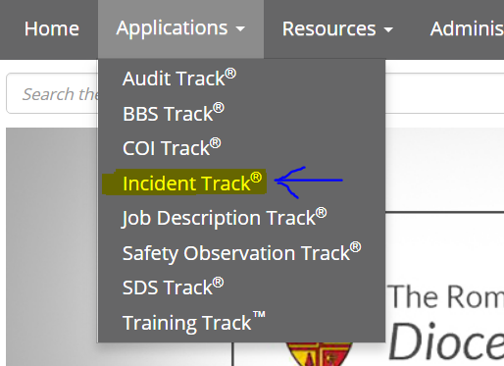

Select Incident Type of Claim
- Click on the +New button
- Select enter a new claim

- Select General Liability from the Incident Type drop down
- Respond "NO" to Near Miss
- Respond "NO" to “Was the incident an insurance claim?”
NOTE: Volunteer Accidents are the only time you answer NO to this question.
Your screen should look like this. Click, continue.

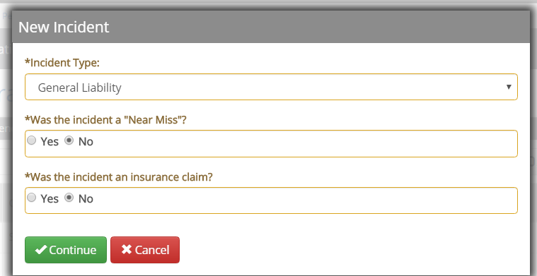

Going forward all information entered will be in one of the tabs listed on the left side of your screen. The following will take you through the tabs and the information that is needed on each tab.
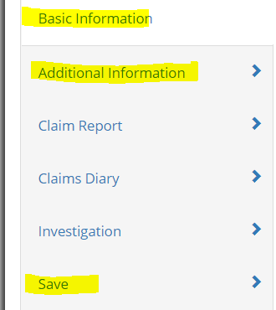
The tabs highlighted in yellow, need to be completed to report the claim. The other tabs listed can be used to enter information to complete the file on the claim as more information is gathered.

Enter Basic Information – 1st tab on left
When
- Short Description – Volunteer Accident – Volunteers Name – Entities Name
- Description – Explain how the accident happened. What was the volunteer doing at the time of the accident? In what capacity were they volunteering?
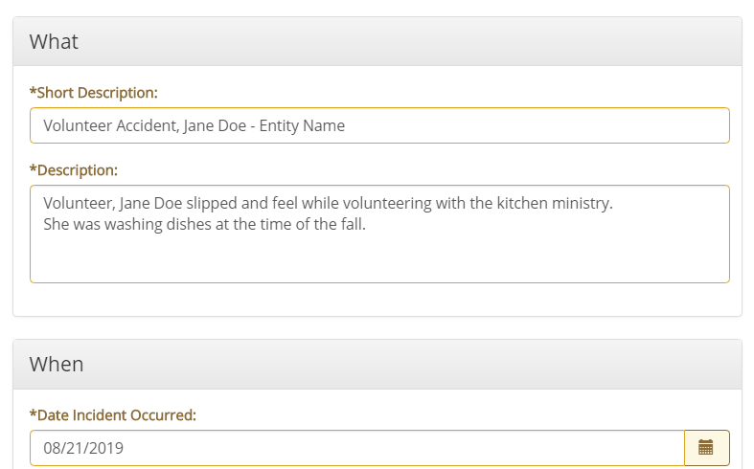
When
- Select date of incident from calendar under When
Where
- Where the incident occurred, first select your entity from the drop down under Location
- Select whether it occurred on or offsite
  - If it occurred offsite, enter the address

Enter Additional Information - click on 2nd tab on left
General
- Enter all known information on Additional Information tab and click save when completed.
  - Time of day the injury occurred
  - Date recorded – entered into the system
  - Location – where on campus the injury occurred.
  - Was the incident preventable
  - Employee activity
Contact
NOTE: This is contact information for someone at the school or parish.
- First Name
- Last Name
- When to contact
- Primary Email
- Primary Phone
General Liability
- Type of Claim – Injury
- Any general notes you think should be known about the accident.
- Reported By
- Reported To
Claimant Information
- Claimant Name
- Address
- Primary Phone
- Primary Email
- Age
- Gender
Injury
- Describe the injury in as much detail as possible.
- What aid-treatment was given.
- How did they leave the property? Did someone pick them up, by ambulance, or on their own?

Save Information - 6th tab on left
Note: This step is very important. If not completed correctly, the claim will NOT be reported to Commercial Risk Management.
- Submit the Claim – Make sure box is checked before moving on, there is a 10 second delay.
- Distribute the claim – Make sure box is checked before moving on, there is a 10 second delay.
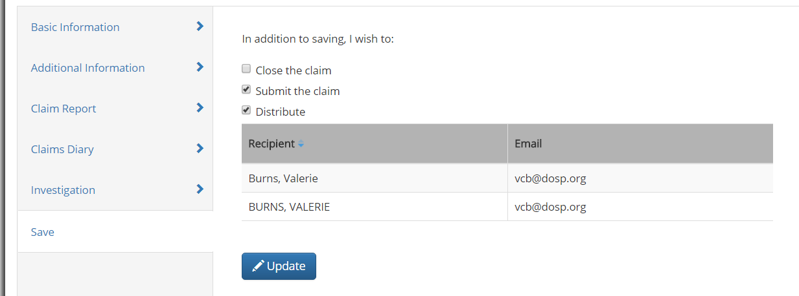
Once your screen looks like above, you can then click the green save and close. This will only be done once, when you initially set up the claim to avoid duplicate submissions.

Verify claim was retrieved by CRM
- Click on Manage and choose the drop down Claims Submissions to see date received
- If not received within 24 hours, notify Valerie Burns.
Valerie Burns – For Site Access or Claim Entry – vcb@dosp.org or 727-374-0222
Connie Ferret, W3 – For technical support - cferret@w3ins.com or 800-783-5085 x240
Matt MacMahon, W3 – For Technical Support - mmacmahon@w3ins.com or 800-783-5085 X168

