Log on to the Incident Track System:
- Go to lossfreerx.com and enter unique username and password
  - Please verify your username and password now prior to an employee injury. If you need assistance entering the system please contact the DOSP Insurance Office.
- Click on Applications and select Incident Track from the drop down menu
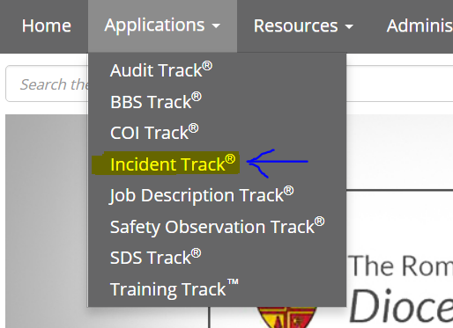

Select Incident Type of Claim
- Click on the +New button
- Select enter a new WC claim

- Select work related injury from the Incident Type drop down Work-Related Injury
- Respond "NO" to Near Miss and OSHA questions
- Respond "YES" to “Was the incident an insurance claim?”
- Select Florida as the "state" from the drop down menu
Your screen should look like this. Click, continue.

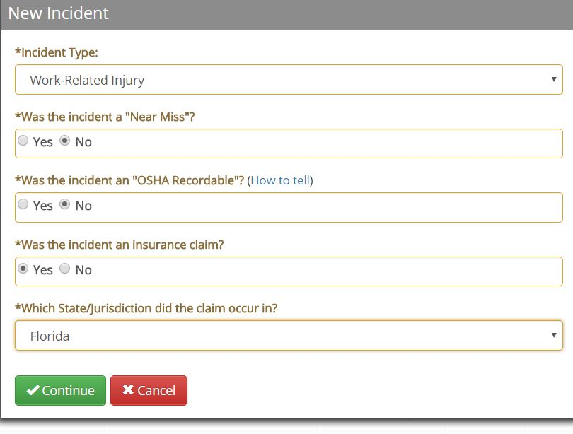

Going forward all information entered will be in one of the tabs listed on the left side of your screen. The following will take you through the tabs and the information that is needed on each tab.
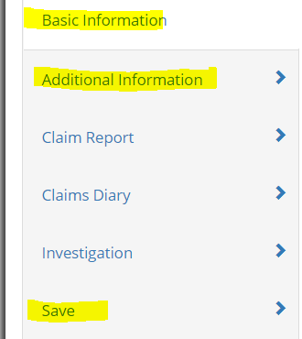
The tabs highlighted in yellow, need to be completed to report the claim. The other tabs listed can be used to enter information to complete the file on the claim as more information is gathered.

Enter Basic Information – 1st tab on left
Employee Information
- Enter Employee information under Who
Select Employee Involved from the drop down menu.
- Once the Employee is located, click the pencil icon to add employee demographics (below)
- If the employee does not appear in the drop down list, Click the blue + icon, add the employee and enter employee demographics below.
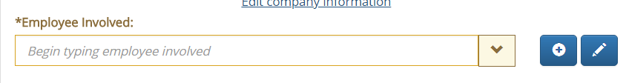
NOTE: The employee demographic information must be entered in order for the WC carrier to set up the claim, facilitate treatment, and contact the injured worker.
Add Employee Demographics
- General tab: Enter First Name, Last Name, Department (WC Code), Supervisor, Date of Birth and full Social Security #
- Employment tab: Enter Date of Hire and select appropriate position from the drop down box or add the Job Title found in Paylocity Work Tab. Add Wages and select wage period, indicate average hours worked per day and average days worked per week.
- Contact tab: Enter Employee Phone number and address
What
- Short Description - Short description should begin with abbreviated name of your entity.
  - Short Description Example: Tampa CHS –Trip and Fall
- Long Description - Long description of the incident gives a more detailed explanation of how the employee was injured.
  - Long Description Example: Employee tripped and fell over box in storage room.
Note: If the employee only received first aid at your site, please enter “First Aid” in the short Description. In the Long Description, be as descriptive as possible.
When
- Select date of incident from calendar under When
Where
- Where the incident occurred, first select your entity from the drop down under Location
- Select whether it occurred on or offsite
  - If it occurred offsite, enter the address

Enter Additional Information - click on 2nd tab on left
General
- Enter all known information on Additional Information tab and click save when completed.
  - Time of day the injury occurred
  - Date recorded – entered into the system
  - Location – where on campus the injury occurred.
  - Was the incident preventable
  - Employee activity
Injury
- Severity
  - If it appears that the employee will not return to work within the week, choose “Lost Time Injury” from the drop-down under Severity.
  - Click the +New button below. A box will appear to add an event.
    - Select “Left Work” from the drop down and click on the calendar to indicate the last day worked, then click “Ok.”
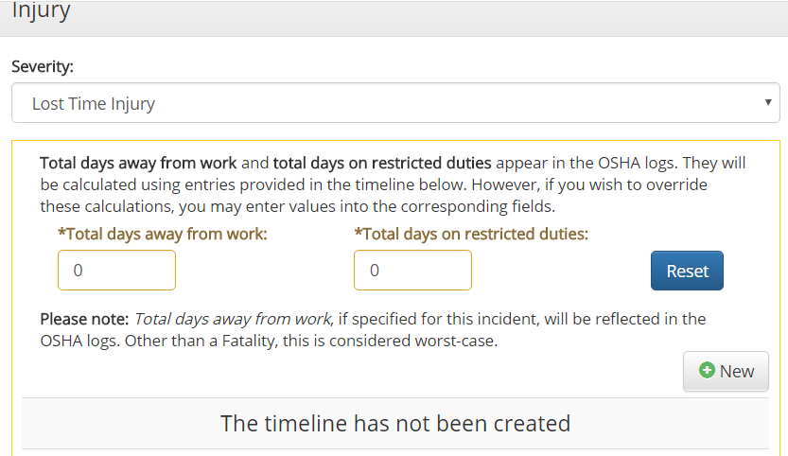

Treatment
- Answer the following questions.
  - Treated on site By:
  - Was first aid administered?
  - Off – site Treatment:
Note: If answered yes, complete the Clinic/Hospital Where Treatment Occurred. The approved clinic/medical providers for your area can be preloaded using the gear icon under Manage Lists. However, you can also manually enter this information. No need to enter Nature or Injury or Injury Source. Any documents can be uploaded in this area under attachments by clicking the +New button and uploading the document
Enter Claim Report - 3rd tab on left
First Report of Injury
- Select Workers Compensation Policy from the Policy drop down
Claim Administrator
- Select Commercial Risk Management on the drop down for the Third Party Administrator. Information will auto populate.
Florida
- Nature of Business, enter the correct Nature of Business from drop down. Church, School, Charity
- Location - Enter exact location within premises where injury occurred (break room, classroom, hallway)
- Click on calendar to choose correct date first reported
- Respond appropriately to the next questions (however do not respond to questions regarding payment of wages) and click save
Enter Claim’s Diary - 4th tab on left
Note: This step does not need to be completed to report the claim it can be completed at a later date.
- Add claims notes if applicable by category to on claims diary tab by clicking on the +New button.
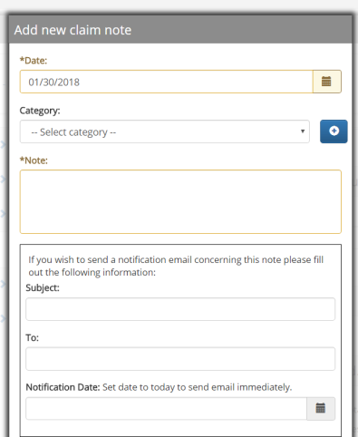
Date: Of the note being entered.
Category: Select from the drop down box.
Note: Free text area to write your note.
If you wish to send this information to CRM or the Insurance Office enter the information listed.

Notes may be entered periodically throughout the time of the claim.
Enter Investigation Information - 5th tab on left
Note: This step does not need to be completed to report the claim it can be completed at a later date.
Who
  - Click the +New button and select Employee from the Team Member Selection, then select your name from the drop down
  - Click the +New button to add any information about Witnesses involved
When
- In the When Section, indicate when the investigation was started and completed by using the calendar
What
- Add any specific comments relating to the investigation and attach any documents that are applicable (photos, police reports, witness statements, etc.)
Cause
- Click the +New Button to identify any: At Risk Behaviors, Conditions, or Root Causes that contributed to the injury.
Corrective Actions
- Click the +New Button and complete the form regarding any actions that were taken to prevent further accidents and save and close
Save Information - 6th tab on left
Note: This step is very important. If not completed correctly, the claim will NOT be reported to Commercial Risk Management.
- Submit the Claim – Make sure box is checked before moving on, there is a 10 second delay.
- Distribute the claim – Make sure box is checked before moving on, there is a 10 second delay.
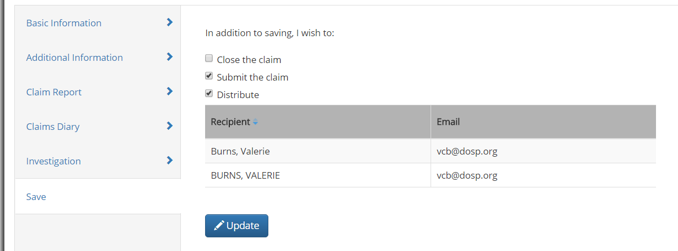
Once your screen looks like above, you can then click the green save and close. This will only be done once, when you initially set up the claim to avoid duplicate submissions.

Verify claim was retrieved by CRM
- Click on Manage and choose the drop down Claims Submissions to see date received
- If not received within 24 hours, notify Valerie Burns.
Valerie Burns – For Site Access or Claim Entry – vcb@dosp.org or 727-374-0222
Connie Ferret, W3 – For technical support - cferret@w3ins.com or 800-783-5085 x240
Matt MacMahon, W3 – For Technical Support - mmacmahon@w3ins.com or 800-783-5085 X168

Please give the employee both of these form for initial medical treatment.
Authorization for Treatment: Attached are both a sample form and a blank form to be completed and given to the employee for initial medical treatment.
My Matrix Prescription Information: Attached are both a sample form and a blank form to be completed and given to the employee for initial medical treatment. If a prescription is given the employee is to give this form to the pharmacy.

