Log on to the Incident Track System:
- Go to lossfreerx.com and enter your unique username and password
  - Please verify your username and password now prior to an employee injury. If you need assistance entering the system please contact the DOSP Insurance Office.
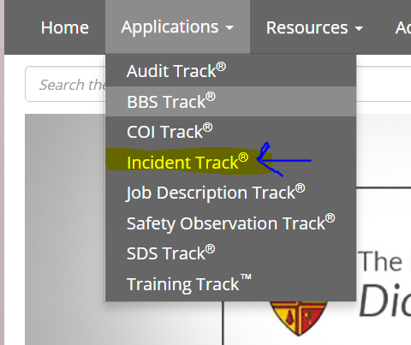
- Click on the Applications and select Incident Track from the drop down menu.

Select Incident Type of Claim
- Click on the +New button
- Using the Select Type of Incident drop down
  - Select Property

- Respond "NO" to Near Miss
- Respond "YES" to “Was the incident an insurance claim?”
  - Your screen should look like this. Click, continue
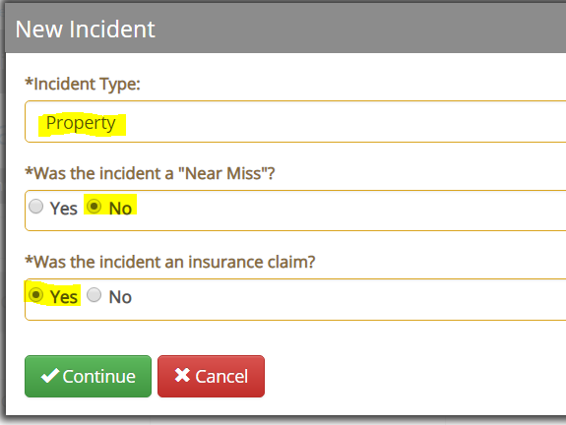

Going forward all information entered will be in one of the tabs listed on the left side of your screen. The following will take you through the tabs and the information that is needed on each tab.
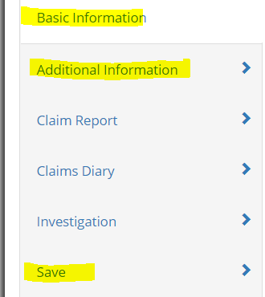
The tabs highlighted in yellow, need to be completed to report the claim. The other tabs listed can be used to enter information to complete the file on the claim as more information is gathered.

Basic Information (1st tab on the left)
- Who
  - Site Incident occurred - Make sure the site where the accident occurred is listed.
- What
  - Short Description - Short description should begin with abbreviated name of your entity. Example of Short Description: Tampa CHS -Trip and Fall’
- Long Description – Describe the accident in more detail. Example of Long Description: Parent of student tripped and fell over a box left in the hallway and sprained their ankle.
- NOTE: If this claim is a report only then start the Long Description as REPORT ONLY.
- When
  - Select date of incident from calendar under When section

- Where
  - Select your entity from the drop down under Location.
  - Incident occurred offsite? Select either On Site or Off Site. (Note if the accident i occurred offsite, you must enter the address of the location.
Additional Information (click on 2nd tab on left)
- General section. At the very least enter the following information.
- Time of Day Incident Occurred
    - Date Recorded
  - Location within site - The location within the site would be exactly where the incident occurred. Example: Hallway
  - Property
    - Type of Damage – Select from the drop down menu
    - Estimated Amount - This is your estimate of the value of the damage. As damage is assessed and repair bids are submitted will be adjusted by CMG.
  - Policy
    - Property/Home Policy: Select Property Insurance from the drop down menu. This will populate the insurance carrier information.
  - Insured
    - Use Company as Insured – No
    - Company Name – Parish or School Name
    - Address – Enter Parish or School address
  - Contact
    - Enter the person at the entity who will be the contact person for the claim process.
      - Example of information needed:: First Name, Last Name, Email, and Phone #

Scroll to the bottom of the page
- Attachments
  - Click on the + button to add any attachments.
    - Example: Any photographs taken or written reports.
  - Each attachment is uploaded one at a time and saved as they are uploaded.

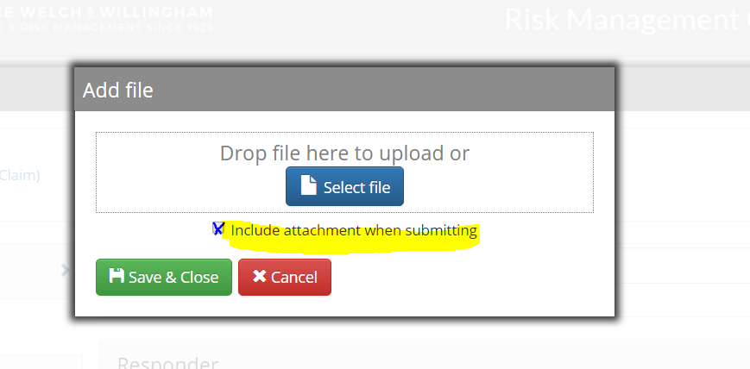
- Click the “Include the attachment when submitting for each attachment. This will allow Catholic Mutual Group (CMG) to view the attachments when retrieved from the vault.
Save (Click on the 5th tab on the left)
- Submit the Claim – Box must be checked.
- Distribute the claim – Box must be checked.
This is the most important step in the process to ensure that the claim is submitted to Catholic Mutual for processing. This will only be done once, when you initially set up the claim to avoid duplicate submissions.

Your screen should look like the following.
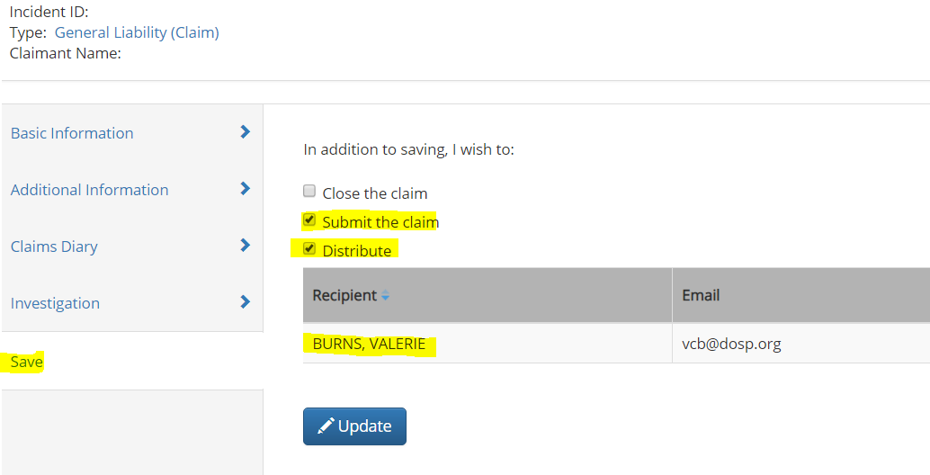

Final Step – verify your claim was retrieved by Catholic Mutual.
- From the Home Screen
- Click on Manage - choose the drop down Claims Submissions
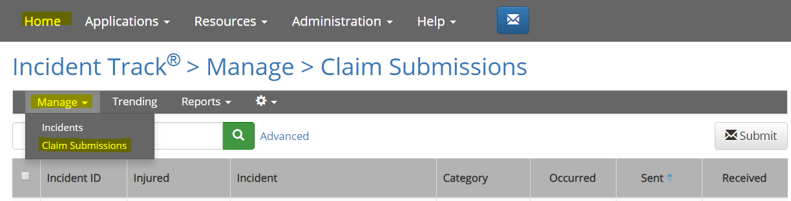

The date Catholic Mutual Group retrieved the claim will be listed under Received. If it has not been retrieved within 24 hours Monday – Friday please contact Valerie Burns at the DOSP Insurance & Risk Mgt. Office. 727-344-1611 ext. 5222 or by email vcb@dosp.org.
If not received within 24 hours, notify Valerie Burns.
Call W3 for technical support
-Connie Ferret
cferret@w3ins.com
800-783-5085 x240
or
-Matt MacMahon
mmacmahon@w3ins.com
800-783-5085 X168

