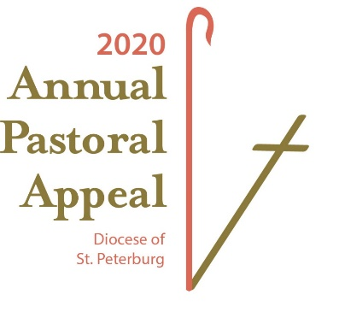
Leadership
Resource Manual

For Pastors, Parish Priests, Deacons, Religious, Business Managers, Parish Staff, Ministry, Lay Leaders & Volunteers
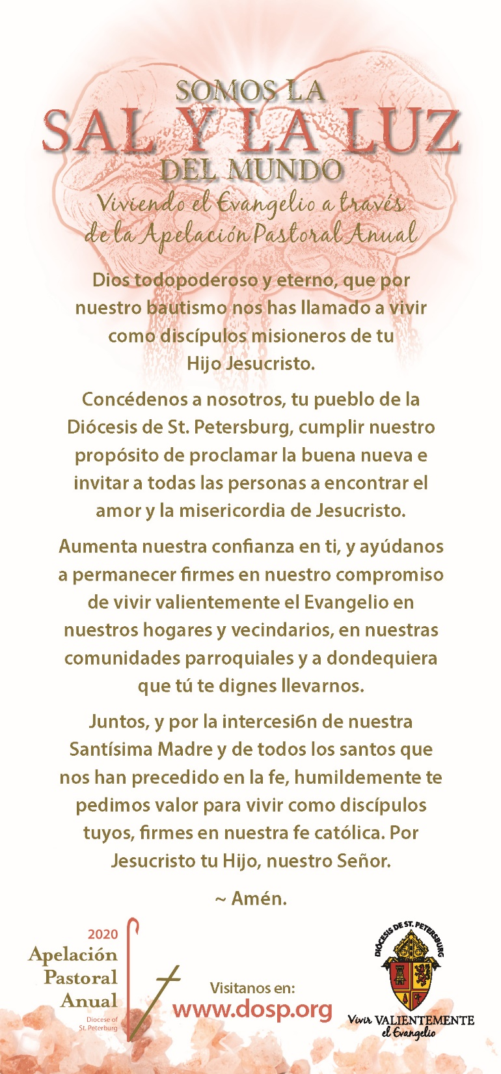
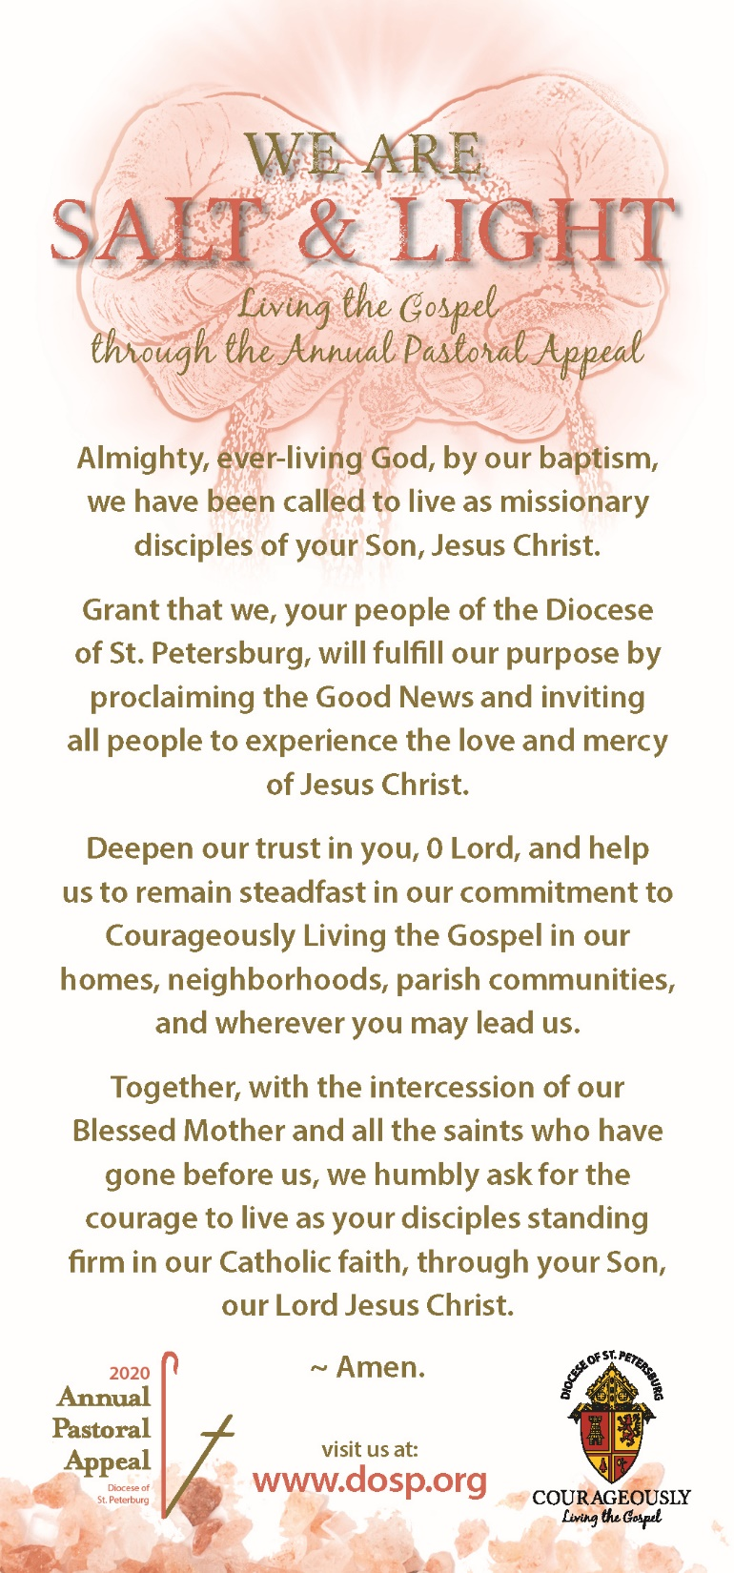
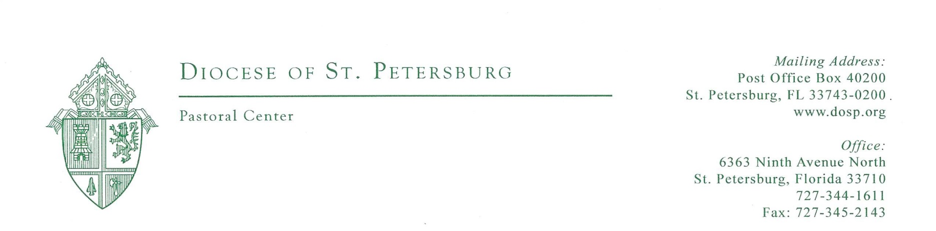
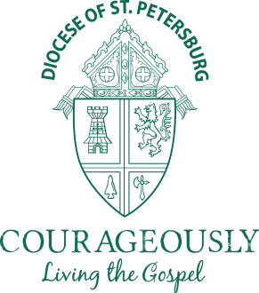

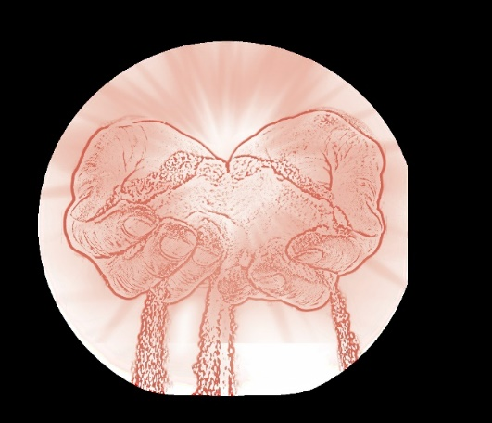
Happy New Year! We would like to take this opportunity to thank you for your leadership in the 2019 Annual Pastoral Appeal (APA), and introduce to you the 2020 APA:

WE ARE SALT & LIGHT
Living the Gospel through the Annual Pastoral Appeal

Have you ever wandered what it means to be salt and light for the world?

In Isaiah 58:7-8 he describes it well, “Share your bread with the hungry, shelter the oppressed and the homeless; clothe the naked when you see them, and do not turn your back on your own. Then your light shall break forth like the dawn…” Jesus ministered to all around him. He healed those he touched and taught those in his path. He touched people’s lives in a way that made them want to share their stories and their experiences and minister to those they encountered. As Catholics, we know Jesus touches our lives and living courageously by sharing the flavor of our own witness with His love and mercy, is all He wants and exactly why we are salt and light for the world.

Within this manual and available on our APA webpage at www.dosp.org/apa, are various best practices, helpful hints and effective tools and resources to guide you through a successful 2020 APA. However, it is important to keep in mind that the most effective strategy for a successful APA is to personalize your message and your approach. Share stories about how the ministries, programs, and services funded by APA, help you personally, your parish and how coming together as a diocese we make an impact on thousands of people each year. Every gift is courageous, a gesture of good faith and an investment in building up the Kingdom of God as Jesus intended.

We are thankful and proud to be part of all you have done in your APA efforts. We are here to serve you and help you reach your maximum potential by striving to bring you updates on the good works being done in our diocese in the name of Jesus Christ. May His blessings be upon your parish for strength and success.

Thank you for all that you do,
Most Respectfully,

Meegan Wright, Executive Director Jeanne Smith, Associate Director Office: (727)344-1611 ext. 5337 Office: (727)341-6825 Cell: (727)278-3131 Cell: (727)251-0003 Email: mlw@dosp.org Email: jms@dosp.org

Table of Contents

Table of Contents 4
Just the Facts 5
Preparing for Success 6
2020 Calendar of Activity 7
Successful APA Checklist 10
2019 Fiscal Year Actuals 11
Ways to Give 13
APA Campaign Reporting 14
Campaign Processing 16
Remittance of APA Envelopes to Campaign Processing 17
Parish Mailing Update Information 18
In-Pew Solicitation for Commitment Weekend 19
How to Make Your In-pew Solicitation Successful 19
Breaking Down the In-Pew Envelope 20
Sample In-Pew Commitment Weekend Pulpit Presentation 21
In-Pew Solicitation for Multicultural Parishes 22
Promotional Materials & Resources 23
Prayers of the Faithful 24
Pastor & Pulpit Announcements 25
Bulletin Announcements 30
Diocesan Speakers 33

Just the Facts
What is the Annual Pastoral Appeal (APA)?
Every year, each parish and mission in the Diocese of St. Petersburg is given an assessment. That assessment is calculated based on an approved formula that considers self-reported total revenue of each parish and mission. The purpose of the assessment is to support diocesan ministries, programs and services that meet the physical, educational and spiritual needs of thousands within and outside of parish and mission boundaries.

The Annual Pastoral Appeal (APA) is a fundraiser created in the Office of Stewardship and Development to assist parishes and missions in raising funds for their assessment responsibility directly from their parishioners, instead of using offertory and operational resources. This appeal encourages participation from every Catholic household and promotes the good works of those who courageously live the Gospel and uphold the mission of Jesus Christ within our local Church. It allows us, as one faith community, to fulfill God’s call to discipleship by proclaiming the Word and serving each other with mercy and love.

For every dollar donated directly through APA, the amount a parish pays toward assessment goes down by the same amount.

Why do we need this manual?
The purpose of this Leadership Manual is to provide a detailed plan of the 2020 Annual Pastoral Appeal and include the necessary information to assist in making the effort successful in every parish and mission. The elements outlined represent best practices, helpful guidelines and sample communications designed to keep your appeal on track. It offers many options to enable the entire parish community, from pastor to parishioner, to achieve optimal results. Be creative…this is only a resource of structure and best practices; it does not compare, nor does it limit, what you may be able to produce with a group that knows your parish best.

Summary of APA 2019:
Countless faith-filled people giving of their time and talent to focus on our mutually-shared vision: Courageously Living the Gospel, realizing the commission issued to us by Jesus Christ to make disciples of all nations. Enhanced pastoral ministry, outreach and refreshed plans to serve God’s people, all developed with a sacred purpose to proclaim, invite and encounter what we have already witnessed, the love and mercy of Jesus Christ.

Following a record-breaking year for the Annual Pastoral Appeal, we are short of where we were last year. As of December 1, 2019, 25,716 donors have pledged or paid $9,585,909 toward parish goals. Compared to last year on the same date, we are down $348,318 in gifts and 1,658 in donors. We are down, that means our work of education continues, however, acknowledging the faithful who support the parish and the Church is always a good idea.

What’s NEW for 2020?
Enduring Courageously Living the Gospel, the pivotal movement within our diocese and something that will continue to be at the forefront of what we do and how we do it as disciples of one faith family in the name of Jesus Christ. As we Live the Gospel through the Annual Pastoral Appeal, we commit to share this call to action from all who participate in successful efforts of proclaiming, inviting and encountering, all of which will enrich our faith life and bring those we serve closer to Christ.

- Direct Mail 2.0 – reaching out to non-donors in new ways
- All APA resources will be updated to demonstrate how we: Live the Gospel through the Annual Pastoral Appeal
- Donors currently giving electronically will be given the opportunity to renew their gift early

Preparing for Success
While the words “Annual Pastoral Appeal (APA)” are familiar to most parishioners, many do not realize what the appeal actually accomplishes. APA provides the funds to support over 50 ministries, programs and services. It is our job as pastors, pastoral associates, religious, parish or diocesan staff, and lay leaders to educate our fellow Catholics about the good work that is accomplished because of the Annual Pastoral Appeal.

Let’s consider the following statements:
- People who feel inspired to give to a cause tend to give as much as they can
- People who feel obligated to give tend to give the minimum expected

People are more likely to offer financial support to something that they believe in, knowing that their gift will make a difference and help others. We cannot assume that people across the Diocese of St. Petersburg are aware of the variety of services that are provided through ministries, programs and services supported by APA. Therefore, the task of communicating about its many good works is critical.

As APA promoters, we have several jobs in front of us:
- We need to start early and create a dated plan
- We need to educate ourselves about the appeal and all that it supports so that we can speak about them with confidence
- We need to look over the APA materials, so that we understand all the tasks that need to be done to make the appeal a success in our parish
- We need to make sure that ALL parishioners are given the opportunity to give to the appeal
- We need to pray for the success of the APA – pray for those we talk with, that they may open their hearts and their minds and listen to God’s call. Pray for a positive spirit in your parish toward the appeal, and pray that we can accomplish the work that God has entrusted to us

-borrowed in part from the Diocese of Austin, TX

2020 Calendar of Activity
December 3 APA 2020 Preview Meeting

Dec. 1-Jan. 5, 2020 Thank you Bulletin Insert Weekends (APA 2019) Bulletin inserts are available with or without tear off gift form. Please note, the Office of Stewardship and Development can assist in redesigning this insert to include donor names.

January 6 Materials for APA 2020 Commitment Weekend shipped to/digitally shared with all parishes

January 13 1st Request letter delivered to Post Office
- Letter packet sent to previous donors in the Diocese of St. Petersburg, Includes:
personalized letter from Bishop, brochure, prayer card, personalized intent/gift card and return envelope
- Non-Donors will receive personalized letter from Bishop Parkes with attached giving opportunity and modified brochure
- Pastors/Parish Priests will received personalized letter from Bishop Parkes, brochure, prayer card, personalized intent/gift card and return envelope

January 18/19 APA 2020 Prayer Weekend
Begin new bulletin articles, pulpit announcements and prayer of the faithful intersessions.

- Distribute prayer cards at each Mass
- Recite the APA prayer this specific weekend before Mass, during the announcements or before the final blessing, and each weekend thereafter

January 25/26 APA 2020 Education Weekend
Pastors, parish priests and Deacons are encouraged to give witness to the positive impact the ministries, programs and services supported through the APA have on your parish and our diocese.

- Lay witness could also be offered with the same perspective building on their affiliation with said ministry, program or service
- Show the APA 2020 Video – The WE ARE SALT & LIGHT video focuses on diocesan wide Faith in action and the mission of our growing Church. It highlights a few of the ministries/ programs/services funded by APA
- Utilize the video vignettes and Snap Shots on specific ministries promoting the good works done for those in need throughout our diocese
- Continue bulletin articles, pulpit announcements, prayer of the faithful intercessions, and using the APA prayer to pray for success
- Remind parishioners at all Masses that the weekend of February 8/9 is APA 2020 Commitment Weekend, and to come prepared to participate with the intent card they received at home

February 1/2 APA 2020 Clergy Support Weekend
Pastors, parish priests and Deacons are encouraged to give witness to the positive impact the ministries, programs and services supported through the APA have on your parish and our diocese.

- Lay witness could also be offered with the same perspective building on their affiliation with said ministry, program or service
- Show the APA 2020 Video – The WE ARE SALT & LIGHT video focuses on diocesan wide Faith in action and the mission of our growing Church. It highlights a few of the ministries/ programs/services funded by APA
- Utilize the video vignettes and Snap Shots on specific ministries promoting the good works done for those in need throughout our diocese
- Continue bulletin articles, pulpit announcements, prayer of the faithful intercessions, and using the APA prayer to pray for success
- Remind parishioners at all Masses that the weekend of February 8/9 is APA 2020 Commitment Weekend, and to come prepared to participate with the intent card they received at home

February 8/9 APA 2020 Commitment Weekend
The authenticity in which the APA is explained and associated with your parish activity and how this solicitation exercise is done will determine the response of each parishioner.

- Pastor, parish priest or Deacon leads this commitment with his own testimony through homily or reflection and filling out pledge/gift card with assembly. If you have prepared your parishioners for this weekend the enthusiasm will be contagious, and results will show support of our united mission.
- Invite all parishioners at each Mass to participate with you in the Annual Pastoral Appeal in-pew solicitation and collection by using the intent cards they have brought with them or the pledge envelopes they have completed at Mass
- Continue bulletin articles, pulpit announcements, prayer of the faithful intercessions, and using the APA prayer to pray for success

February 22/23 APA 2020 Follow-Up Weekend
- Thank you is never over used or understated. Gratitude with successful detail should be expressed to those who have made a pledge or gift to the Annual Pastoral Appeal as of this date.
- Request consideration from those who have not yet responded
- Request special consideration from those who have never given, ask them to invest in the mission of our local Church in which your parish is a participant
- A reminder should be made to all, that continual information will be in the bulletin, at the pulpit, and in the prayer of the faithful intersessions, as well request their continual personal prayer of success for your parish and all parishes throughout the diocese for the overall appeal goal and the mission of our Church

February 26 Ash Wednesday – Lent begins
40 days of Prayer, Fasting and Almsgiving
- All parishioners should be asked to keep your parish needs at the forefront of their Lenten offerings
- Continue bulletin articles, pulpit announcements, prayer of the faithful intercessions, and using the APA prayer to pray for success

April 5 Palm Sunday- Holy Week begins
April 9 Easter Triduum
April 12 Easter Sunday

April 20 2nd Request letter delivered to Post Office
This follow-up is a personal request letter of support from the pastor, sent to previous APA donors who have not responded to date.
Includes: personalized letter from the pastor, personalized intent/gift card and return envelope.

May-September Ongoing Activity
Until your parish APA goal is met, we recommend using any and all resources created within your parish and/or the materials the Office of Stewardship and Development have made available to you online for promotion, such as:
- Continue bulletin articles, pulpit announcements, prayer of the faithful intercessions, and using the APA prayer to pray for success
- Report the progress of APA to your parishioners each week
- Ask those that have not given to give
- Pray. Guide all expectation and action through prayer.
- Encourage Lay Witness. Personal testimony will engage parishioners and prompt them to give.
- Evangelize. Your parish ministries and outreach and all diocesan ministries, programs, and services are part of the Church’s mission of helping those in need. Building that awareness and the triumph of bringing souls closer to God is what APA is all about. Share the good news through stories of success.

September 7 3rd Request letter: LYBUNT/SYBUNT – (Last or Some Year But Unfortunately Not This year)
This letter is sent to parishioners who gave in the last year or the previous two years and have not given yet this year.
Includes: personalized letter from the pastor, personalized intent/gift card and return envelope.

October 1 All Souls Mailing
This letter is a Thank you from the Bishop sent to all APA donors who gave $365 (a dollar a day) or more, which includes a request for prayer intentions for loved ones who have passed away. These prayer intentions are collected and placed in the Chapel of the Pastoral Center and prayed for at each Mass during the month of November.

EOY Success Go For the Goal
This mini-appeal can be organized and modified specifically for your parish to reach your APA goal. It may be started July through September, and will include all elements of the APA, on a more condensed schedule.

Successful APA Checklist
In order to build momentum and inspire participation, it is vital to plan and implement activity that educates and gains the attention of historical donors as well as new donors. Here are some helpful tips to assist in a successful parish APA effort.

- Pray. The power of prayer creates a unified strength that should always be encouraged and never underestimated.

- Review your results from last year. Use the final report to evaluate all approaches that were taken, determine ways to improve results and create a plan that will achieve your parish goal. Share that plan with your parishioners.

- Make your own pledge first. This cannot be stressed enough. As a faithful parish leader, make your own gift/pledge first, leading others to support the Appeal by your own example.

- Offer EVERYONE the opportunity to participate. After offering education and understanding of the APA, convey the impact for your parish and our diocese. Be sure to offer information about the various ways to give.

- Include and encourage youth, parish ministries & staff. Being part of the APA for your parish draws these important ambassadors into participation in the life, mission and work of our Catholic faith community.

- Know the facts. Be sure that everyone sharing the good news of the physical, educational and spiritual programs funded by the Annual Pastoral Appeal is speaking with factual information. There is plenty of it, and it’s all good.

- Target a specific amount. Do not generalize gift giving. Mention pledge options to maximize your offer. Everyone appreciates knowing what is expected of them.

- Keep your sights high. Do not seek the lowest gift option first. Figure out an average gift for your parish (using the highest amount), but always affirm that EVERY gift helps your parish and changes a life.

- Keep a positive attitude. This is a parish appeal, and a positive approach to its objective and overall importance to your parish should remain sincere and upbeat.

- Prepare informative parish announcements. Bulletin and pulpit announcements each week regarding the Appeal are essential. Be short, informative and grateful.

- Ask. Ask. Ask. If you do not ask, donors will not give. Everyone likes to be asked. A donor does not know what you want, need or what is expected until they are asked.

- Thank everyone! There is no substitute for genuine gratitude and affirmed progress. These two things help us to recognize that by giving, we increase our blessings!

WE ARE Salt & Light

Living the Gospel through the Annual Pastoral Appeal

2019 Fiscal Year Actuals
Sources of Revenue:
 | Donations from Parishioners for APA 2018(for 2018-2019 Operations) | 8,472,507
 | Parish Assessments for Fiscal Year 2018-2019 | 3,319,494
 | Total APA and Assessment | 11,792,001 | (11,850,000 Goal)
 | Program Service Fees and Reimbursements | 4,241,536
 | Bequests, Donations, Grants, and Interest Earnings | 64,132
 | Total Operating Revenue | 16,097,669

 |  |  | Specific
 |  |  | Program | Net | % of
Operating Expenses: |  | Expense $ | Revenue $ | Expense $ | Net Expense
Clergy, Religious, Vocations and Seminarian Education
 | Seminarian Education and Support Costs | 1,034,351 | (550,000)
 | Vocations Office, Chancellor, Secretary for Priest Personnel, Vicar for Religious | 517,926 | (10,875)
 | Graduate Study for Priests, Continuing Education and Formation for Priests, Clergy Care, Permanent Diaconate Program | 1,061,849 | (191,977)
 | Facility Cost for Associated Ministries | 147,893 | (5,923)
 | Total | 2,762,019 | (758,775) | 2,003,244 | 18.3%
Catholic Formation and Education
 | Office of Catholic Schools and Centers | 813,468 | (281,494)
 | Office of Faith Formation, Lay Pastoral Ministry Institute, Campus Ministry, 60% of Youth and Young Adult Ministry Office, Scouting, Marriage Preparation | 920,341 | (288,945)
 | Tuition Assistance Grants | 752,541 | (512,541)
 | Support of BMCHS, ACE and ECHO Programs | 61,089 | (12,000)
 | Legal Expense | 29,367 | -
 | Contributions made for National Collections (Catholic University of America and Catholic Communications Campaign) | 75,172 | -
 | College Campus Ministry | 61,600 | -
 | Facility Cost for Associated Ministries | 184,272 | (7,538)
 | Total | 2,897,850 | (1,102,518) | 1,795,332 | 16.4%
Catholic Social Services
 | Catholic Charities of the Diocese of St. Petersburg and Ministries of Mercy | 1,015,667 | (12,084)
 | Prison Ministry, Life Ministry | 200,585 | (22,668)
 | Contributions made for National Collections (Church in Latin America, Church in Central and Eastern Europe, Home Missions, Holy Land, Black and Indian Missions) | 169,140 | -
 | Contributions to La Clinica Guadalupana and many nonprofits | 217,090 | -
 | Facility Cost for Associated Ministries | 99,388 | (3,769)
 | Total | 1,701,870 | (38,521) | 1,663,349 | 15.2%

Parish, School and Diocesan Services
 | Multicultural Office, Community Relations, Marriage Tribunal, Office of Worship, Ordinations and Celebrations, Propogation of Faith Office, Archives, Subsidies to Missions and Apostolates, Cathedral Subsidy, 40% of Youth and Young Adult Ministry Office | 1,441,644 | (154,998)
 | Stewardship and Development, APA Marketing | 326,834 | (1,080)
 | Construction Management Office, 70% of Real Estate Office | 250,897 | (13,440)
 | Human Resources Office | 195,947 | -
 | Safe Environment Office | 448,260 | (256,550)
 | Legal Services | 102,783 | -
 | Parish and School Financial Reporting | 580,024 | (588,541)
 | Campaign Processing Office | 260,815 | -
 | Spirit FM | 1,105,681 | (1,023,747)
 | Bethany Center | 404,869 | (30,000)
 | Facility Cost for Associated Ministries | 465,555 | (19,384)
 | Total | 5,583,309 | (2,087,740) | 3,495,569 | 31.9%
Pastoral Leadership
 | Office of the Bishop, Vicar General, Secretary for Administration, Secretary for Christian Services, Bishop Emeritus | 956,552 | (240,684)
 | FCC, FCCB, SEPI USCCB Assessments and Holy See Quotas | 420,507 | -
 | Facility Cost for Associated Ministries | 97,010 | (4,308)
 | Total | 1,474,069 | (244,992) | 1,229,077 | 11.2%
Administration and Temporal Affairs
 | Accounting and Finance, Information Services | 477,472 | -
 | Legal Expense, 30% of Real Estate Office | 132,461 | (5,759)
 | Capital Expenditures | - | -
 | Bad Debt | 95,802 | -
 | Facility Cost for Associated Ministries | 72,758 | (3,231)
 | Total | 778,493 | (8,990) | 769,503 | 7.0%
Total Operating Expenses |  | 15,197,610.75 | (4,241,536) | 10,956,075 | 100%

Diocesan Operating Funds also include depreciation expense, as well as certain funds that are restricted for specific purposes which are not a part of the financial results shown in this section and operate at a loss of approximately $500,000.

Ways to Give
Pledging:
Many people feel that they can participate at a sacrificial gift level if they make payments over a period of time. We currently work with monthly and annual pledge cycles. Donors who pledge will receive reminders according to their designated payment schedule.

One-Time Gift:
A one-time gift can be paid at the time of commitment or payment can be scheduled a later date.

Online Giving:
We accept all major credit/debit cards (MasterCard, American Express, Visa and Discover) as well as direct debit payments. Electronic giving can be completed two ways:
- Donor managed online giving is available through our diocesan website at: https://s.dosp.org/give
- Authorization forms for credit cards and direct debit donations are available on all pledge cards and
in-pew envelopes.

If your parish would like assistance setting an APA e-giving link from the parish website, please contact Meegan Wright at mlw@dosp.org.

Checks:
When making a payment by check, please ensure the donor makes checks payable to the Annual Pastoral Appeal.

Gifts of Appreciated Stocks, Securities or IRA:
Federal tax law allows a charitable deduction for the full market value of the securities on the date of a gift, and thanks to the passage of the PATH Act in the US Congress, making permanent the opportunity to give IRA assets to charity, free from federal tax, you can transfer up to $100,000 from your Individual Retirement Account (IRA). For more information or assistance, please contact Kathy King in our Campaign Processing Office at kck@dosp.org or by phone at 727-341-6841.

Matching Gifts:
Many companies have Matching Gift Programs for charity or educational purposes. Contact your company’s Human Resource Office concerning matching gift opportunities. Please keep in mind, there are necessary applications and procedures to follow; so once a donor completes the steps required by their company, please direct them to contact Kathy King in our Campaign Processing Office at kck@dosp.org to ensure the process is completed successfully.

APA Campaign Reporting
Parish Summary updates are emailed weekly through the APA Messenger. If you are not currently receiving this communication, please email Jeanne Smith at jms@dosp.org and you will be added to the distribution list.

Detail Donor and Parish Roster Reports are available in real time through ParishSoft Family Suite at https://stpetersburg.parishsoftfamilysuite.com/. When converted into an Excel spreadsheet, you are able to maximize your opportunities to say thank you or invite your parishioners to give to the Annual Pastoral Appeal through parish level communications. If you have any questions or need assistance with Family Suite, please contact Ray Miller at rnm@dosp.org.

PLEASE NOTE: for full download function, use Mozilla Firefox as your Internet browser.
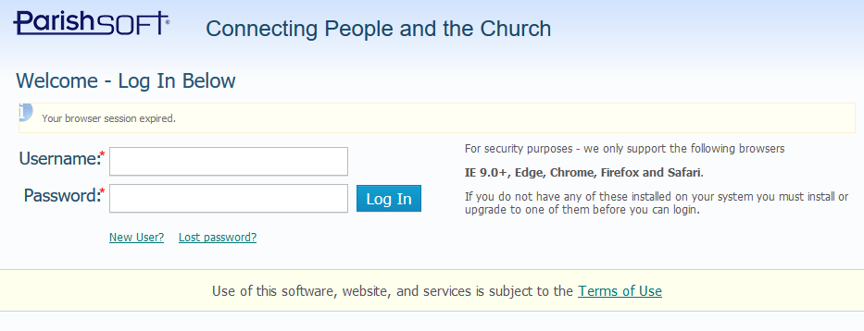
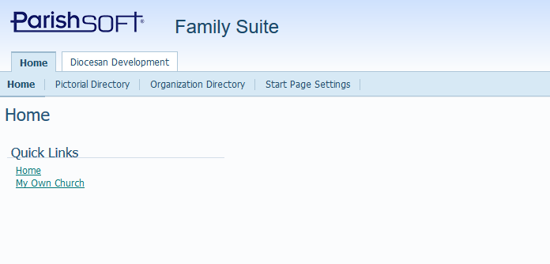

A Family Suite log-in is
required to gain access to reports.
This is only given through Pastor permission.

Once you log-in, select the
“Diocesan Development” tab

For DETAIL DONOR REPORTS:

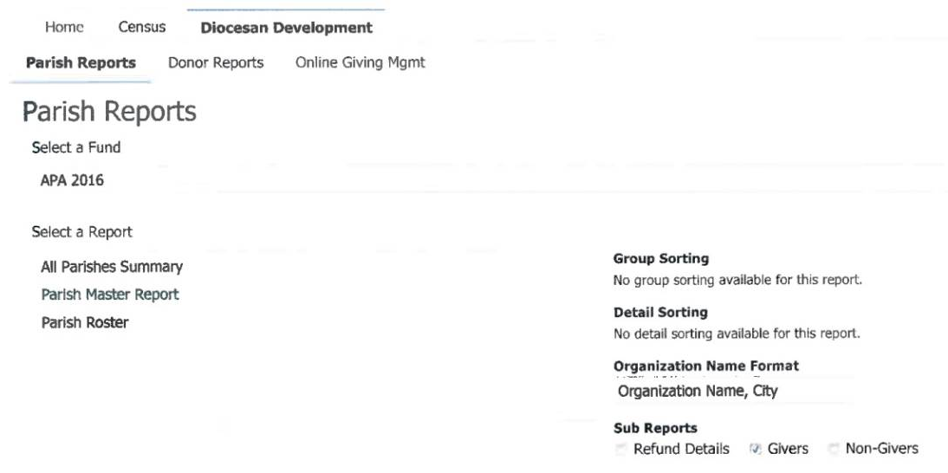
1-Select the “Parish Report” tab

2-Select a Fund (which APA year do you want a report for? 2016, 2015, 2014, etc.)

3-Select “Parish Master Report” from
the list

4-Remove the “checks” from the “Refund Details” and “Non-Givers” boxes.
This means a check mark should be in place for “Givers” ONLY.

5-Push the “Download PDF” button at the bottom of the screen.

For PARISH ROSTER REPORTS:

1-Select the “Parish Report” tab

2-Select a Fund (which APA year do you want a report for? 2016, 2015, 2014, etc.)

3-Select “Parish Roster” from
the list

4-Make sure checks appear in both “Givers” and “Non-Givers” boxes.

5-Push the “Download PDF” button at the bottom of the screen.

Through ParishSoft Family Suite you can also access your parish roster, convert it into an Excel spreadsheet and sort it different ways in order to maximize your opportunities to say “thank you” or invite your parishioners to give to the Annual Pastoral Appeal.

For any other specialized reporting, please contact Kathy King at kck@dosp.org.

Campaign Processing
15
The Campaign Processing Office is here to serve you and our generous donors from throughout the entire Diocese. We embrace the importance of accuracy and efficiency and strive to improve our procedures regularly so that we maybe the best stewards of what we have been entrusted.

Meegan Wright – Executive Director of Stewardship and Development Email: mlw@dosp.org
Responsible for day-to-day operations of the Campaign Processing Office as well as diocesan cash acceptance. Manages department personnel and oversees day-to-day processing and operations of the Annual Pastoral Appeal, diocesan capital campaigns, parish capital campaigns, WBVM Spirit FM 90.5 and matching gift fundraising.

Kathleen King - Senior Processing Specialist Email: kck@dosp.org
Primary contact for all Campaign Processing and responsible for day-to-day processing of diocesan capital campaigns, parish capital campaigns and WBVM Spirit FM 90.5 fundraising. Manages stock transactions as well as all electronic giving efforts. Responsible for daily reconciling reports, month end reconciling reports and parish campaign reports. Assistant to all parishes in data base maintenance.

Michelle Markievich - Processing Specialist Email: mmm@dosp.org
Responsible for day-to-day credit card and direct debit processing for all campaigns, Annual Pastoral Appeal donor activity, general research of donor requests. Assistant to all parishes in data base maintenance.

Marie Burkett - Processing Specialist Email: marie@dosp.org
Responsible for day-to-day credit card and direct debit processing for all campaigns, Annual Pastoral Appeal donor activity, general research of donor requests. Assistant to all parishes in data base maintenance.

Contact the Campaign Processing Office
by phone at 727-341-6841
or by fax at 727-347-6508

Remittance of APA Envelopes to Campaign Processing
In order to serve all of our parishes in the most efficient way, the following procedures have been established to help expedite the remittance of APA envelopes received in each parish and forwarded to the Campaign Processing Office.

- For security and accuracy purposes, please do not open any APA envelopes

- To ensure prompt and accurate posting, please make sure all gift envelopes have your parish name on them

- Beginning in January, you may receive APA pledge envelopes in the collection basket

- The APA pledge cards and envelopes should be collected and sent to:

For UPS/FedEx For USPS
Campaign Processing Office Campaign Processing Office
Bishop W. Thomas Larkin Pastoral Center Bishop W. Thomas Larkin Pastoral Center
6363 Ninth Avenue N. Post Office Box 40200
St. Petersburg, FL 33710 St. Petersburg, FL 33743-0200

- To ensure the integrity of the enclosed gift the preferred method of sending in envelopes is FEDEX or UPS. If you use the USPS, please defer to the Pastoral Center PO Box

- Please submit all APA gifts to the Campaign Processing Office on a regular basis

- For Audit and Internal Control Purposes:
- The Campaign Processing Office cannot verify the contents or accuracy of envelopes if the seal is broken
- Parish staff handling the collection should count the number of APA envelopes and attach a slip with the envelope count on top of the bundle

- For remittance of cash gifts: APA gifts of loose cash should be deposited into the parish account and a check for the total amount of the cash gifts should be forwarded to the Campaign Processing Office with remittance identifying the check and cash gifts to ensure accurate acknowledgement

If you have any questions,
please contact the Campaign Processing Office at 727-341-6841.

Parish Mailing Update Information
As all parish leaders know, current mailing information is vital for maintaining a relationship with your parishioners. Sharing the integrity of this information is equally important.

The development of a comprehensive annual giving program like the Annual Pastoral Appeal can be a daunting task. The most important part of its success is identifying potential donors and acquiring their contact information in order to prepare personalized direct mail packets parishioners receive at home.

Do you know your parishioners?

Are you using their correct mailing information?

Do you want the APA letter coming from your pastor and our Bishop to be addressed correctly?

If you answered “Yes” to any/all of these questions, it is vital to keep your parishioner records up to date.

If your parish is not on ParishSOFT, we hope you are using the Family Suite program to share the additions, deletions and corrections of your parishioners’ mailing information. This updates the diocesan mailing data automatically.

The address information we have for your parishioners is what you provide us and is what will be used for the upcoming APA mailings on behalf of your parish. If you have not recently done so, please update your parish mailing information so that the upcoming mailings from the bishop and your pastor will reach all of your parishioners.

Each parish has been assigned to a campaign processing specialist and any issues regarding parishioner address information should be brought to their attention. They have each been in contact with a representative at their assigned parishes to discuss current status, updates and share notifications their office receives from parishioners.

Accurate mailing information sharing = a more accurate mailing

A more accurate mailing = more opportunities for your parishioners to feel
they are being included and invited to participate

In-Pew Solicitation for Commitment Weekend
An in-pew solicitation process is recommended for obtaining donations from a large portion of your parishioners at one time. This method of inviting participation requests a response by parishioners while at Mass following an informational and motivating clergy or lay witness presentation. If implemented thoroughly and properly, results have proven this practice increases both the number of donors and the dollars contributed.

How to Make Your In-pew Solicitation Successful
- Be sure that parishioners are given at least two weeks advanced notice before they are asked for their gifts. This allows them to come to church prepared to make a pledge or one-time donation.

- Posters should be displayed in appropriate visible locations. Utilize special bulletin and pulpit announcements, as well as Prayers of the Faithful petitions to inform people of the upcoming appeal and its benefits to the parish and those in need.

- Recruit a lay witness. The use of a lay witness is an effective way of increasing participation. Select a parishioner who has been affected by or who is participating in a diocesan ministry, program or service funded by the appeal. They should be active, energetic and enthusiastic speakers. Remember that people give to people.

- One week prior to your scheduled in-pew commitment weekend, remind and encourage parishioners to read the Annual Pastoral Appeal letter and brochure that was mailed to them.

- On your scheduled in-pew weekend, place in-pew pledge envelopes and pens/pencils at the end of the pews. To assist with this, recruit volunteers from hospitality/ushers to assist in placing materials prior to the first Mass on Commitment Weekend and have volunteers available after every Mass to replenish the supply and straighten up.

- After the celebrant gives a brief homily, the celebrant or a lay witness shares a brief positive experience regarding a ministry, program or service funded by the Annual Pastoral Appeal and how it has affected them.

- Either the celebrant or the lay witness should then give step-by-step instructions on how to fill out the in-pew pledge envelope, encouraging the pledge option. Be sure they indicate a suggested amount (for example, offer a parish average gift amount) as part of the instruction. Urge the parishioners to complete the envelopes in church and provide an explanation on the ways to give (pledge, pledge with payment, one-time gifts). Remind donors that pledging will allow them to increase their gift without changing their budget too much and provides an easy payment plan.

- At this time, your parishioners should be prepared to make their donations. Allow 2-3 minutes for the parishioners to make their contributions. Those making a payment should enclose it and seal the envelope.

- The ushers or special collectors should now collect the gifts or parishioners should bring them to the altar.

- As with all methods of solicitation, the follow-up is a necessary and vital element of success to the appeal. Therefore, we recommend counting the gifts submitted as soon as possible, and preparing a bulletin and pulpit announcement citing the number who participated, along with an invitation for those who have not yet participated to do so.

- Make sure all envelopes are stamped with your parish name and send them to the Campaign Processing Office immediately.

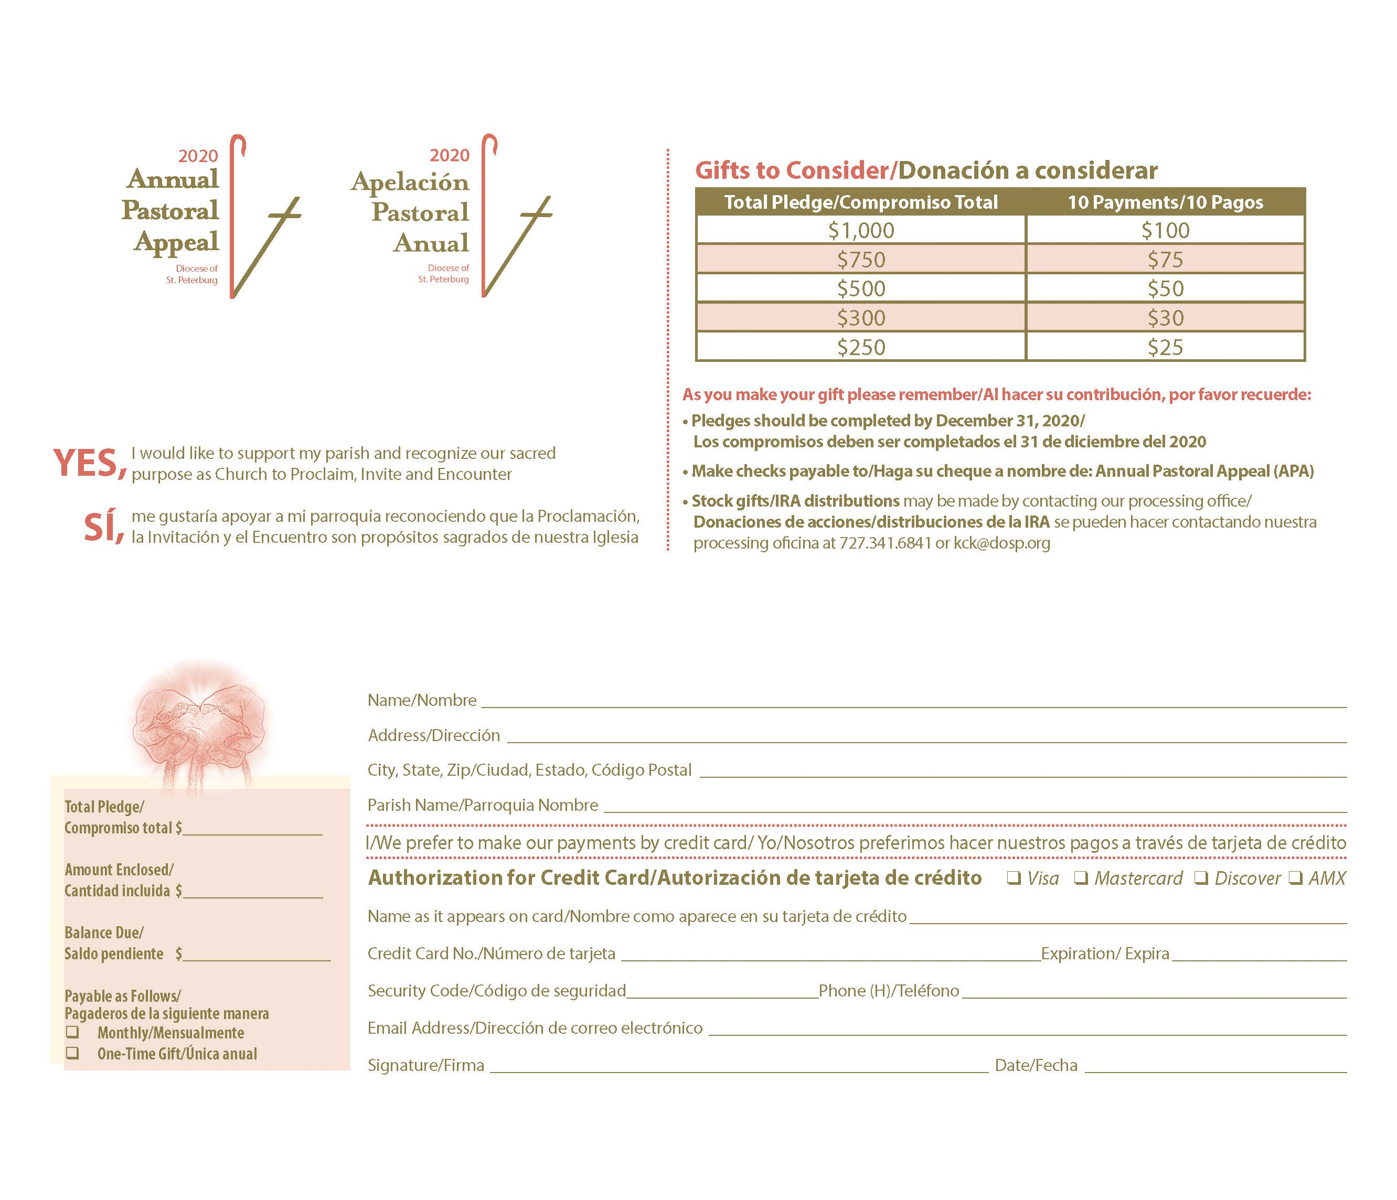
Breaking Down the In-Pew Envelope
1

4
3

2

5

6

7
8

10

9

1. APA 2020 Logo
2. Donor’s commitment to giving
3. Sample giving plans for donors to show how a pledge breaks down monthly
4. Important facts to remember:
- Pledges to be completed by December 31, 2020
- Make checks payable to
- Stock gifts info
5. Name and mailing address of donor
6. Amount recorded as pledge
7. Total dollar amount of payments included
8. Balance due (amount to be paid)
9. Payment schedules available to the donor (how many payments to complete the pledge)
10. E-giving via credit card

Questions? Contact the Office of Stewardship and Development at 727-341-6825.

Sample In-Pew Commitment Weekend Pulpit Presentation
This instruction is most successful when delivered by the pastor either before Mass or after the homily.

Here at (your parish name) and throughout our diocese we have much to be grateful for. We have truly been blessed as a faith family. This past year our parish and our diocese embarked on a new journey with a mutually-shared vision: Courageously Living the Gospel. We continue that journey, renewed with a sacred purpose of proclaiming the gospel and inviting those we encounter to join us. It truly an exciting time to be a disciple of Christ in the Diocese of St. Petersburg.

I want to introduce the 2020 Annual Pastoral Appeal (APA): WE ARE SALT & LIGHT Living the Gospel through the Annual Pastoral Appeal. This is our diocesan annual appeal that invites every parishioner to participate in supporting the ministries, programs and services of our local Church, which serve us in our parish and many in need outside of our parish boundaries.

As your pastor, I want to let you know that I support this appeal and the hope it provides for both our parish and for those whom are brought closer to Christ. (You may mention here the ministries, programs and services that your assessment dollars fund and that this fundraiser known as APA helps pay that assessment.)

You should have received a packet in the mail at home which includes a message from Bishop Parkes, as well as a brochure that provides information on how your donations support diocesan ministries, programs and services. More information can be found online in the 2019 Annual Report – please see our bulletin for the website. I would like to emphasize the spiritual effect the appeal has on our parish and diocese. This appeal provides the means to continue the mission that Christ has entrusted to us: to serve, to educate, to care for the poor, and to be a beacon of hope for all. The ministries, programs, and services that are funded from this effort allow us to fulfill this responsibility, and we are all invited to make a gift, a courageous gift, that demonstrates how as disciples we are living the gospel and sharing it with those we encounter.

I pray that each family will assess their own resources and generously make a gift of substance and not merely one of convenience. This appeal is based on equal sacrifice, not equal giving. I cannot ask everyone to consider the same size gift, but I ask that everyone let their gift reflect how generous God has been with His gifts. Can you consider a gift of $25, $40 or $50 each month for the rest of this year? That amount will equal a pledge of $250, $400 or $500 by the end of the year.

I know from personal experience that it is easier to make a gift of sacrifice if you can spread it out, rather than make a full, one-time gift. It is easy, when surrounded by so many people, to think that it won’t matter if you don’t participate. But each gift does make a difference, and it is noticed. I need everyone to prayerfully consider participation. For those who have never given, it is vital to understand we are God’s Salt of the earth and Light of the world. Our parish needs you to take a leap of faith – our parish needs you, and so does the Church.

As you think about what you will give, remember, this gift is different from your gift each weekend to our parish. This is in addition to your offertory giving. Also, please know these pledges are a “good faith effort.” I know that everyone will do their very best to fulfill their pledges, and that is all we ask - that you do your best. We know that things happen, and you may need to change your pledge in the future. That’s ok. If a change is needed in the future, it can be made. And if that change is an increase, well, that is ok, too.

At this point, I ask everyone to make their commitment over the next few minutes. If you did not bring your pledge card from home, please complete a pledge envelope found in your pew. Please fill in all the information on the pledge envelope clearly. The pledge envelope has a section marked “Gifts to Consider” which breaks down what 10 equal monthly payments would be, and what the total pledge will come to if all payments are completed. For example, 10 monthly payments of $30 equal a total pledge of $300. Once you decide on the amount you want to give, fill out the giving information on the bottom left of the envelope – the area marked “Total Pledge/Amount Enclosed/Balance Due.” Also indicate if you want to make payments monthly or annually, or as one-time gift to complete your “Balance Due.”

A down payment on your pledge is not necessary or required. If you are able to make one, please do. If you can’t make a down payment, don’t let that stop you from making your pledge.

For those of you who have already made a gift or pledge by sending in your pledge card that you received at home, I thank you for your generosity. I am going to pause to give those who haven’t yet completed their commitment time to fill out their pledge forms, while I do the same. (PAUSE AND FILL OUT A PLEDGE ENVELOPE, EVEN IF YOU HAVE ALREADY DONE SO. THIS WILL ENCOURAGE YOUR PARISHIONERS TO DO THE SAME.)

At this time, I ask the Hospitality Ministers/Ushers to pick up all pledge envelopes, including those pledge cards received at home that have been brought in today (or have parishioners bring them to the altar). Thank you once again for listening with an open heart. All gifts are an act of courage and in a few weeks when the active phase of the APA concludes, I know we will have done our part as a parish family to live the Gospel through the Annual Pastoral Appeal.

In-Pew Solicitation for Multicultural Parishes
For many cultures, sacrificial giving may not be the custom, and support for Church by a way of pledging may not be a common or known practice. Below are some suggestions for adapting in-pew solicitation for multicultural parishes. As you present other options, please remember that it is important to stress the message of equal sacrifice, not equal gift.

Pledge with Weekly Payments:
Ask parishioners to consider a total amount to pledge, direct them to write that amount on the bilingual envelope provided, or perhaps, to choose one of the suggested amounts already listed on the envelope. Explain to the community that the amount they may choose to give can be paid over a number of specific weeks utilizing a particular envelope provided by the parish (in-pew). During your announcement, indicate the specific dates that will be assigned for the collection of the envelopes. During those weeks, envelopes will be collected at Mass during a special collection and submitted to the Campaign Processing Office as soon as possible.

EXAMPLE:
Your parish implements this idea and will conduct the effort over a period of 5 weeks.
Option one: Parish could use different colored envelopes for each week. The envelopes should have a place for the participant to write their name, address and the amount included.
Option two: The parish could use envelopes that are marked with a series of numbers and that represent collection weeks. The parish will have available (in-pew) the numbered envelope that corresponds for each collection. The envelopes should have a place for the participant to write their name, address and the amount included.
Parish Community Gift:
The entire community (Spanish, Vietnamese, or others), could offer a specific amount as their APA pledge to the parish. Over a period of time throughout the year, the community will fundraise, collect, donate funds, and submit as many payments as necessary toward the amount pledged. Parishioners can also individually consider a total amount to be pledged over a period of time. Please note, if a parishioner chooses this option, they will need to complete their own pledge card on behalf of the parish community.

Promotional Materials & Resources
In order to achieve your parish/mission goal set forth this year for the Annual Pastoral Appeal, we encourage you to utilize the provided promotional materials to educate and inform parishioners about the pastoral, education and charitable ministries supported through their donations.

Special Request Resources

- Direct Mail Packets – If a member of your parish notifies you that they did not receive a packet, please contact the Office of Stewardship and Development at 727-341-6825 to request a personalized mailing for the parishioner. It will include: letter, brochure, pledge card, and return envelope.
- Diocesan Speaker – Each year, we provide a list of diocesan directors available to speak at Masses over the course of a weekend on behalf of their office(s)/ministry(s)/program(s) about how gifts to the appeal fund that particular outreach. The main purpose is to put a face on diocesan ministry and educate parishioners about the work we do and how we are able to do it. This list can be found on page 33 of this manual.
- DVD of 2020 Video – We can provide a DVD of the APA video by request. Please contact the Office of Stewardship and Development at 727-341-6825.

Resources Shipped to all Parishes January 6, 2020

- Posters
- In-pew pledge envelopes
- Extra brochures
- Leadership Manual
- Prayer Cards

Resources Available through Manual and/or Download at www.dosp.org/apa/2020-materials/

- 2020 APA Video – The APA video is complete in English & Spanish and approximately 5 minutes in length. If your parish requires a DVD in order to utilize the video, please contact the Stewardship and Development Office at 727-341-6825.
- Prayers of the Faithful
- Pulpit and Bulletin Announcements – Suggested pulpit and bulletin announcements are provided in this manual in English and are also available for download in both English and Spanish in Word on the 2020 APA parish resource page (www.dosp.org/apa/2020-materials/).
- Bulletin Inserts – Bulletin inserts in both English and Spanish will be available for use. The 2020 Annual Pastoral Appeal inserts focus on general information, education and promotion of the Appeal. They should be timed for use as the direct mail request packets are sent to parishioners in January.
- Snapshot Inserts - The “Snapshot” inserts provide more details about one particular ministry, service or program funded through donations to the Appeal and can be used at any time throughout the year to coincide with individual parish efforts to continue educating parishioners and building participation. Please note: over the course of the year, additional items will be added, including, but not limited to, new ministry “Snapshots”, “Go For the Goal” and “Thank You” inserts.
- Online Giving – all donors can access online electronic giving at www.dosp.org and as always contact the Campaign Processing Office at 727-341-6841 for assistance if needed.
- Ministry Mini-Videos – To focus on one particular ministry or office, download a ministry “Focus On” video for use on your website or for presentation at Mass.
- Give Now Graphic – Download a “Give Now” JPG file for use in providing your parishioners a link to diocesan online giving.

Prayers of the Faithful
To continue awareness and prayer, the following are sample prayer intentions for your consideration and use:

- As we begin the 2020 Annual Pastoral Appeal, let us pray for our shepherd, Bishop Gregory Parkes, and give thanks for his support of our parish and his leadership of the Diocese of St. Petersburg...
We pray to the Lord.

- For a successful Annual Pastoral Appeal from which the courage and generosity of our parishioners will benefit our parish, and extend God’s love and mercy to those in need…
We pray to the Lord.

- By being His Salt & Light may we share the promise of the Gospel of Jesus Christ through our faith and actions and do so with humble confidence in response to God’s grace which has so freely been given to us...
We pray to the Lord.

- That we may see the good works of our local Church through the Annual Pastoral Appeal as an opportunity to be the Salt of the earth and the Light of the world and extend our love and service beyond our parish boundaries to our local community…
We pray to the Lord.

- In thanksgiving for all that the Lord has given to us, may we be His Salt and Light and show our gratitude by being a witness of His love and mercy to others through our generous gift to the 2020 Annual Pastoral Appeal…
We pray to the Lord.

- That God may bless our parish, strengthen our faith and grant us the spirit of Christian stewardship by opening our hearts to be His Salt of the Earth and Light of the World to those we encounter…
We pray to the Lord.

- That those who have responded generously to the Annual Pastoral Appeal witness the love and joy that stewardship brings and are inspired to courageously work toward a future filled with justice, peace, beauty and love…
We pray to the Lord.

- That each one of us will be open to God’s call and prayerfully consider how best we can be His Salt and Light for those seeking a relationship with Jesus Christ…
We pray to the Lord.

- That God will bless our parish family and every parish throughout our diocese for the courageous support of the ministries, programs and services funded through the Annual Pastoral Appeal...
We pray to the Lord.

- That we may continue to journey with Jesus Christ filled with faith and gratitude, living the Gospel through the Annual Pastoral Appeal…
We pray to the Lord.

Pastor & Pulpit Announcements
January 5 - January 12 Thank You Weekends

Pastor/Celebrant Announcement
With this New Year comes the launch of the 2020 Annual Pastoral Appeal (APA). Please remember that we always strive for a successful effort here in our parish. This year’s theme for the APA is: We are SALT & LIGHT. As baptized individuals, as a parish and as a diocese, by supporting the good works done in the name of Jesus Christ as joyful stewards, we are Living the Gospel through the Annual Pastoral Appeal.

Participating in APA gives us opportunities to live the Gospel, share our faith and bring God’s hope and love to all those we encounter. Please be generous with your gift to the Annual Pastoral Appeal for our parish.

Pulpit Announcement
Feeling blessed, we offer great thanks to everyone who generously made a sacrificial gift in the last year to the 2019 Annual Pastoral Appeal. Your faithful support has helped our parish and brought thousands within our diocese closer to God through the ministries, programs, and services funded through APA. We are blessed to have such caring and compassionate parishioners.

January 18/19 Prayer Weekend

Pastor/Celebrant Announcement
I wish to take a moment to thank all of you for your prayer, participation and generosity to our parish. This is a place where we come to seek salvation, where we feel comfortable, yet we understand we have to give of our time, talent and treasure to keep it active and vibrant, and to preserve it for those who come after us.

This year the Annual Pastoral Appeal is themed: WE ARE SALT & LIGHT, Living the Gospel through the Annual Pastoral Appeal. This is an opportunity to give thanks for our own blessings and courageously continue be a source of hope and life for each other and for people in need, here and now, and the future.

Please pray for the success of the 2020 Annual Pastoral Appeal. Pray for our parish and our diocese, that those in need of charity, service, formation, and education will be assisted by us with God’s promise of love and mercy. Pray that by our witness and courageous response, those in need will know the same comfort and hope that we have in our hearts and lives. In the coming weeks, you will receive an invitation from Bishop Parkes to participate in the 2020 APA. Please review the brochure that is included, which displays the good works of our local Church made possible by APA.

Our parish needs your help, and more importantly, those who benefit from the services and outreach funded through the Appeal need your help. Every gift makes a difference. I ask that you pray about your own participation in this year’s APA. Our Commitment Weekend is in three weeks. Please come prepared to help give the hope of Jesus to someone in need through a gift to the Appeal. Thank you, and may God continue to bless you.

Pulpit Announcement
As we pray this weekend for the Annual Pastoral Appeal, remember we are beneficiaries of a rich history, and we give thanks for the hope given to us by the self-sacrifice of clergy, religious, and laity that have come before us. As we pray for the success of our 2020 Annual Pastoral Appeal, let’s encourage each other to live as missionary disciples and build up our local Church now and for future generations. Our APA reaches beyond ourselves and our parish/mission, and gives hope to thousands through the ministries, programs and services that enrich a Christ-centered way of life. Our APA Commitment Weekend is in three weeks. Please come prepared to participate and stand strong in our Catholic faith.

January 25/26 Education Weekend

Pastor/Celebrant Announcement
By now you should have received an invitation from Bishop Parkes to participate in the 2020 Annual Pastoral Appeal. In two weeks, we join with him and all our sisters and brothers throughout the Diocese to give thanks for what we have received and to give hope to those we encounter.

The Annual Pastoral Appeal provides each of us with the opportunity to touch the lives of others with love and charity. This is a blessing for us AND for those we are able to help. Outreach efforts funded by the appeal help people struggling with homelessness, life and justice issues. It helps provide awareness and assistance for those that encounter racism and celebrates diversity. APA funds the promotion of Vocations, and our men studying for the priesthood, permanent diaconate and religious life. It provides for the assistance to youth and young adult ministers for development and spiritual enrichment, supports the advancement of our diocesan communications and radio ministry to evangelize far and wide, and offers opportunities for people of all ages looking to grow in their relationship with Jesus Christ.

The brochure that is included with the packet mailed to you highlights some of the ministries, programs and services supported by your Annual Pastoral Appeal gift. For those of you who have previously supported APA, I extend my heartfelt gratitude. You have helped our parish tremendously with this financial responsibility and while you may not have personally seen the joy felt by the thousands of people helped through your gift, I want to assure you that your gift has transformed lives. (Consider mentioning to those who have never given that now is the time to Courageously Live the Gospel, take that leap of faith…the parish needs them and so does the Church).

I ask all of you to join me to be God’s Salt and Light for others and joyfully make a gift to the 2020 Annual Pastoral Appeal. Please reflect on the blessings that you have been given and pray about how you can use your gifts to be a witness of God’s presence in our diocesan community. In two weeks, our parish will be conducting our Commitment Weekend in-pew collection for the Annual Pastoral Appeal. I pray that together we will demonstrate our charity to those in need. Thank you, and may God continue to bless you.

Pulpit Announcement
By now you should have received your invitation in the mail from Bishop Parkes to participate in the 2020 Annual Pastoral Appeal. This year’s APA theme is: WE ARE SALT & LIGHT, Living the Gospel through the Annual Pastoral Appeal, a message that states God’s intentions for us and provides an opportunity to reflect on our own blessings, and what we do in His name. This is our call to action to be grateful for what God has given us and participate in His work not yet done. Please prayerfully consider how you can help to provide the gift of hope to all who encounter the ministries, programs and services funded by APA.

Our Commitment Weekend collection is in two weeks. Your generous gift or pledge to the Annual Pastoral Appeal on behalf of our parish will help us reach our goal and provide support for the ministries, programs and services that are essential to continue God’s work in our diocese, both now and for the future. Please spend some time in prayer to decide on the sacrifice you can make to give hope to those who are less fortunate. Be a witness of God’s love with your gift.

February 1/2 Clergy Support Weekend

Pastor/Celebrant Announcement
I want you to know that I support the Annual Pastoral Appeal and respect that this is an opportunity to touch the lives of others, those we may never know, with love and charity. This is a fundraiser for our parish that benefits us as well as those we can help who may be struggling with homelessness, or life and justice issues. Our gifts provide awareness and assistance for those that encounter racism and together we can celebrate diversity. We will help to fund the support of Vocations, our men studying for the priesthood, permanent diaconate and religious life. We will also help to provide for the assistance to youth and young adult ministers for development and spiritual enrichment and the advancement of our diocesan communications and radio ministry to evangelize far and wide. Our gifts will contribute to opportunities for people of all ages looking to grow in their relationship with Jesus Christ.

The Good Works that we do as a diocesan Church are carried out in the ministries, programs and services supported by our Annual Pastoral Appeal gifts. For those of you who have previously supported APA, I extend my heartfelt gratitude. You have helped our parish tremendously and while you may not have personally seen the joy felt by the thousands of people helped through your gift, I want to assure you that your gift has transformed lives.

I ask all of you to join me and joyfully make a gift to the 2020 Annual Pastoral Appeal. Please reflect on the blessings that you have been given and pray about how you can use your gifts to be a witness of God’s presence in our diocesan community. Next week, our parish will be conducting our commitment weekend in-pew collection for the Annual Pastoral Appeal. I pray that together we will demonstrate our charity to those in need. Thank you, and may God continue to bless you.

Pulpit Announcement
This year’s APA theme is: WE ARE SALT & LIGHT, Living the Gospel through the Annual Pastoral Appeal, a message that states God’s intentions for us and provides an opportunity to reflect on our own blessings, and what we do in His name. This is our call to action to be grateful for what God has given us and participate in His work not yet done. Please prayerfully consider how you can help to provide the gift of hope to all who encounter the ministries, programs and services funded by APA.

Our Commitment Weekend is next weekend. Your generous gift or pledge to the Annual Pastoral Appeal on behalf of our parish will help us reach our goal and provide support for the ministries, programs, and services that are essential to continue God’s work in our diocese, both now and for the future. Please spend some time in prayer to decide on the sacrifice you can make to give hope to those who are less fortunate. Be a witness of God’s love with your gift.

February 8/9 Commitment Weekend

Pastor/Celebrant Announcement (or if in-pew solicitation presentation is made by a lay witness or other parish leader)
It’s an exciting time to be a part of the Diocese of St. Petersburg, journeying with a vision that brings us together as a joyful community of disciples, proclaiming the Good News and inviting all people to encounter the love and mercy of Jesus Christ. I want to thank everyone who has supported our parish by giving to the APA in the past. Those whose lives have been transformed through the Good Works of our Catholic faith community are thankful for your generosity. For the past two weeks, I have reminded you of the importance of your participation in the APA. This Appeal is an opportunity to share our gifts in support of our parish and our diocesan community. It is an effective and cost-efficient way to provide necessary services, such as human resources, insurance, construction, and financial guidance to our own parish, as well as offer services, faith formation programs, ministries and programs outside of our parish boundaries. I am asking today for your generous response. WE ARE SALT & LIGHT, and this is our opportunity as a parish to Courageously live the Gospel through the Annual Pastoral Appeal. Every gift, every prayer, and every sacrifice sends a Gospel message of hope to someone seeking the love and mercy of Christ. Thank you, and may God continue to bless you.

February 15/16 and 22/23 Follow-Up Weekends 1 & 2

Pulpit Announcement
Every parishioner can fully participate in the mission of our Catholic Church and the continued works of Jesus Christ by participating in the Annual Pastoral Appeal. Please prayerfully consider the blessings you have been given, and the prayers answered in your times of need. If you weren’t prepared to make a commitment last week, we ask you to make a gift or pledge of support to the essential ministries, programs and services of our diocese. These diocesan outreach efforts are a true blessing to those we serve, fulfilling the physical, educational and spiritual needs of thousands that we could not serve from our parish alone. Your gift may be paid over the next 10 months or you can make a one-time gift. Every gift is courageous, there is no gift too small and every gift changes a life. Every gift can inspire hope for those we serve. Pledge envelopes are located (describe where you have the envelopes) for your convenience.

February 26 – April 12 Lenten and Easter Prayer Weekends

Optional Pulpit Prayer for Lent
Our God sent His only Son to be among us here on earth. Jesus’ life, death and resurrection are His gift to us. He is with us always. Let us pray that the Holy Spirit will guide us in our prayers and grant us the grace and blessings that sustain and fortify us to joyfully serve one another with honor and glory to God.

April 18/19 2nd Request Weekend

Pulpit Announcement
With renewed spirit and hearts full of love and gratitude for the life, death and resurrection of Jesus Christ, we must be His Salt and Light and serve one another with His love and mercy. For those who have made a gift or pledge to the Annual Pastoral Appeal, thank you. Your sacrifice will help our parish to prosper and will give hope to those in need throughout our diocese. A follow-up message is being mailed to those who have not yet made a commitment, with an invitation to be a conscious, active participant in the mission of our Church, and to participate in the Annual Pastoral Appeal. Those that are alone, sick, and homeless, those in jail and their families, those who may be having difficulty in their marriage, those seeking forgiveness and wanting to return to the Church, and those seeking a better life by following Christ, are aided and healed by the ministries, programs and services funded through APA. Jesus has entrusted the care of those less fortunate to us. Be generous with your gift to the Annual Pastoral Appeal. Envelopes can be found (describe where you have the envelopes). They may be placed in the collection basket, brought to the parish office or mailed directly to the Campaign Processing Office at the Pastoral Center.

April 26 – until goal is reached Update & Continued Communications

Pulpit Announcement
Option 1:
We all have received countless blessings and the gift of faith which God so freely gives us. The theme for the 2020 Annual Pastoral Appeal, WE ARE SALT & LIGHT, Living the Gospel through the Annual Pastoral Appeal, calls us to action to be disciples of Jesus Christ and help to share his love and mercy to all. Please continue to pray for those in need and for those seeking a better life in and through Jesus Christ. With a gift to the Annual Pastoral Appeal, you help our parish to prosper and you give witness to God’s abundant blessings by demonstrating a courageous and grateful response to His call to love and serve one another. No gift is too small and every gift changes a life. Pledge/gift envelopes may be found (describe where you have the envelopes) for your convenience.

Option 2:
I would like to update you on the progress of our 2020 Annual Pastoral Appeal. Each parish contributes financially to support the physical, educational and spiritual needs of our local diocesan Church. This year, our parish’s portion is $__________________. As of last week, a total of $___________ has been committed from _________ of our households.

If you have already made your gift or pledge to this year’s Appeal – thank you!

If you have not made your commitment yet, your help is still very much needed. We are striving for 100% participation to reach our goal. Please remember, no gift is too small. Every gift is courageous and makes a difference. Pledge envelopes are located (describe where you have the envelopes) for your convenience.
Please continue to pray for the success of the Annual Pastoral Appeal and consider a gift or pledge if you have not done so already. Thank you.

Option 3:
We are continuing to support the 2020 Annual Pastoral Appeal in our parish. Thank you to everyone who has made a gift. We are doing well, with $_________ in commitments from ________ families. Does that include you?

The priorities in our lives change from day to day, but hopefully God remains at the center of all we say and do. Our parish and God’s people throughout our diocese need your help. You may never meet those you help, or you may think you gift is too small or not needed. It is time for all of us to be part of a bigger blessing, one that transforms lives. If you have not yet made a gift or pledge to the Annual Pastoral Appeal, please give now. I assure you, every gift is needed. Please support the mission God has entrusted to you. Please make a pledge or one-time gift. Pledge envelopes are located (describe where you have the envelopes) for your convenience. Every gift, every prayer, makes a difference and changes someone’s life.

Bulletin Announcements
Now – January 12 Thank You Weekends

Thank you * Thank you * Thank you * to everyone who generously gave to our 2019 Annual Pastoral Appeal. Your faithful support has helped our parish tremendously and has brought thousands within our diocese closer to God through the ministries, programs, and services funded through APA. We have much to be thankful for, and your participation in APA tops the list! Thank you!

OR

Thank you * Thank you * Thank you * to everyone who generously made a sacrificial gift to the 2019 Annual Pastoral Appeal. Your faithful support has helped our parish tremendously and brought thousands within our diocese closer to God through the ministries, programs, and services funded through APA. And of course, through your participation, our parish achieved goal! (if applicable)

With this New Year comes the launch of the 2020 APA in our parish, and an invitation from our bishop to participate will arrive soon through the mail. We hope that you will consider supporting this year’s effort as we pray for Bishop Parkes, give thanks for his support of our parish and leadership of the Diocese of St. Petersburg, and the Good Works we do in the name of Jesus Christ.

January 18/19 Prayer Weekend

This year the Annual Pastoral Appeal is themed: WE ARE SALT & LIGHT, Living the Gospel through the Annual Pastoral Appeal, a message that states who God intends us to be, a source of hope and life for each other and people in need here and now, and in the future. Together, let’s pray that the Holy Spirit will guide our journey and bestow His grace upon us as we serve others. That He will grant success of our appeal, which reaches beyond ourselves and our parish, and gives hope to thousands through the ministries, programs, and services that enrich a Christ-centered way of life. Our parish Commitment Weekend is on February 8/9, please bring your intent card from home or pick-up an in-pew pledge envelope at Mass and come prepared to participate and courageously be part of the Good Works of our diocese.

Let us also pray for our parish and our diocese, that those in need of charity, service, formation, and education will be assisted with God’s promise of love and mercy and that by our witness and courageous response, those in need will know the same comfort and hope that we have in our hearts and lives. Soon, you will receive an invitation from Bishop Parkes to participate in the 2020 APA. Please review the brochure that comes with it and learn more about the good works of our local Church made possible by APA.

January 25/26 Education Weekend

Soon you will receive a personal invitation from Bishop Parkes to participate in the 2020 Annual Pastoral Appeal. Remember that APA not only assists our parish in fulfilling our financial commitment to the ministries, programs and services of our larger Church, but also helps to provide the physical, educational and spiritual needs of thousands that we could not serve from our parish alone. Your pledge or gift to APA on behalf of our parish funds these services that are essential to advance the mission of Christ and help those in need. Our parish Commitment Weekend is in two weeks. While reflecting on your own blessings, consider how you can bring the joy of Jesus Christ to someone in need.

February 1/2 Clergy Support & Education Weekend

As you receive your personal invitation from Bishop Parkes for participation in the 2020 Annual Pastoral Appeal, remember that APA not only assists our parish in fulfilling our financial commitment to the ministries, programs and services of our larger Church, but also helps to provide the physical, educational and spiritual needs of thousands that we could not serve from our parish alone. Your pledge or gift to APA on behalf of our parish funds these services that are essential to advance the mission of Christ and help those in need. Our parish Commitment Weekend is next week. While reflecting on your own blessings, consider how you can bring the love and mercy of Jesus Christ to someone in need.

February 8/9 Commitment Weekend

Today is our Commitment Weekend for the 2020 Annual Pastoral Appeal: WE ARE SALT & LIGHT, Living the Gospel through the Annual Pastoral Appeal. Everyone is asked to join Bishop Parkes and all parishes and missions throughout our diocese in making a pledge or gift for the benefit of each parish, and more importantly, for the many in need throughout the five counties of our diocese. Every gift is valuable. Sometimes it is hard to envision how one gift could make a difference in an organization the size of our diocese, but it does. Every Catholic in every parish, when united, can advance the mission of Christ, loving and serving one another and we must remember God blesses each of us every day and there is no limit to His mercy. No one can do everything, but everyone can do something. Our focus is not equal gift, but equal sacrifice. Being His Salt and Light calls us to transform the lives of others for the good. Thank you in advance for continuing to support our parish and our diocesan faith family in so many ways.

February 15/16 and February 22/23 Follow-Up Weekends 1 & 2

Thank you to everyone who has responded to the request to participate in the 2020 Annual Pastoral Appeal. Your gift is received with great humility, thanks and gratitude by the thousands of people supported through your donation. As we journey together, let’s give thanks for the Good Works being done in Jesus’ name throughout our diocese. APA is an opportunity to learn more about the 50+ ministries, programs and services available throughout our diocese. If you have any questions about APA, the services it funds, or how it benefits our parish, please call our parish office or visit our diocesan website at https://www.dosp.org/ and discover something new about our local Church outreach. If you have not yet responded, please know we want and need your participation! Every gift, every prayer, and every sacrifice brings hope to someone seeking the love and mercy of Christ.

February 26- April 12 Lenten and Easter Prayer Weekends

Optional for Lent
As we reflect on our many blessings during this season of prayer, fasting and almsgiving, let us be mindful to give God thanks and praise. Monsignor/Father _______________would like to extend his personal gratitude to all who have generously participated in the 2020 Annual Pastoral Appeal. As we pray on the Life, Death and Resurrection of our Lord, remembering the unconditional sacrifice He made for us and our salvation, may we remember those in most need throughout our diocese, and courageously respond with grateful hearts and generosity.

April 18/19 2nd Request Weekend

Rejoice in the resurrection! Thank you to the ______ households that have responded generously to the 2020 Annual Pastoral Appeal. We have reached $__________ toward our goal amount $____________. A follow-up message will be going out to those who have not yet made a commitment along with an invitation to be a conscious, active participant in the mission of our Church with a gift to the Annual Pastoral Appeal. If you have not yet made a pledge or gift, please prayerfully consider sharing a portion of the blessings you have received to help to advance our mission of love and mercy in Jesus’ name to uphold His kingdom here in our local Church. Every gift is courageous, no gift is too small and each gift changes a life. You can make a one-time gift, or you can pledge an amount that is payable over 10 months. Our parish wants and needs your active participation and support.

April 26 – until goal is reached Update & Continued Communications

Option 1:
Thank you to our parishioners who have responded generously with pledges and gifts in support of our 2020 Annual Pastoral Appeal. Your generosity helps our parish financially support the ministries, programs and services provided by our local diocesan Church. To date, we have received $___________ from _____ households toward our $__________ goal. If you have not yet made your pledge or gift, it’s not too late! Every gift is courageous, no gift is too small and each gift changes a life. We want your participation and need your support.

Option 2:
The 2020 Annual Pastoral Appeal continues to make progress in our parish. _______ households have responded generously with $ _________ in pledges and gifts toward our goal of $_________. If you have not yet joined in, we want your participation and need your support. Please pray and respond with a gift that inspires those seeking the love and mercy of Christ! You are the Salt of the Earth and the Light of the World, help someone else be that too!

Option 3:
Our parish is filled with caring, generous people who understand and embrace the Annual Pastoral Appeal and the good that it brings to our parish and to our diocese. Thank you to all who have given a sacrificial gift to this year’s APA. Your generosity to APA supports the mission of Jesus Christ, allowing us to bring God’s love and mercy past our parish boundaries. If you have not yet made a gift, it’s never too late. You are His Salt and Light for the world to see. Let faith be your guide, hope be your inspiration and love inspire your action. Every gift of every size spreads the loving message of Jesus Christ.

Diocesan Speakers
Our diocesan ministries are funded in part through donations to the Annual Pastoral Appeal. In gratitude we welcome the opportunity to share the joy of our ministries, programs and services with your parishioners.

Due to individual office and personal scheduling, early planning it is encouraged. You are welcome to contact these speakers directly or contact Jeanne Smith in the Office of Stewardship and Development at jms@dosp.org for assistance in scheduling.

From the Pastoral Center: 727-344-1611

Catechist Formation Kathy Filippelli, Associate Director
Catholic Schools and Centers Chris Pastura, Superintendent
Catholic Schools and Centers Dr. Mark Majeski, Associate Superintendent
Catholic Schools and Centers Dr. Ann Davis, Associate Superintendent
Chancellor/Office of the Bishop Deacon Rick Wells, Chancellor
Construction Hung Pham, Executive Director
Diaconate Deacon Jim Grevenites, Assistant Director
Diaconate Deacon Peter Andre, Coordinator of Pastoral Field Education
Office of Marriage and Family Life Diane Kledzik, Associate Director
Evangelization, Formation, Youth and Family Life Brian Lemoi, Executive Director
Hispanic Ministry Carlos Flores, Associate Director
Hispanic Ministry/Lay Pastoral Ministry Institute George Cruz, Hispanic Commission
Lay Pastoral Ministry Institute Dale Brown, Associate Director
Life, Justice and Advocacy Ministry Sabrina Burton Schultz, Director
Office of the Bishop Frank Murphy, Secretary for Administration
Prison Ministry Deacon Peter Andre, Director
Safe Environment Michael Craig, Program Manager
Stewardship/APA Meegan Wright, Executive Director
Stewardship/APA Jeanne Smith, Associate Director
Vocations Office Father Chuck Dornquast, Director
Vocations Office Heidi Varley, Associate Director
Youth and Young Adult Ministry Ryan Phelan, Director
Mike Buckler, Associate Regional Director-North Cty

From Catholic Charities: 727-893-1313 Margaret Rogers, Interim Executive Director

From WBVM Spirit FM 90.5: 813-289-8040 John Morris, Station Manager

