Diocese of St. Petersburg Issues a Faithful Response
to the Coronavirus
In response to recent concerns over the spread of Coronavirus, the Diocese of St. Petersburg has prepared guidelines for parishes, schools and families to help our communities to take the necessary steps for the safety of all. Our response is focused on prevention, precautions and prayer. Many of these guidelines are based on the Centers for Disease Control and Prevention (CDC) protocols and common-sense practices that are communicated regularly during Flu and Cold Season. We are closely monitoring communications from the CDC and will adapt protocols as needed. We are also praying in solidarity with those who are ill, public health officials and health care workers.
Visit our website to stay informed of updates: www.dosp.org/coronavirus

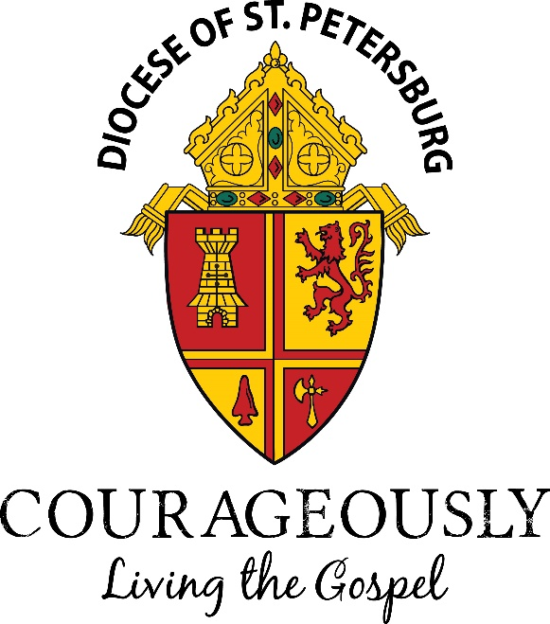
Prevention
Individual Prevention Measures
- It is incumbent on each individual to proactively follow common sense measures for the spread of Coronavirus and other types of flu. Here are the top nine tips based on protocols from the Centers for Disease Control and Prevention:
  - Stay home from Mass, church activities and school if you are feeling sick or your immune system is compromised. It is not a sin and it will not impact your grades.
  - Avoid touching your eyes, nose and mouth.
  - Cover coughs and sneezes with a tissue and then throw the tissue in the trash.
  - Wash your hands often for at least 20 seconds using soap and water, especially after coughing, sneezing, blowing your nose or using the bathroom.
  - Use alcohol-based hand sanitizers if you do not have access to soap and water. (Hand sanitizers need to be at least 60% alcohol-based to be effective.)
  - Do not exchange the Sign of Peace with physical contact if concerned about a handshake. Be respectful when other people prefer not to shake hands.
  - Consider receiving Communion in the hand, rather than on the tongue.
  - Refrain from the Communion cup, especially if not feeling well or anxious about the spread of disease.
  - Clean and disinfect frequently touched objects and surfaces using regular household cleaning products.
Precautions
Precautions in Our Churches
- Recognizing that certain communities may have more risk factors or vulnerable populations, at this time, it is the discretion of the pastor to enact certain measures within our churches, such as:
  - Temporarily suspending the distribution of the Precious Blood, knowing that one receives the fullness of the Body, Blood, Soul, and Divinity of Jesus Christ in the Consecrated Host.
  - Temporarily suspending a physical sign of peace, such as a handshake or a hug, inviting parishioners instead to bow one’s head or wave as they offer peace to those around them.
  - Canceling social events or other measures as necessary.
- Holy Water should be replaced regularly, and fonts should be sanitized each time the water is changed.
- Extra vigilance should be given to cleaning and disinfecting door handles, tops of pews and chairs and hymnal covers.
- Hand Sanitizer may be available in our churches and schools for guests and employees. (Hand sanitizers need to be at least 60% alcohol-based to be effective.)
Precautions in Our Schools and Faith Formation Programs
- We continue to take steps to prevent the spread of illnesses, including coronavirus across our campus, some of which include:
  - Asking that children and employees who have symptoms of respiratory illness to stay home and not come to school until they are free of fever (100.4° F [37.8° C], signs of a fever, and any other symptoms for at least 24 hours, without the use of fever- or other symptom-altering medicines (e.g. cough suppressants).
  - Scheduling regular times throughout the day for children to clean their hands with an alcohol-based hand sanitizer or wash their hands with soap and water for at least 20 seconds.
  - Reminding students about coughing and sneezing etiquette.
  - Routinely cleaning all frequently touched surfaces in the school, such as desks, computers, tables and doorknobs and providing disposable wipes so that commonly used surfaces can be wiped down before each use.
Precautions in our Workplaces
- Employees who are not feeling well, coughing or have a fever are to remain home and seek medical care.
- Guests visiting our offices who are seen coughing will be asked to wear a face mask.
Precautions for Extraordinary Ministers of Holy Communion
- Wash hands before Mass and use alcohol-based, anti-bacterial solution before and after distribution of Holy Communion.
- Open the purificator fully and use a clean portion of the purificator to wipe the inside and outside rims of the chalice after each communicant has received.
- Give the cup a 1/4 to 1/3 turn before presenting to the next communicant.
Prayers
Prayers for the Faithful are available so that we may be joined in our petitions for the health of our brothers and sisters here and around the world. Please find these prayers below and include them in Mass as appropriate.
• For those who are suffering in the current outbreak of sickness that they might be healed, and for the happy repose of all who have died from this illness in recent weeks; let us pray to the Lord
• For scientists, health professionals, public officials and all who are serving the common good in this difficult and uncertain time, that they will be filled with wisdom and understanding; let us pray to the Lord.
• That in times of illness our merciful and loving Father will strengthen our faith and trust in his goodness and divine providence; let us pray to the Lord.
• That our compassionate Father would touch all affected by the current outbreak with healing and peace; let us pray to the Lord.

