Hope in Uncertainty: An Activity Kit for Families
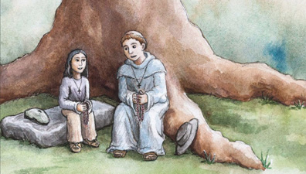
The present COVID-19 pandemic has significantly unsettled people's lives. Many families are isolated at home in order to promote public health. Schools have closed their doors, leaving teachers, parents, and students struggling to adjust to distance learning.
In times of trouble, we turn to holy witnesses of the past to learn how we ought to live with faith.
The Martyrs of La Florida activity kit is designed to help families meaningfully dedicate time to learning about America's early martyrs and the world in which they lived. The kit's activities and resources are intended to foster family discussions about self-sacrifice, freedom and hope in adversity, which the Martyrs of La Florida modeled so well.
Download for free the Hope in Uncertainty: An Activity Kit for Families here.

