St. Matthew Family, The past few weeks have been hard. Between social distancing and the safe-at-home order, we have had to give up our normal routines and embrace a new way of life. At this point, our families, our...

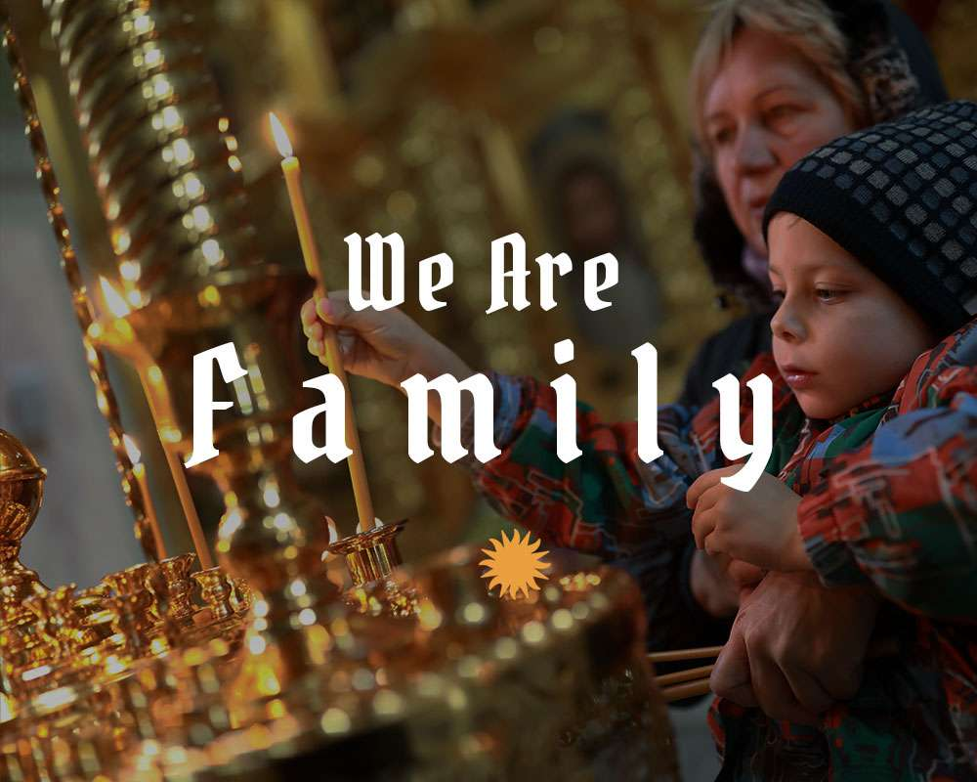
Dear St. Matthew Family,

The past few weeks have been hard. Between social distancing and the safe-at-home order, we have had to give up our normal routines and embrace a new way of life. At this point, our families, our roommates, or living alone might be driving us crazy! However, in spite of the challenges we are facing, the fact is: we are all family.

Being a family is never easy. It takes intentionality and a willingness to be humble and vulnerable. Whether it's with the people you are currently (stuck) with, or with friends online, we have to do our part to build up that community. Even the Pope has asked us to find new ways to be close in our relationships.

Frustration and tensions will inevitably arise. When they do, be willing to take a step back and look at yourself first. Voice your feelings (calmly), and talk through what is going on with the people around you. Do your best to remember that all of us are in this together. We are all scared and anxious and trying to figure out how to handle life in the face of the unknown.

Ultimately, remember: we are all sons and daughters of the Father, which makes us brothers and sisters in Him. He made each one of us with unique and unrepeatable gifts and talents, and for whatever reason, He chose each of us to be here in this moment of history. Let’s do our best to see the good in each other, choose cheerful hope, and help each other be the light that God is calling us to be.
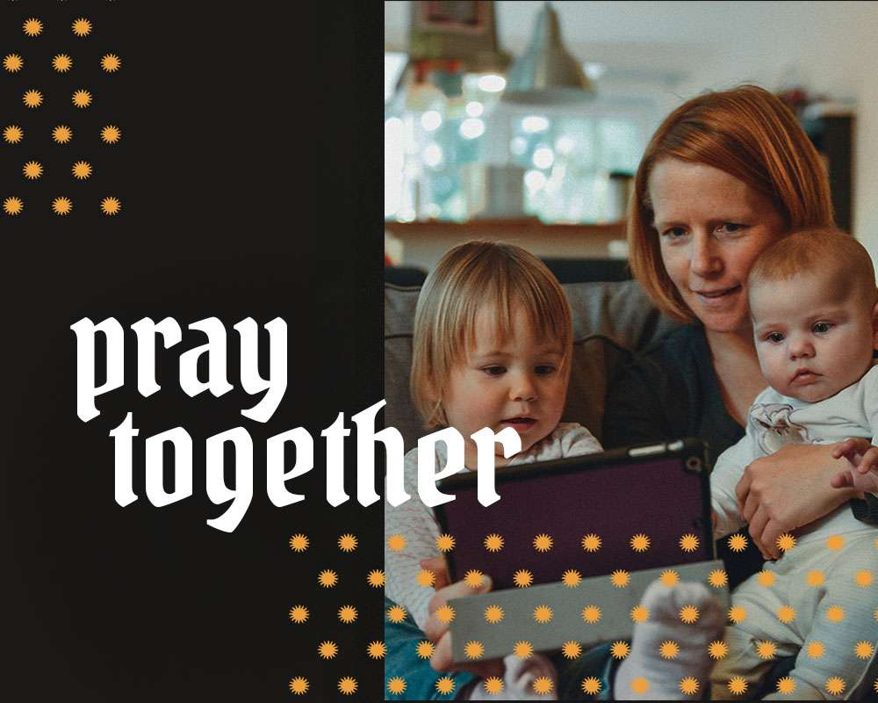
Live in the Light

Pray Together, Stay Together
As a parish, we will continue to support you with weekly Mass live streams on Facebook (that you can watch at any time after the 4pm Saturday Vigil Mass or 7:30 am Sunday Mass and you DON'T need a Facebook account to watch!), and we hope it is an opportunity to pray together. Imagine what our families would look like if we used this time to incorporate family prayer — even beyond Sunday Mass — into our weekly or daily rhythms.

Praying together as a family can take many different forms. Here are some ideas on how you can incorporate new ways of praying into your family’s prayer life. If you enjoy more traditional methods of prayer, perhaps you might like to try a scriptural family rosary or some of the prayer resources Catholic Family Faith offers on their website.
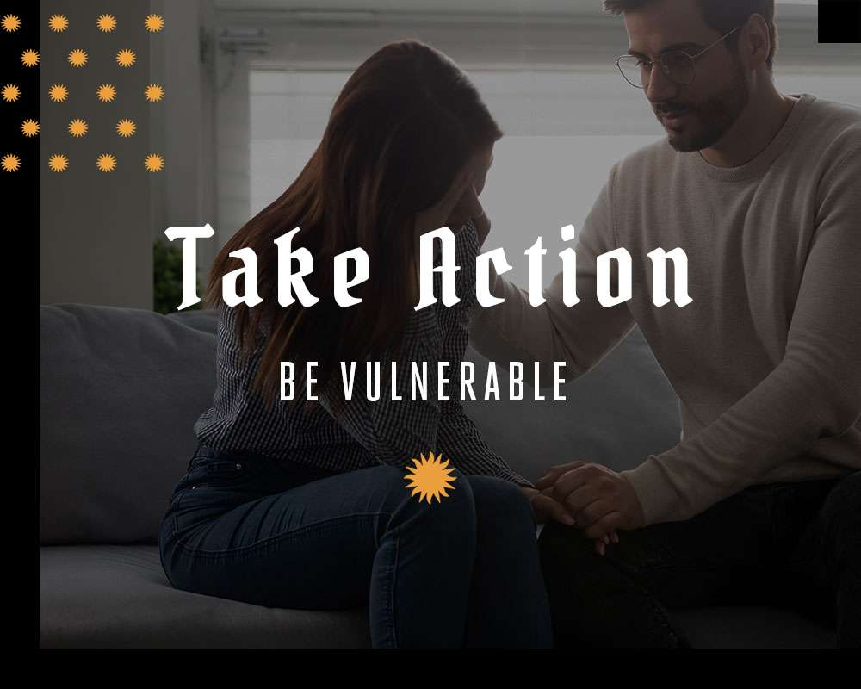
Fr. Tom’s Action Items for the Week

Be Vulnerable with One Another
Spending quarantine with the same people, in the same house, day-in and day-out, for days on end, can be a little taxing. Jim Gaffigan, a Catholic comedian, husband, and father of five, had some thoughts on spending lockdown with his family that might make you feel more normal, give you a few laughs, and maybe even give you a glimmer of hope for what good can come out of all this forced family time together.

On a more serious note, this week, I want to encourage you to share how you’re feeling in an intentional household conversation. As Brené Brown highlights in her world-famous TED talk, vulnerability is the antidote to disconnection. It might be challenging and uncomfortable at first, but it will help us work through conflicts, live more meaningful days, and feel even deeper joy.

Here are some questions to ask one another in your household conversation:
- What are 3 words that describe how you’re feeling?
- What have been your favorite moments of being at home?
- What have been your least favorite moments of being at home?
- Do you have any ideas for something we/I could do better or differently?
- Is there anything you are still angry about? Is there anyone you’d like to apologize to?
- What 3 words describe how you’re feeling now?
This is a moment that we get to do the deep, difficult, rewarding work of connecting with one another. Be vulnerable and trust each other.

“So faith, hope, and love remain, these three; but the greatest of these is love.” 1 Corinthians 13:13

Sincerely,
Fr. Tom J. Anastasia

Sent by Mandy Rose | Reply

Direct replies to this email can only be seen by admins. Click the blue Reply button above to leave a public comment.
Email me when people reply to this note

my info • unsubscribe

9111 90th Ave. N, Largo, FL 33777 • StMat.org

