**St. Patrick Faith Formation Update April 3, 2020**

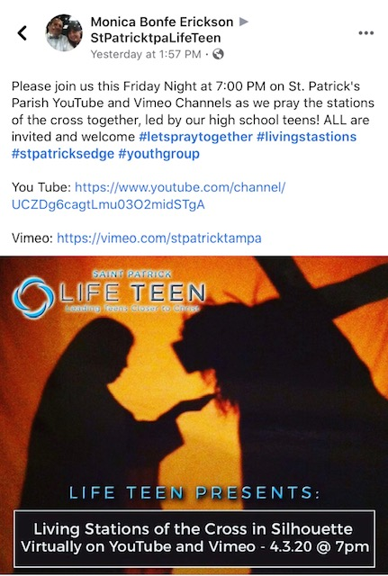**Dear** **Faith Formation Families,**

* **We hope everyone has the chance to watch the station of the cross on utube or vimeo tonight. We are are working on transitioning to remote learning for our Pre-K-grade 5 curriculum. I hope families will be able to use the resources I have included with this message.**
* Activity: [“Examination of Conscience”](https://www.smp.org/resourcecenter/resource/13587/)
* Activity: [“Jesus Prayer Maze”](https://www.smp.org/resourcecenter/resource/13588/)

**HOLY WEEK:**

* Activity: [“Connecting to Jesus”](https://www.smp.org/resourcecenter/resource/13592/)
* **EASTER:**
* Activity: [“Road to Emmaus” Chorus Play](https://www.smp.org/resourcecenter/resource/13591/)
* ****Activity: [“Love Word Search”](https://www.smp.org/resourcecenter/resource/13595/)