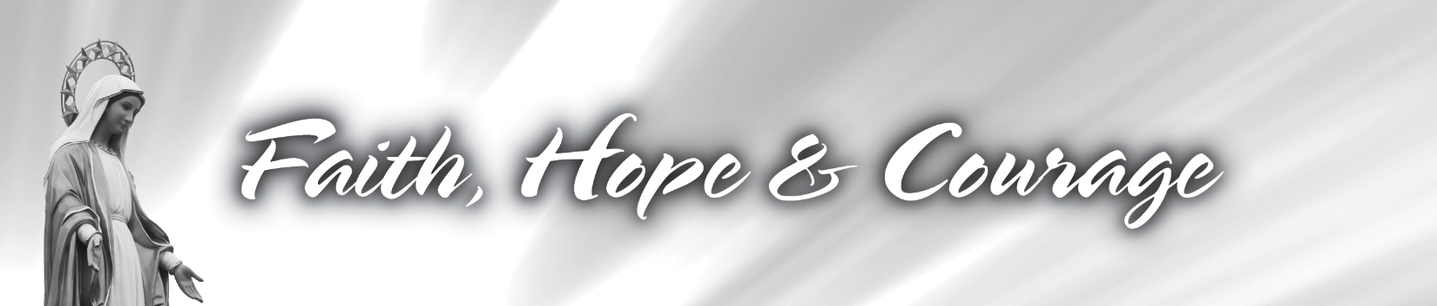

ANNOUNCEMENT WEEKEND –
SAMPLE SCRIPT FOR FOLLOW-UP

INTRODUCTION
Open with Faith, Hope & Courage introduction graphic, transition to Pastor.

PASTOR (ON CAMERA)
Dear Brothers and Sisters in Christ, this weekend we celebrated the Feast of the Assumption. In my Homily, I shared how Mary is an amazing example for us because she courageously answered “yes” every time the Lord asked something of her, full of faith, full of hope in the promise of salvation.

I want to say “thank you” once again to all who have said “yes” time and again so that we can continue in our mission to bring others to Christ, even in trying times. Now, I am asking everyone to say “yes” to working together on a new plan to move forward.

We all know times are challenging, and none of us know what is ahead. But instead of facing what is to come with fear, I am committed to moving forward with Faith, Hope & Courage.

Right now is a perfect time to share information about the changes we have been experiencing, how we can plan together for effective ministry and outreach, as well as the overall health of the parish... I invite you to take time to review the special parish update I shared at Masses this weekend. It is available for download on our website.

It is important for everyone to understand where we stand today, and that your parish leadership wishes to make sure ministry and outreach will survive and even thrive. We can’t do it without your input.

Please take time to consider participating with prayer, a one-time gift now if you can, and a commitment or recommitment to a monthly contribution. And don’t forget to also let us know how we can help you. You can use the commitment card mailed to you, or use the online e-commitment card on our website.

This is an important decision each of us needs time to consider. More information will be coming your way over the next couple of weeks to show that what we do as a parish family makes a world of difference to so many.

Thank you for making this challenging time one of many blessings for me. Please know you can reach out to me if you have any questions.

CLOSING
Close with Faith, Hope & Courage participation graphic.

