Please support the 2021 APA!

Article text –
Article text -

Article text -

Article text -

Article text -

Article text -

Article text -

Article text -

Article text -

Article text –

Article text –
Article text -

Article text -

Article text -

Article text -

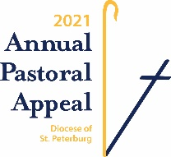
Gifts to the Annual Pastoral Appeal
help us courageously live the Gospel.

Visit www.dosp.org/giveapa
to make your gift today!

Your gift to the Annual Pastoral Appeal
generously and courageously
helps us live the Gospel.
Learn more at www.dosp.org.

