In-pew Solicitation for Commitment Weekend
In-pew solicitation is the method of requesting a response from parishioners while at Mass following an informational and motivating clergy or lay witness presentation. A strong in-pew solicitation following an increase in Annual Pastoral Appeal (APA) education and awareness messages is recommended for obtaining commitments from a large portion of your active parishioners at one time and increasing the total dollars contributed. It is also the best way to gain new donors to the appeal.

How to Make Your In-pew Solicitation Successful

- Give at least two weeks advanced notice before parishioners are asked for their gifts. Posters should be displayed in appropriate visible locations. Utilize special bulletin inserts and announcements, web posts and pulpit announcements, as well as Prayers of the Faithful petitions to inform people of the upcoming appeal and its benefits to the parish and those in need.

- People give to people so recruit a lay witness to increase participation. Select a parishioner who has been affected by or who is participating in a diocesan ministry, program or service funded by the appeal. They should be active, energetic and enthusiastic speakers.

- One week prior to Commitment Weekend, remind and encourage parishioners to read the APA letter and brochure that was mailed to them, and to visit www.dosp.org/giveapa to view ministry videos and learn more.

- On Commitment Weekend, place in-pew pledge envelopes and pens/pencils in/at the end of the pews. To assist with this, recruit volunteers from hospitality/ushers to assist in placing materials prior to the first Mass and have volunteers available after every Mass to replenish the supply and straighten up.

- After the celebrant gives a brief homily, the celebrant or a lay witness shares a brief positive experience regarding a ministry, program or service funded by APA and how it has affected them.
The celebrant or the lay witness then gives step-by-step instructions on how to fill out the in-pew pledge envelope, encouraging the pledge option which allows them to make payments over time. Be sure they indicate a suggested amount (for example, offer a parish average gift amount) as part of the instruction. Urge the parishioners to complete the envelopes at that moment and provide an explanation on the ways to give (pledge, pledge with payment, one-time gifts).

- Allow 2-3 minutes for the parishioners to complete their in-pew pledge envelope. Those making a payment should enclose it and seal the envelope.

- The ushers or special collectors should now collect the gifts or parishioners should bring them to the altar.

- Follow-up is a necessary and vital element of success to the appeal. Therefore, prepare a bulletin and pulpit announcement citing the number who participated, along with an invitation for those who have not yet participated to do so.

- Make sure all envelopes are stamped with your parish name and send them to the Campaign Processing Office immediately.

Breaking Down the In-Pew Envelope
1
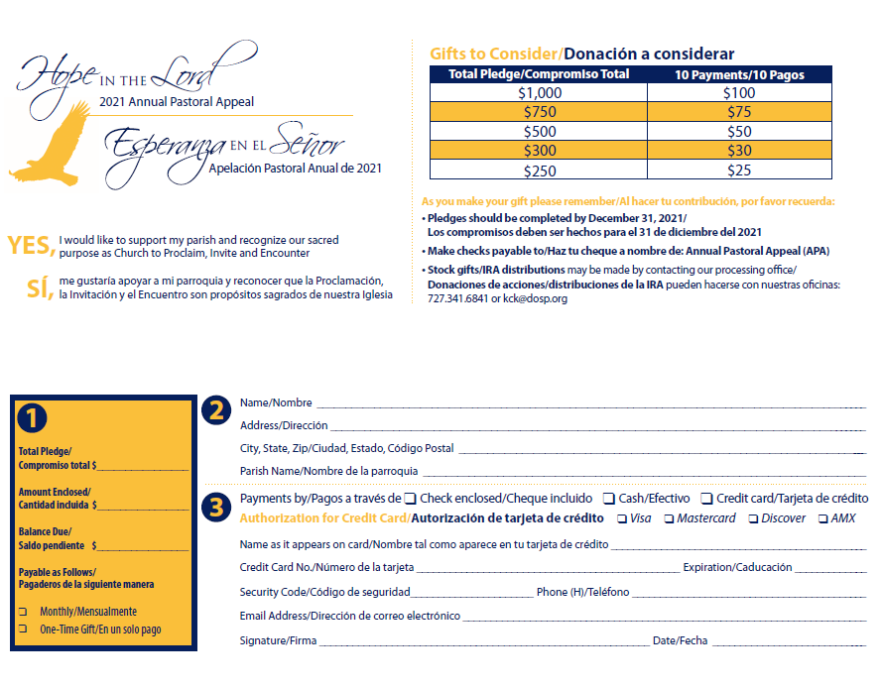

3
4
2

5

9
8
6
7

10

1. APA theme
2. Donor’s commitment to giving
3. Sample giving plans for donors to show how a pledge breaks down monthly
4. Important facts to remember:
- Pledges to be completed by December 31, 2021
- Make checks payable to
- Stock gifts info
5. Name and mailing address of donor
6. Amount recorded as pledge
7. Total dollar amount of payments included
8. Balance due (amount to be paid)
9. Payment schedules available to the donor (how many payments to complete the pledge)
10. E-giving via credit card

Questions? Contact the Office of Stewardship and Development at 727-344-1611.

In-Pew Commitment Weekend Pulpit Presentation Outline/Sample Presentation
This instruction is most successful when delivered by the pastor either before Mass or after the homily.

- Transition:
Here at (your parish name) and throughout our diocese we have much to be grateful for. We have truly been blessed as a faith family. This past year our parishioners, our parish and our diocese have experienced challenges, and in some cases hardship. Even through difficult times, though, we are a people of God who place our hope in the Lord. We are starting to see a light at the end of this tunnel, and hopefully, feeling renewed with a sacred purpose of proclaiming the gospel and inviting those we encounter to join us.

- Introduction of APA:
I want to introduce the 2021 Annual Pastoral Appeal (APA): Hope in the Lord. This is our diocesan annual appeal that invites every parishioner to participate in supporting the ministries, programs and services of our local Church, which serve us in our parish and many in need outside of our parish boundaries.

As your pastor, I want to let you know that I support this appeal and the hope it provides for both our parish and for those whom are brought closer to Christ. (You may mention here the ministries, programs and services that your assessment dollars fund and that this fundraiser known as APA helps pay that assessment.)

You should have received a packet in the mail at home which includes a message from Bishop Parkes, as well as a brochure that provides information on how your donations support diocesan ministries, programs and services. More information can be found online at www.dosp.org.

- Ask:
This appeal provides the means to continue the mission that Christ has entrusted to us: to serve, to educate, to care for the poor, and to be a beacon of hope for all. We are all invited to make a gift, a courageous gift, that demonstrates how as disciples we are living the gospel and sharing it with those we encounter. Now more than ever, it is vital for us to do what we can, when we can. To act as a people who put their faith in God and do good works in his name. I am asking you to make a commitment to the appeal today.

- Promote a sacrificial pledge:
This appeal is based on equal sacrifice, not equal giving. I cannot know how this past year has affected every family, and therefore, I cannot ask everyone to consider the same size gift. What I can do is ask is for all to pray and make a gift that is right for them. I know from personal experience that it is easier to make a gift of sacrifice if you can spread it out, rather than make a full, one-time gift. Can you consider a gift of $25, $40 or $50 each month for the rest of this year? That amount will equal a pledge of $250, $400 or $500 by the end of the year.

As you think about what you will give, remember, this gift is in addition to your offertory giving not in place of. Also, please know I know that everyone will do their very best to fulfill their pledges, and that is all we ask - that you do your best.

If last year taught us anything, we should know by now that unexpected things happen, and you may need to change your pledge. That’s ok. If a change is needed, it can be made. And if that change is an increase, well, that is ok, too.

- Ask for those who have never given to give/Show impact:
For those who have never given, it is vital to understand their participation matters. It is easy, when surrounded by so many people, to think that no one will notice if you don’t participate. But each gift makes a difference, and it is noticed. It is noticed by the:
- 9,000+ homeless served by Catholic Charities at Pinellas Hope
- the 150 youth who participate in the Good Samaritan Project
- the 140 involved in Campus Ministry programs each year
- the 15 men in formation to become priests at St. Vincent de Paul Regional Seminary

- Explain the pledge envelope/Give them time to make a commitment:
At this point, I ask everyone to make their commitment over the next few minutes.

For those of you who have already made a gift or pledge by sending in your pledge card that you received at home, I thank you for your generosity and your patience as we take a little time now to encourage others to participate.

If you did not bring your pledge card from home, please complete a pledge envelope found in your pew. Please fill in all the information on the pledge envelope clearly. The pledge envelope has a section marked “Gifts to Consider” which breaks down what 10 equal monthly payments would be, and what the total pledge will come to if all payments are completed. For example, 10 monthly payments of $30 equal a total pledge of $300.

Once you decide on the amount you want to give, fill out the giving information on the bottom left of the envelope – the area marked “Total Pledge/Amount Enclosed/Balance Due.” Also indicate if you want to make payments monthly or annually, or as one-time gift to complete your “Balance Due.”

A down payment on your pledge is not necessary or required. If you are able to make one, please do. If you can’t make a down payment, don’t let that stop you from making your pledge.

I am going to pause to give those who haven’t yet completed their commitment time to fill out their pledge forms, while I do the same. (PAUSE AND FILL OUT A PLEDGE ENVELOPE, EVEN IF YOU HAVE ALREADY DONE SO. THIS WILL ENCOURAGE YOUR PARISHIONERS TO DO THE SAME.)

- Collect commitments:
At this time, I ask the Hospitality Ministers/Ushers to pick up all pledge envelopes, including those pledge cards received at home that have been brought in today (or have parishioners bring them to the altar). Thank you once again for listening with an open heart. All gifts are an act of courage and in a few weeks when the active phase of the APA concludes, I know we will have done our part as a parish family to live the Gospel through the Annual Pastoral Appeal.

In-Pew Solicitation for Multicultural Parishes
For many cultures, sacrificial giving may not be the custom, and support for Church by a way of pledging may not be a common or known practice. Below are some suggestions for adapting in-pew solicitation for multicultural parishes. As you present other options, please remember that it is important to stress the message of equal sacrifice, not equal gift.

Pledge with Weekly Payments
Ask parishioners to consider a total amount to pledge, direct them to write that amount on the bilingual envelope provided, or perhaps, to choose one of the suggested amounts already listed on the envelope. Explain to the community that the amount they may choose to give can be paid over a number of specific weeks utilizing a particular envelope provided by the parish (in-pew). During your announcement, indicate the specific dates that will be assigned for the collection of the envelopes. During those weeks, envelopes will be collected at Mass during a special collection and submitted to the Campaign Processing Office as soon as possible.

EXAMPLE: Your parish implements this idea and will conduct the effort over a period of 5 weeks.
- Option one: Parish could use different colored envelopes for each week. The envelopes should have a place for the participant to write their name, address and the amount included.
- Option two: The parish could use envelopes that are marked with a series of numbers and that represent collection weeks. The parish will have available (in-pew) the numbered envelope that corresponds for each collection. The envelopes should have a place for the participant to write their name, address and the amount included.
Parish Community Gift
The entire community (Spanish, Vietnamese, or others), could offer a specific amount as their APA pledge to the parish. Over a period-of-time throughout the year, the community will fundraise, collect, donate funds, and submit as many payments as necessary toward the amount pledged. Parishioners can also individually consider a total amount to be pledged over a period-of-time. Please note, if a parishioner chooses this option, they will need to complete their own pledge card on behalf of the parish community.

