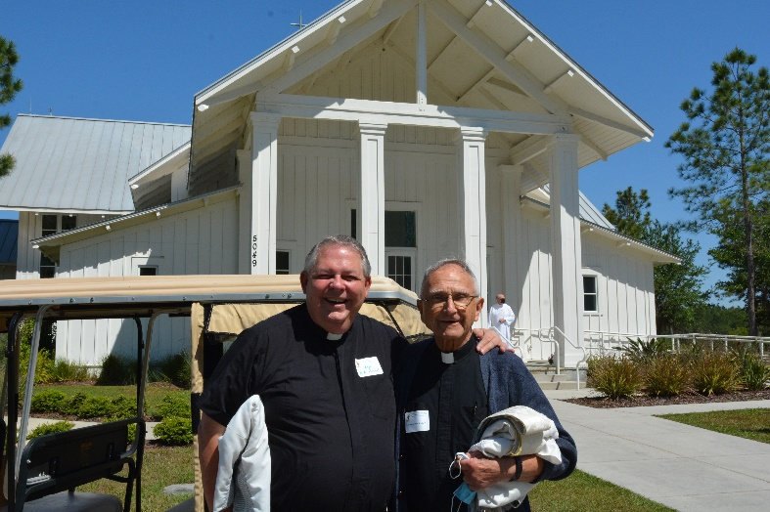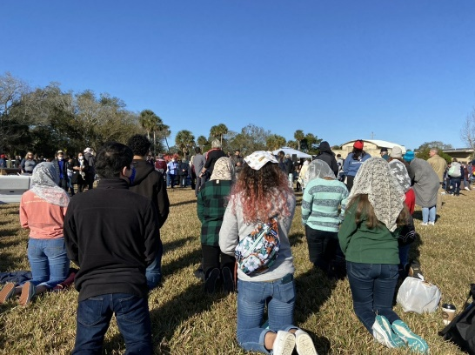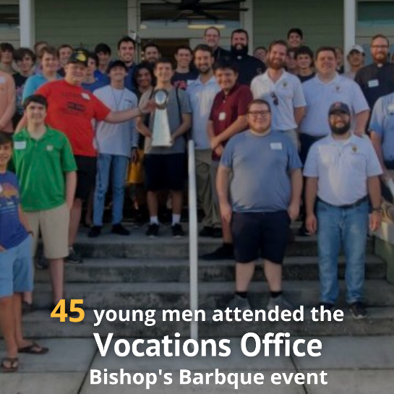

“At a time when I feel overwhelmed you make the path appear smooth and manageable.

**I appreciate your walking with me**.”

* Laura, St. Paul Parish, Tampa

*Almighty, ever-living God, by our baptism, we have been called to live as missionary disciples of your Son, Jesus Christ.*

*Grant that we, your people of the Diocese of St. Petersburg, will fulfill our purpose by proclaiming the Good News and inviting all people to encounter the love and mercy of Jesus Christ.*

*Deepen our trust in you, O Lord, and help us to remain steadfast in our commitment to Courageously Living the Gospel in our homes, neighborhoods, parish communities, and wherever you may lead us.*

*Together, with the intercession of our Blessed Mother and all the saints who have gone before us, we humbly ask for the courage to live as your disciples standing firm in our Catholic faith, through your Son, our Lord Jesus Christ.*

*Amen.*

**To make a gift to APA, please visit www.dosp.org**

*Please keep our parish and our diocese in your prayers.*

**Thank you** to our faithful parishioners who have already participated in the Annual Pastoral Appeal this year. In addition to helping thousands in need across our diocese, your gift is an enormous help to our parish in strengthening our own ministry and maintaining a vibrant faith community.

If you have not yet made a gift, it is not too late.

We haven’t reached our goal and we need your

help. Your assistance today will support many

ministries, programs and services that help our

parish and all parishes within our five-county

diocese. Your gift allows us to be **teachers of**

**the Word** in Catholic schools and faith formation

programs, **advocates for those who have no**

**voice** and **servants of hope** for those in need physically and spiritually. Most of all, we are able to **share the Gospel message in faithful action** with those we welcome and accompany into a closer relationship with Jesus Christ.

As Christian stewards, we receive God’s gifts gratefully, cultivate them responsibly, share them lovingly in justice with others and return them with increase to the Lord. For information about the Annual Pastoral Appeal and the ministries it supports, please visit **www.dosp.org/2021ministryupdate.**