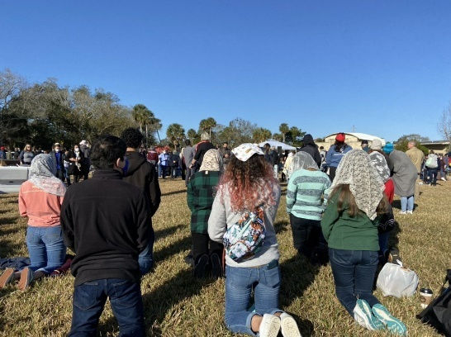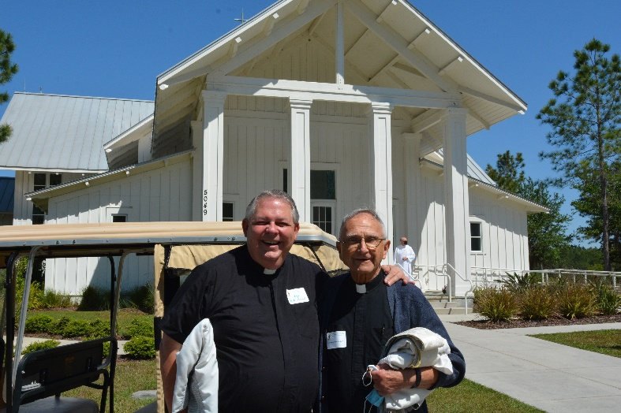

“At a time when I feel overwhelmed you make the path appear smooth and manageable.

**I appreciate your walking with me**.”

* Laura, St. Paul Parish, Tampa

*Please note:*

*- All donors with a balance due will be sent monthly reminder statements through Dec. 2021*

*- Make checks payable to Annual Pastoral Appeal*

*- Questions? Call 727-341-6825*

**2021 Annual Pastoral Appeal Gift Form**

**Name:**

**Address:**

**City, State, Zip:**

**Parish Name:**

**Parish City:**

**Gift Amount:**

❑ $500.00

❑ $300.00

❑ $250.00

❑ $100.00

❑ Other:**$**

**Amount enclosed:**

**$**

**Balance due:**

**$**

**Thank you** to our faithful parishioners who have already participated in the Annual Pastoral Appeal this year. In addition to helping thousands in need across our diocese, your gift is an enormous help to our parish in strengthening our own ministry and maintaining a vibrant faith community.

If you have not yet made a gift, it is not too late.

We haven’t reached our goal and we need your

help. Your assistance today will support many

ministries, programs and services that help our

parish, and all parishes within our five-county

diocese. Your gift allows us to be **teachers of**

**the Word** in Catholic schools and faith formation

programs, **advocates for those who have no**

**voice** and **servants of hope** for those in need physically and spiritually. Most of all, we are able to **share the Gospel message in faithful action** with those we welcome and accompany into a closer relationship with Jesus Christ.

For information about the Annual Pastoral Appeal and the ministries it supports, please visit [**www.dosp.org/2021ministryupdate**](http://www.dosp.org/2021ministryupdate)**.**

Please consider your gift, complete the form below and return it in the collection basket or to the parish office, and please remember, *no gift is too small and all are greatly appreciated.*

**To make a gift online, please visit www.dosp.org/giveapa**