Social Media – Additional Options tied to Gospel
2022 Catholic Ministry Appeal Fall Participation Focus

August 27-28, 2022

Gospel - Lk 14:1, 7-14:
On a sabbath Jesus went to dine at the home of one of the leading Pharisees, and the people there were observing him carefully.

He told a parable to those who had been invited, noticing how they were choosing the places of honor at the table.
"When you are invited by someone to a wedding banquet, do not recline at table in the place of honor.
A more distinguished guest than you may have been invited by him, and the host who invited both of you may approach you and say, 'Give your place to this man,' and then you would proceed with embarrassment to take the lowest place.
Rather, when you are invited, go and take the lowest place so that when the host comes to you he may say,
'My friend, move up to a higher position.'

Then you will enjoy the esteem of your companions at the table. For every one who exalts himself will be humbled,
but the one who humbles himself will be exalted."

Then he said to the host who invited him, "When you hold a lunch or a dinner, do not invite your friends or your brothers or your relatives or your wealthy neighbors, in case they may invite you back and you have repayment.
Rather, when you hold a banquet, invite the poor, the crippled, the lame, the blind; blessed indeed will you be because of their inability to repay you. For you will be repaid at the resurrection of the righteous."

Theme:
When you hold a banquet, invite the poor, the crippled, the lame, the blind; blessed indeed will you be because of their inability to repay you. For you will be repaid at the resurrection of the righteous

Al contrario, cuando des un banquete, invita a los pobres, a los lisiados, a los cojos y a los ciegos; y así serás dichoso, porque ellos no tienen con qué pagarte; pero ya se te pagará, cuando resuciten los justos

Photo / Foto: (download from the resource page dosp.org/catholicministryappeal/parishresources/)

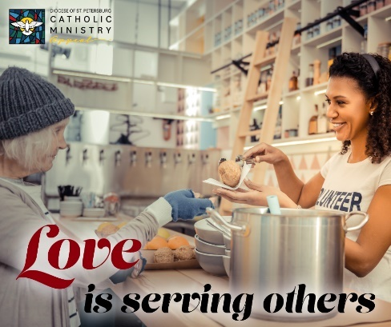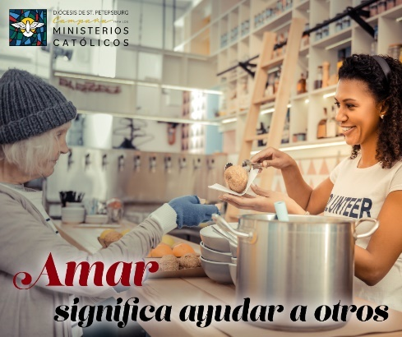

Copy / Texto:
True love responds to the earthly and everyday needs of our community. You can show your love for your parish community by supporting our Catholic Ministry Appeal.

El amor verdadero responde a las necesidades terrenales y cotidianas de nuestra comunidad. Puedes mostrar tu amor por tu comunidad parroquial apoyando nuestra Campaña para los Ministerios Católicos.

September 3-4, 2022

Gospel - Lk 14:25-33:
Great crowds were traveling with Jesus, and he turned and addressed them, “If anyone comes to me without hating his father and mother, wife and children, brothers and sisters, and even his own life, he cannot be my disciple.
Whoever does not carry his own cross and come after me cannot be my disciple.

Which of you wishing to construct a tower does not first sit down and calculate the cost to see if there is enough for its completion? Otherwise, after laying the foundation and finding himself unable to finish the work the onlookers should laugh at him and say, ‘This one began to build but did not have the resources to finish.’
Or what king marching into battle would not first sit down and decide whether with ten thousand troops he can successfully oppose another king advancing upon him with twenty thousand troops? But if not, while he is still far away, he will send a delegation to ask for peace terms.
In the same way, anyone of you who does not renounce all his possessions cannot be my disciple.”

Theme:
…anyone of you who does not renounce all his possessions cannot be my disciple.

…cualquiera de ustedes que no renuncie a todos sus bienes, no puede ser mi discípulo.

Photo / Foto: (download from the resource page dosp.org/catholicministryappeal/parishresources/)

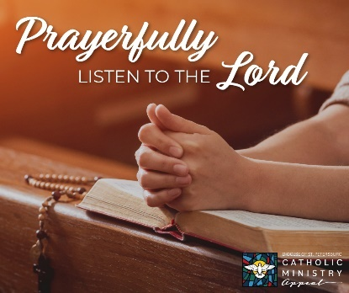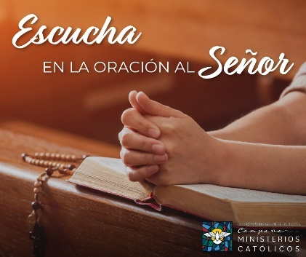
Copy / Texto:
Jesus gives us signs at certain times when we need a moment to pause and rethink our priorities. One way he’s doing so in our parish community is through the invitation to contribute to the Catholic Ministry Appeal. The need is real. How will you respond?

Jesús nos da señales en aquellos momentos en que necesitamos un momento para detenernos y reorganizar nuestras prioridades. Una forma en que lo hace en nuestra comunidad parroquial es mediante la invitación a donar a la Campaña para los Ministerios Católicos. La necesidad es real. ¿Cómo vas a responder?

September 10-11, 2022

Gospel - Lk 15:1-10:
Tax collectors and sinners were all drawing near to listen to Jesus, but the Pharisees and scribes began to complain, saying, “This man welcomes sinners and eats with them.”
So to them he addressed this parable. “What man among you having a hundred sheep and losing one of them would not leave the ninety-nine in the desert and go after the lost one until he finds it?
And when he does find it, he sets it on his shoulders with great joy and, upon his arrival home, he calls together his friends and neighbors and says to them, ‘Rejoice with me because I have found my lost sheep.’ I tell you, in just the same way there will be more joy in heaven over one sinner who repents than over ninety-nine righteous people who have no need of repentance.
“Or what woman having ten coins and losing one would not light a lamp and sweep the house, searching carefully until she finds it? And when she does find it, she calls together her friends and neighbors and says to them, ‘Rejoice with me because I have found the coin that I lost.’ In just the same way, I tell you, there will be rejoicing among the angels of God over one sinner who repents.”

Theme:
In just the same way, I tell you, there will be rejoicing among the angels of God over one sinner who repents.

Yo les aseguro que así también se alegran los ángeles de Dios por un solo pecador que se arrepiente.

Photo / Foto: (download from the resource page dosp.org/catholicministryappeal/parishresources/)

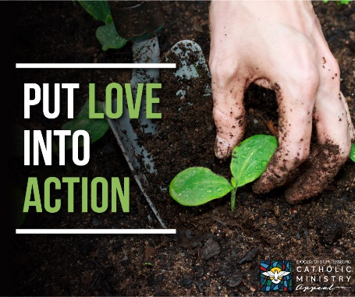 OR 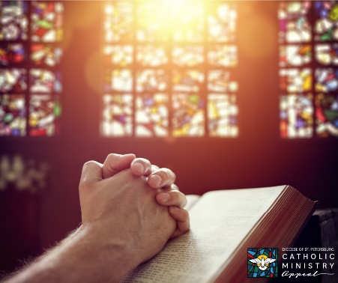

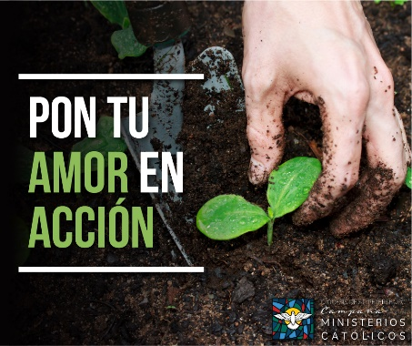 OR 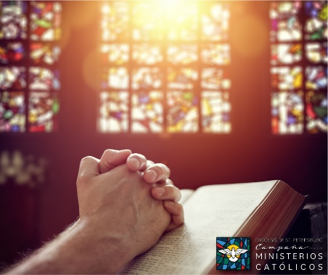

Copy / Texto:
May the Holy Spirit continue to guide the work of the Church throughout our diocese and through prayer, action and sacrifice may we bring Christ’s message of love and mercy to all.

Que el Espíritu Santo continúe guiando el trabajo de la Iglesia en toda nuestra diócesis, y que a través de la oración, acción y sacrificio podamos llevar a todos el mensaje de Cristo de amor y misericordia.

September 17-18, 2022

Gospel - Lk 16:10-13
Jesus said to his disciples:
"The person who is trustworthy in very small matters is also trustworthy in great ones;
and the person who is dishonest in very small matters is also dishonest in great ones.
If, therefore, you are not trustworthy with dishonest wealth, who will trust you with true wealth?
If you are not trustworthy with what belongs to another, who will give you what is yours?
No servant can serve two masters.
He will either hate one and love the other, or be devoted to one and despise the other.
You cannot serve both God and mammon."

Theme:
You cannot serve both God and mammon.

En resumen, no pueden ustedes servir a Dios y al dinero.

Photo / Foto: (download from the resource page dosp.org/catholicministryappeal/parishresources/)

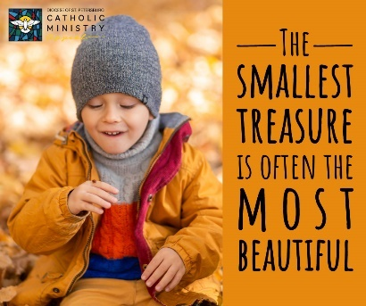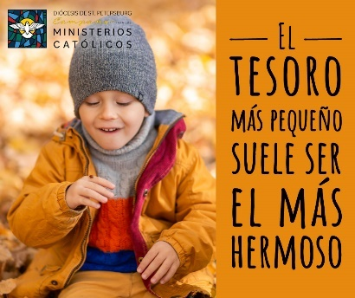
Text:
The smallest treasure is often the most beautiful

Leyenda:
El tesoro más pequeño suele ser el más hermoso

Copy / Texto:

When God is alive in our hearts the simplest of things are often our most precious gifts. Your gift to our annual appeal is making an impact on our parish and we are so grateful.

Cuando Dios está vivo en nuestros corazones, las cosas más pequeñas son a menudo los regalos más preciosos. Tu donación a nuestra campaña anual está creando un impacto en nuestra parroquia y estamos muy agradecidos.

