SOCIAL MEDIA GUIDE
2023 Catholic Ministry Appeal
Facebook, Instagram, and Twitter are great tools to communicate with your parishioners and spread the word. It is our hope this social media guide and sample plan serves you well as we continue ministering and serving our community through the Catholic Ministry Appeal.

Below you can find designing tips, dimensions, and a sample week of postings to get you started.
Designing Tips
- Canva is a great tool to design and craft your message. It is free and provides easy design templates. Please create an account to get started.
- Plug and post! Create a template in Canva, Adobe Spark or Photoshop! Stylize your template to be branded to the Catholic Ministry Appeal with room for a large photo and catchy text.
- Remember to…
  - Brand each graphic with the Catholic Ministry Appeal logo.

  - People like seeing other people. Pick a strong photo of real people – candid or portrait. Limit the text on the photo. The stronger the photo, the less explaining you will need – save it for the body of the post.

  - Engage! Provide a call to action – ask your audience for feedback, take a poll, follow a link, join in prayer, highlight a Parish Champion, etc.

  - Keep it Simple! Limit the amount of text on the post (typically 80 words or less). Provide the main information in the body text of the post.

  - Be positive and uplifting!

  - Use Hashtags but don’t overdo it. Pick one or two relevant to your particular parish and make sure to use #CatholicMinistryAppeal so we can highlight your extraordinary efforts!
- Visit the Catholic Ministry Appeal resource page to download and create your own social media posts!
- Free stock photo resources are available here.

Dimensions
- Facebook – 940 x 788 px / 1080 x 1080 px / 1920 x 1920 px
- Instagram – 1080 x 1080 px / 1920 x 1920 px
- Twitter – 1024 x 512 px
4-Week Social Media Sample
Below are samples of social media posts that cover four weeks of the active phase which include: Kickoff Weekend (1/14-15/23), Education Weekend (1/21-29/23), In-Pew/Commitment Weekend
(2/4-12/23) and Follow-Up Weekend (2/18-26/23). To keep a catalog of all posts for the Catholic Ministry Appeal, please use the hashtag #CatholicMinistryAppeal.
The graphics and photos can be downloaded on our resource page. If your parish needs assistance adapting/personalizing graphics, please contact Michelle Mesiano at mnm@dosp.org.
We recommend having one person in charge of posting, and that they also be dedicated to responding to any comments IMMEDIATELY.

Kickoff Weekend (1/14-15/23)
Purpose/  General Guidance | Graphic Description/ Posting Examples | Copy
Drive viewers to the main video and learn more | 2023 CMA Teaser.mp4 | Giving to the Catholic Ministry Appeal means… Youth & Young Adult Ministry, Ministry to Catholic Schools, Catholic Charities and Ministry to Priests are supported, and the more gifts we receive the more our ministries can grow.  Visit www.dosp.org/catholicministryappeal to learn more!  #CatholicMinistryAppeal #CourageouslyLiving
Education Weekend #1 (1/21-22/23)
Pastor Letter of Support drops 1/16/23
Purpose/  General Guidance | Graphic Description/ Posting Examples | Copy
Explain the Catholic Ministry Appeal and communicate expectation / impact | 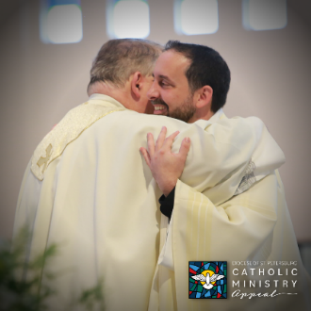  Accompanying (1)  - or -  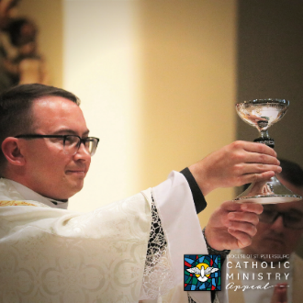  Accompanying (2) | Accompanying our missionary disciples through the Catholic Ministry Appeal means supporting our priests, deacons and lay leaders in their pastoral journey so they can continue offering our people the formation and foundation needed to bring God’s message, mission, and ministry to our faith communities and world.  Visit www.dosp.org/catholicministryappeal to learn more!  #CatholicMinistryAppeal
Education Weekend #2 (1/28-29/23)
Catholic Schools week 1/30/23 – 2/3/2023
Purpose/  General Guidance | Graphic Description/ Posting Examples | Copy
Share how the appeal supports Catholic education | 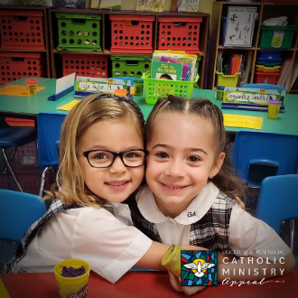  Encountering (4)  Encountering (3) | OPTION 1:  “You want your child in an environment where there's joy, faith, forgiveness, and kindness, and where those things are a part of everyday life. That’s what is expected. You can't get that anywhere else.” – Chris Pastura, Superintendent of Catholic Schools  Encountering God and Nurturing our Spiritual Life through the Catholic Ministry Appeal means encountering the face of God by sharing the faith and reaching out to others. The Ministry to Catholic Schools offer all who seek God an opportunity to encounter Him and enrich our spiritual lives, fostering our response to God’s call to serve.  Visit www.dosp.org/catholicministryappeal to learn more!  #CatholicMinistryAppeal
OPTION 2:
“You can get a good education in a lot of different places. You're not going to get an education where the Gospel of Jesus Christ is lived, taught and breathed every day. It’s a beautiful place.” – Chris Pastura, Superintendent of Catholic Schools

Encountering God and Nurturing our Spiritual Life through the Catholic Ministry Appeal means encountering the face of God by sharing the faith and reaching out to others. The Ministry to Catholic Schools offer all who seek God an opportunity to encounter Him and enrich our spiritual lives, fostering our response to God’s call to serve.

Visit www.dosp.org/catholicministryappeal to learn more.

#CatholicMinistryAppeal
In-Pew/Commitment Weekend #1 (2/4-5/23)
Purpose/  General Guidance | Graphic Description/ Posting Examples | Copy
 | 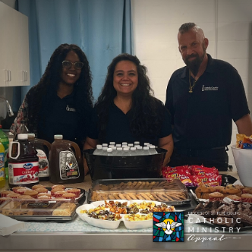  Embracing (2)  - or -  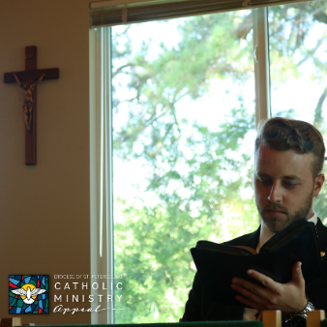  Embracing (1) | Embracing God’s Call to Serve through the Catholic Ministry Appeal means hearing His call and actively carrying out His mission and ministry with love, gratitude and concern for others.  Ministries like < Seminarian Education & Support, & Promotion of Vocations/Catholic Charities> encourage all to act, expressing God’s saving love within us as we help give shape to the world.  Visit givetoministry.dosp.org to show your support!  #CatholicMinistryAppeal
In-Pew/Commitment Weekend #2 (2/11-12/23)
Purpose/  General Guidance | Graphic Description/ Posting Examples | Copy
 | 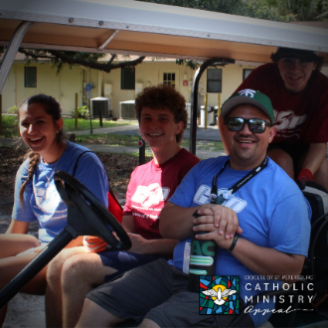  Encountering (2) | “What I greatly appreciate about the Good Samaritan Project (GSP) in general is that it’s not just about getting service hours. It’s about encountering Christ in each other,” Fr. Xavy, Chaplain at Tampa Catholic High School.  Encountering God and Nurturing our Spiritual Life through the Catholic Ministry Appeal means encountering the face of God by sharing the faith and reaching out to others.  Make your commitment today by visiting givetoministry.dosp.org.  #CatholicMinistryAppeal
Follow-up Weekend #1 (2/18-19/23)
Purpose/  General Guidance | Graphic Description/ Posting Examples | Copy
 | 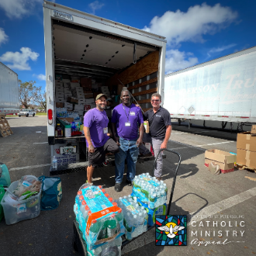  Embracing (3) | Acts of love, charity and service can be done with your support of the Catholic Ministry Appeal.  Are you ready to make your commitment? Visit givetoministry.dosp.org to get started.  #CatholicMinistryAppeal
Follow-up Weekend #2 (2/25-26/23)
Purpose/  General Guidance | Graphic Description/ Posting Examples | Copy
 | 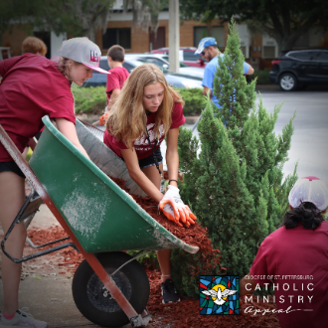  Encountering (1) | The Catholic Ministry Appeal paves the way for us to bring ministry to life. Together, we can courageously live the Gospel by loving God, loving others and making disciples.  Visit givetoministry.dosp.org to make your commitment.  #CatholicMinistryAppeal #CourageouslyLiving

