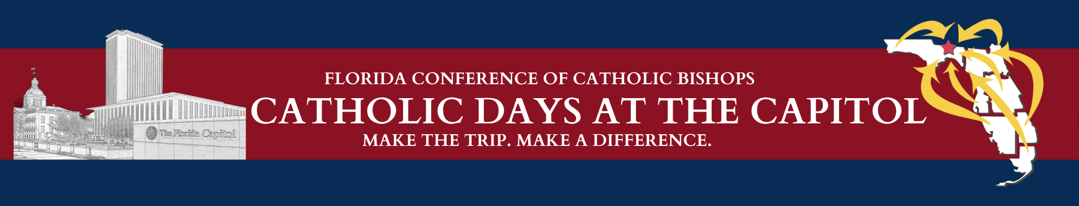

PARTICIPANT SCHEDULE OF EVENTS
TENTATIVE

TUESDAY, February 6, 2024
Donald L. Tucker Civic Center - 505 West Pensacola Street

2:30 p.m. Arrival; Name Tag Pick-up – Hors d’oeuvre Reception

3:00 p.m. Call to Order – Michael B. Sheedy, FCCB, Executive Director

3:05 p.m. Welcome & Opening Prayer

3:10 p.m. Overview & Presentation of Legislative Priorities

4:10 p.m. Closing Prayer

4:15 - 5:30 p.m. Diocesan Planning Sessions

WEDNESDAY, February 7, 2024
Donald L. Tucker Civic Center - 505 West Pensacola Street

7:30 - 7:50 a.m. Photos of Diocesan Delegations with Bishops

8:00 a.m. Legislative Breakfast Buffet
- Welcome & Blessing

8:05 a.m. Award Presentations

8:35 a.m. Remarks – Archbishop Thomas G. Wenski, Archdiocese of Miami

8:55 a.m. Closing Prayer & Sending Forth

The Capitol Complex - 400 South Monroe Street

9:15 a.m. - 5:00 p.m. Scheduled Visits with Legislators

9:30 a.m. - 4:00 p.m. Catholic Days Display Table – Plaza Level

11:00 a.m. – 1:30 p.m. Box Lunch Available - 22nd Floor of Capitol

11:00 a.m. and 3:00 p.m. Tour of Historic Capitol Museum

Co-Cathedral of St. Thomas More - 900 West Tennessee Street

6:30 p.m. 49th ANNUAL VOTIVE MASS OF THE HOLY SPIRIT – “RED MASS”
Reception following Mass – Church parking lot and parish hall

