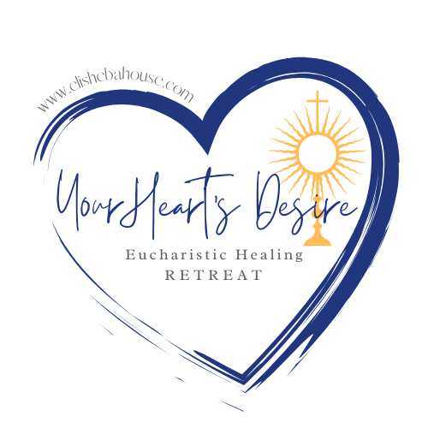

Looking for a Retreat Opportunity?...

Elisheba House will be offering a Eucharistic Healing Retreat for adults in Trinity on June 7-8. There will be Mass, Inspirational Talks, along with an opportunity for Reconciliation, Reflection, and overnight Eucharistic Adoration. Cost is $55 (not including room). To register visit www.elishebahouse.com.

For further information, email info@elishebahouse.com.



**Thank you for helping to promote this wonderful event!**

**Highlight the sentence and image and cut and paste it into an email to the person responsible for creating the bulletin. Bulletin deadlines are usually 2-3 weeks prior to printing.**

**Please request to run Bulletin and Pulpit Announcements on:**

**#1 – 5/5**

**#2 – 5/12**

**#3 – 5/19**

**Also included is a retreat flyer for you print and hang up with your pastor's permission.**

Discover healing presence of the Eucharist...

Join Elisheba House for a Eucharistic Healing Retreat June 7-8 in Trinity.   People throughout the diocese will come together for Mass, Inspirational Talks, Reconciliation, Reflection, and overnight Eucharistic Adoration. Cost is $55 (not including room). To register visit www.elishebahouse.com.  For further information, email info@elishebahouse.com.



#3

Refresh and Renew This Summer...

Don't miss Elisheba House's Eucharistic Healing Retreat June 7-8 in Trinity.   Enjoy Mass, Inspirational Talks, opportunities for Reconciliation, Reflection, and overnight Eucharistic Adoration. Cost is $55 (not including room). To register visit www.elishebahouse.com.  For further information, email info@elishebahouse.com.



**Pulpit Announcement**

**#1 - There will be a Eucharistic Healing Retreat for aduts on June 7-8 in Trinity. Check the bulletin for details and registration information.**

**#2 - Register today for a Eucharistic Healing Retreat for adults on June 7-8, check the bulletin for details.**

**#3 - Limited spots are still available for the Eucharistic Healing retreat on June 7-8. Check the bulletin for more info and to register.**

#2

#1