Gift Remittance Process (Updated as of 1/15/2026 w/ revised FedEx Mailing Instructions)
The mailing to previous donors and non-appeal donors will take place December 30th, and the pastor support mailing to all households will drop on March 6th. Therefore, you may receive 2026 Catholic Ministry Appeal gifts and commitments in the collection basket as early as January 2026.

The following procedures have been established to expedite the remittance of gifts and commitments, and to ensure donors are acknowledged accurately and quickly.

LOCK BOX DEPOSIT – MAILING ADDRESS NOTIFICATION

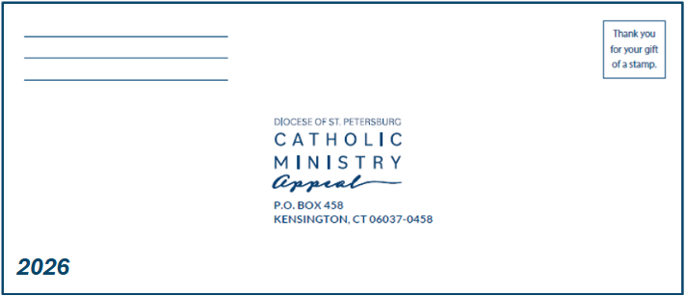
Please be aware: to securely process commitments, we partner with Cathedral Letter Concepts, a lock box service. The return address for this service is: P.O. Box 458, Kensington, CT 06037-0458. To the right is a sample of the return envelopes for all mailed, preprinted pledge cards & in-pew envelopes.

IN-PEW PLEDGE ENVELOPES

- For security and accuracy purposes, please do not open any Catholic Ministry Appeal envelopes. This year, we are taking donor credit card and bank account information, which must be securely opened by Letter Concepts.
- Pastoral Center Staff will personally deliver to you 5 FedEx Envelopes with postage covered by the diocese for these first 5 envelopes.
  - After the in-pew, please match & affix labels to the sealed envelopes received. If no labels match, please try to find the parishioner’s diocesan ID (DUID) in your database. Write the DUID clearly on the front of the envelope. If you’re a Ministry Platform parish and have parishioners without a DUID, please provide the MP Family ID and please prefix the ID with the letters MP.
    - This will greatly assist with processing time and increase accuracy. However, Letter Concepts is still able to identify the parishioners without the DUID.
- Next, stuff the in-pew envelopes into the FedEx Envelopes and send to Letter Concepts.
  - At later points of the appeal when you run out of FedEx envelopes, please send these in your own envelope via Priority Mail (ideally tracked) to Letter Concepts, our diocesan gift processing partners.
- Please submit all gifts to Letter Concepts as they are received. Do not hold or collect gifts or commitments.
- If the donor has not sealed the envelope, please seal and submit it to Letter Concepts.
- To ensure prompt and accurate posting, please make sure all envelopes have your parish name and city on them, and any applicable Diocesan ID (DUID), MP Family ID (if no DUID prefixed with MP), or labels.
- Catholic Ministry Appeal gifts and commitments should be collected, packaged securely and sent to:

For UPS/USPS Priority Mail (Ideally Tracked)  Cathedral Letter Concepts  P.O. Box 458  Kensington, CT 06037-0458 | For FedEx ONLY  Cathedral Letter Concepts  Attn: Processing Department  33 Massirio Drive  Berlin, CT 06037

GIFTS OF CASH in ANY SEALED ENVELOPE

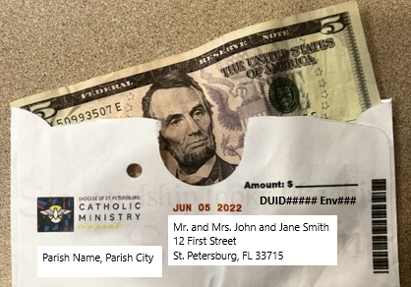
- Letter Concepts Can SECURELY PROCESS CASH. DO NOT OPEN SEALED CASH ENVELOES.
- Send all Envelopes with Cash (including parish appeal envelopes) to Letter Concepts. Send the original envelopes via Priority Mail (ideally tracked) or in the provided FedEx Envelopes. Ensure that the DUID, parish, first name, last name, and address are listed on the envelope.
- Please use the sample above for reference.

PARISH CHECKS WITH LISTS (For Parish Online Giving Page Appeal Gifts, Open Loose Cash, or Other Gift)

- When donations are deposited at the parish through your parish’s online giving page/via Loose Cash Not in an Envelope and one parish check is cut, please submit a list with the proper information. To process this, we must have addresses, correct name spellings, and more. A correct parish list should include: DUID, first name, last name, address, parish envelope number, payment amount, pertinent payment type, frequency, and source. The total amount of the unidentified, loose donor cash gifts should be added to the report with notation of “anonymous cash gifts.”
- Accepted File Formats include:
.csv -or- .xlsx
- Please use this sample for reference:
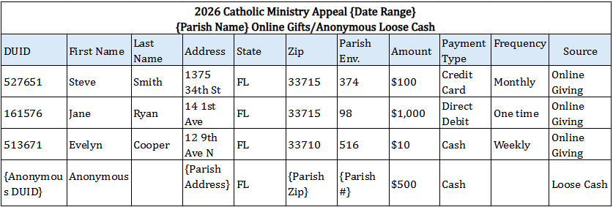

- List the source of gifts on this list as one of these categories; 1) Online Giving, 2), In-Pew, 3) Mailed Pledge Card, 4) Loose Cash.
- Please DO NOT HOLD GIFTS at your parish. Please send monthly at the very least.
- For Appeal Gifts from Parish Online Giving Pages or Open, Anonymous Loose Cash Not in An Envelope send to the Campaign Processing Office at the Pastoral Center:

United States Postal Service (USPS) – First-Class Preferred
Diocese of Saint Petersburg
Attn: Gift Acceptance Team
P.O. Box 40200
St. Petersburg, FL 33743-0200

SMALL, OFFERTORY PACKET APPEAL ENVELOPES

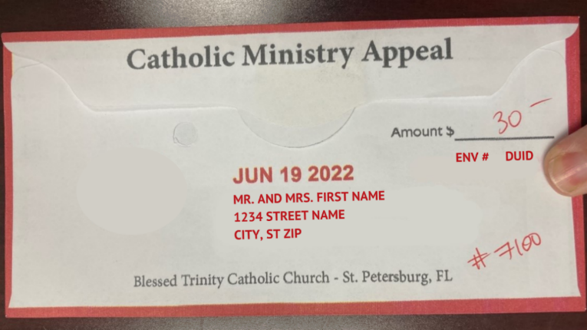

- Unopened small, offertory packet appeal envelopes with checks & cash/coins should be sent to Letter Concepts for deposit JUST LIKE IN-PEW ENVELOPES. Envelopes must include addresses, DUIDS, and parish. If information is missing, please add it to the envelopes before sending, or add a matching label provided.
- Small, offertory packet envelopes with cash and coins should be sent First-Class or, via an overnight service, to Letter Concepts.
- You may use the provided FedEx Envelopes to send these to Letter Concepts.
- Please do not open and do not count these. Letter Concepts will process them securely.

If you have any questions,
please contact Gift Acceptance team at 727-341-6841.

